LUCKY TO BE HERE
A Greek Odyssey
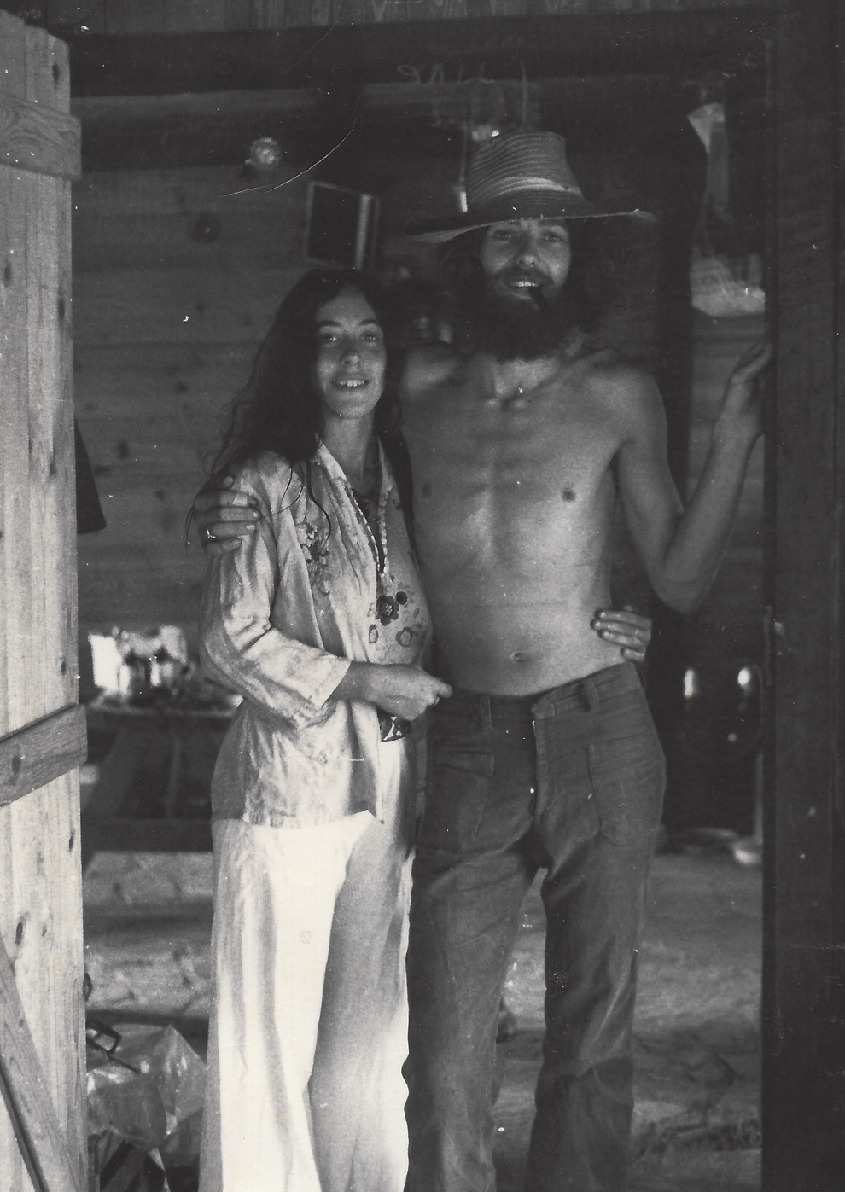
By GEOF BALDRY
Copyright © 2019 Geof Baldry
All rights reserved.
ISBN: 97810743448816

Edited by Angie Sullivan

http://angietranslates.nl/

DEDICATION

This book is for my family, our friends, and anyone who has ever enjoyed Skiathos.

Contents.

- Introduction
- Arrival
- Land
- Shelter
- Family
- Water
- Earning a crust
- Fire
- Wind
- Animals
- Fun
- Skiathos
- Philosophy
- Food
- Afterword – Lucky to be here

This book can be read online for free at www.lucky-to-be-here.com
Links to the website can be passed on freely, as long as the format is not altered and the content is attributed to me, Geof Baldry.
The memories written down here are entirely my own and any mistakes or embellishments are the fault of no one but myself.

Introduction

This book is all about Skiathos, a beautiful Greek island in the Aegean, and how it changed my life. Before my arrival there, I had been a Grammar School kid, a computer operator (when computers were massive boxes, kept in dust free, controlled environments, and had less memory than the cheapest mobile phone), a factory-floor worker, a drop out (Hippie) and a worker in a betting shop. I’d smoked a ton of dope, dropped quite a bit of acid and had hitchhiked around a lot of Europe. I was a boy/man in search of himself – but of course, I didn’t know that at the time. I was just too busy living and learning by moving from experience to experience. In retrospect, fate brought me to Skiathos and Zorbathes, the place where I found the love of my life, learned to love life and to live it to the full. It taught me what was really important in life, nearly killed me, and continues to bring me happy surprises even in my 70’s.
The quote from Lawrence Durrell, at the beginning of this book − “Other countries may offer you discoveries in manners or lore or landscape; Greece offers you something harder - the discovery of yourself.” − is true in many ways. However, it seems to me that it has not been hard; Skiathos, and its residents, made it easy for me.
2 - ARRIVAL

In my second year on Skiathos I bought the piece of land in Zorbathes Valley that has become my home. At the time, I didn’t realise just how strong an attachment I would develop to it and to Skiathos. I bought it with two American friends who were subsequently busted for possession of marijuana and were never able to enjoy Zorbathes, or to realise the hopes and dreams that they’d had for living here. I had met them the first day I arrived on Skiathos and shared a meal in the tiny kalivi that they then inhabited, in the back of the Kolios Valley. However, I already had their names on a piece of paper given to me by a German girl in Freiburg, the first person to ever mention the name Skiathos to me. In retrospect, fate (or the Greek gods) was making sure that I came to Skiathos.
It began like this.
I left Britain in the autumn of 1971 with enough money (inherited from a great aunt) to achieve an old ambition of mine, which was to travel around the world. I left behind me a cloud of hash smoke, a haze of LSD and a lot of friends and acquaintances with whom I had been sharing the hippie life for several years. I inevitably went straight to Amsterdam, which was, and still is, my favourite city, and purchased an old, beat up, Volkswagen van to travel in. As often happened when visiting Amsterdam, I stayed longer than I had intended to and I didn’t leave until late February 1972 after experiencing one of the coldest winters I can remember. I had been living in a kraakhuis (Dutch for squat, which is English for an abandoned house that was used by hippies and others to live in). The broken windows were boarded up and a freezing wind blew through the cracks.
Living with me was Annette, a Dutch girl who I thought I was in love with. She almost certainly liked me a lot but was not as romantic as I was about our relationship. It went awry, as these things tend to do when the flow of love (or what is thought to be love) is mostly one sided, and we split up fairly amicably.
I left the house with some relief and stayed with my old friends Chris and Rose in the Jordaan area before setting out to get some sunshine. Not really knowing where I was going, I headed for Freiburg to see Mike, a German guy I had met the year before via George, an American friend who had stayed with me for some time in Hounslow, England. In the course of my stay there, Mike took me to a party where a German girl called Gabi asked me what I was doing and where I was going. Actually, I didn’t know the answer to either of these questions. My situation was that of a free man with a reasonable amount of money, no emotional ties to anything or anyone. The only real thing on my mind was to find somewhere warm to soak the cold of the kraakhuis (and my failed love affair) out of my bones. Anyway, I told her most of this and said that maybe I would go to Spain (but I had already been there a couple of years before), maybe Corsica (it sounded fairly exotic), but probably Greece, as I fancied going on to India, then down to Australia and eventually around the world. She said that if I was going to go to Greece, I should go to Skiathos as it was a beautiful island and there were some good people living there. She might well have said Timbuktu and I would probably have said yes, but Skiathos it was. She wrote down a list of names of people living there. All of these people became very important in my life and all that happened to me afterwards on the island, but I did not know that at the time.
Perhaps I should digress here a little bit and describe myself. I was 23 and had been a traveller and hippie for the previous 3 years. I had (used to have!) lots of curly hair; a beard and a moustache and you couldn’t see much of my face except my eyes! This is the little signature doodle I used to add to my letters:

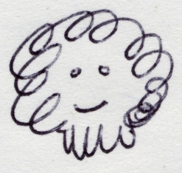

and here’s a photograph:

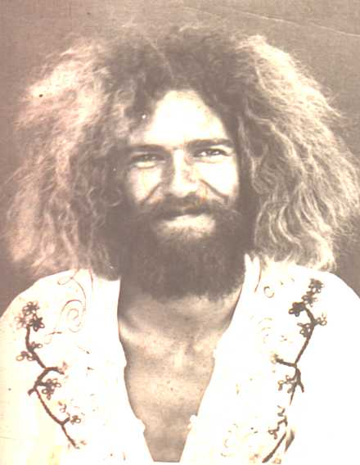

I left Freiburg a couple of days later and had an eventful trip down through Austria and Yugoslavia (then a backward but reasonably safe place). I picked up hitchhikers all the way down to pass the time and to repay my debts from my old hitchhiking days. On 6th March 1972, I arrived at the Greek border and drove down to Volos.
The following day I took a ferry to Skiathos. Upon arrival, my old camper van must have sensed more than I did about the island, as its battery had gone flat on the ferry and it (and I) had to be pushed down the unloading ramp. The van must have known that one day it would die here (which it did); I wonder if it knew more than I did, and saw my fate too? I found Yanni, who was a taxi driver and whose name I had from Gabi, and he recharged my battery. While waiting for my battery to charge, I had noted a group of longhaired foreigners sitting at a kafenion. They subsequently drove off in an old VW coupe.
That afternoon I was sitting in the bank waiting to change some travellers cheques (it took seemingly massive amounts of paperwork and many signatures including the bank manager’s) when Keith, one of the longhairs, came in and asked the manager if he had left his car keys there as he had mislaid them. No one had seen them, but I said that if he had no luck finding them, I would be quite happy to give him a lift to wherever he needed to go. He said he would be back soon and shortly returned to take me up on my offer. I drove him halfway along main road of the island and when I parked at Kolios, he asked where I was staying (I had not the faintest idea) and would I like to share a meal with him and his lady as thanks for giving him the lift. Of course, I accepted and we trudged through a boggy field to his kalivi. A kalivi is usually a one-room stone cottage, often built half off the ground in order to stable the mule or donkey and goats underneath, with a small hearth in the corner for cooking and warmth. Here I met Paula, his lady, who was cooking a stew over a wood fire in the corner fireplace of a room not much bigger than some people’s walk-in closets.
This is how I met the couple with whom I bought Zorbathes and who were among those on Gabi’s list.
I showed them the list and they remembered Gabi as the girl that had stayed with Jim, and Englishman, the summer before. They also gave me a quick rundown on the other people mentioned on her list; Reese and Patty, an American couple, and Franz (a South African giant who Keith was helping to build some tourist accommodation at Vasilias). We had a wonderful, if simple meal and I found myself liking the couple and their romantic life style immensely; it was completely removed from anything I had ever experienced. Afterwards we talked about travelling and Keith told of his adventures in India, where he had lost so much weight from dysentery, that when Paula had met him at Athens airport, she had not recognised him. Keith suggested that I should drive the van to the beach of Vasilias (there was a narrow dirt track down from the main road) as I could park and camp next to the sea and it was reasonably near the only town, Skiathos. I left them quite late that night having sampled retsina and ouzo, and staggered back in pitch darkness to my van. Until that night, I had never been in total darkness (there had always been streetlights or something to light my way) and I had to cure myself of my childhood fear of the dark or stay out all night. Someone had once told me that there was nothing “out there” in the dark that hadn’t been there in daylight so what was there to fear. I repeated this to myself as I made my way to the van and as I got there, I realised that in fact it was true, and the fear was in me and not outside. The first lesson that Skiathos taught me.
I drove the next morning to Vasilias Beach and, once we were down the dirt track, the van immediately refused to start again and I realised I was going to be there for a while, or at least until I could fix the starter motor. Being an engineering idiot at the time (and I am not much better now) it looked like I would have to get someone out there to fix it. The place was beautiful, being just 10 metres from the sea and under the shade of a pretty old, if not ancient, olive tree. The sun was still not very strong, it was March after all, but it seemed like balm to me and I spent some time just sitting around soaking up the warmth and the light (which is so special in Greece). It then proceeded to rain for 2 days, which was pretty miserable, but then the sun returned, and it became glorious. Everything smelt so fresh and the first spring flowers started to push their way through the earth. I was fascinated by the old olive tree whose trunk was so gnarled and twisted that I found myself studying it for hours at a time. Little did I realise that my soul was being captured by the magic of Greece and this particular island.
It turned out that the apartments Franz was building, with Keith’s help, were just a short walk up a steep track above Vasilias Beach and I would nip up for a cup of tea and a game of cards in Keith’s lunch break. Franz was in Athens buying furniture and after a couple of days Pam, his then English lady friend, asked me whether I wouldn’t rather stay up in one of the apartments, help with some of the work and keep an eye on them when she and Franz were away. Pam surprised me by telling me she thought I was the most “together” person around, with my ready smile and friendliness to nearly all I met. I was still a pretty shy guy at that point and didn’t have much self-respect or self-confidence. Pam’s comment started me on the road to discovering who I was and accepting myself as such.
I must explain here that I had never intended to stay more than a couple of weeks on Skiathos and I wanted to continue on my travels onwards soon. However, offers like Pam’s kept popping up and I didn’t leave until much later that year.
I accepted but was a bit nervous about meeting Franz who everyone said was a massive South African Boer who would knock your head off as soon as look at you. The Greek workers who were still finishing the basic structure of the second apartment were definitely in awe of him. He finally returned from Athens and was indeed a giant. Well over 6 foot (around 2 metres+) with feet the size of dinner plates. However, he turned out to be a rough diamond with a good heart and only put on his (seemingly) fierce side when the Greeks wouldn’t come to work because it was raining (or some such excuse).
The house cat was a young male called Kippen. Keith, with his wonderfully dyslexic way of naming things or people, had hit the nail on the head when he gave him his name. Kippen was not the brightest of cats and proved this one day by not noticing that we had replaced a pane of glass in the door that he used to come in and out, cat door fashion. He just jumped up without checking and banged his head against the new glass. After thinking about it for a bit, he must have come to the conclusion that he had got the wrong side of the door and promptly jumped up and hit his head against the pane of glass next to the first one. We were rolling on the floor with laughter and it took us quite a time to get back to some serious work. Kippen, meanwhile, gave up and stomped off in a huff. (The following winter, Kippen came to stay with me in a kalivi and once crept so close to the fire embers to sleep that he managed to singe himself and leapt out of the kalivi window yowling with pain!)
Keith came down, looked at the car, and with a few taps of a hammer and a turn or two with a spanner, freed the starter motor. To celebrate, we drove to the far end of the island to Aghia Eleni Beach where I promptly drove the car off the end of the road and into the sand. It took us several hours, a lot of brushwood and a huge amount of serious swearing to get it out again and I began to wonder if Keith thought I was as big a dickhead as I was feeling. He never told me and I never asked!
Keith introduced me to Jim who was villa sitting and had access to hot water, a shower, and a bath. He was frequently visited by kalivi dwellers in need of a monthly scrub. I also met Reese and Patty, the American couple who lived in a tiny kalivi further back in the woods from Keith’s. Patty greeted me with the rather disparaging comment of being “the boy with the list”, but they turned out to be a friendly and interesting couple who acted as the mainstay of the kalivi crowd. Patty had money and they had bought their kalivi and the land around it. However, they lived a very simple vegetarian life, spoke a fair amount of Greek and looked as if they had been there forever. I was a bit overawed by Reese who, with his long hair and beard, wise eyes and slow American drawl, seemed like some kind of guru.
Keith, Paula and I celebrated my 24th birthday in Skiathos Town where they showed me a couple of the local tavernas, both of which still exist today, Stamati’s and Messogio. We ate and drank copiously (in fact I got pretty drunk which does not happen to me often). The food was great, the wine was wonderful, and it cost all of 30 Drachmas per head. At this time, a US dollar was worth just about that amount and I just couldn’t believe how cheap the night had been.
Keith and I also spent several afternoons at an ouzeri (where the Oasis bar and café now is) under the shade of a massive plane tree, watching the comings and goings, drinking karafakis of tsipouro and snacking on the mezedes that came with them. A karafaki was about 4 small shots of tsipouro (like ouzo but purer, in theory,) and each one came with a substantial plate of little fried fish, calamares, fried courgette or aubergine slices, or dips of skorthalia, tsatsiki, or taramasalata. Each karafaki with its plate of mezedes cost just 17 Drachmas so with 51 Drachmas, we were feeling very merry and full of goodies to boot.
We had formed a pretty close friendship by then although I was still the “new boy” on the island and someone often viewed with not a little suspicion as “the one with the list”. You have to remember that this was still the time of the Colonel’s Junta and many people were afraid of just disappearing. The CIA was reckoned to be mixed up in all kinds of skulduggery and this (seemingly innocuous) person (me) with a list of names was perhaps not all he might seem.
I eventually met everyone whose name Gabi had given me and they all became close friends and/or people who influenced me in many positive ways. Looking back on that evening in Freiburg, I realise now that fate had intended me for Skiathos, although I was completely oblivious to it at the time.
Reese and Patti had 2 horses called The Bay and The Brown, after their colouring, and were busy planning and building a stable for the animals. The stable was about three times the size of their own living quarters in the kalivi, but the horses were also about three times as big! They managed to do this with money Patti’s parents had given her. Reese was a hippie from way back, and a fascinating man. With the help of Franz, (who could build the Acropolis in a few days if he put his mind to it) the stable was built over the course of a few Sundays. A work “party” would be set up to pour the foundations (for example), followed by wine, food and a celebration of achieving something solid. This became a pattern for several building projects (including our own first house). It’s a wonderful way to get a lot done in a day and have fun at the same time. This was also my first experience with seriously hard work. Mixing concrete by hand and then humping it up ladders to pour a ring beam was something I had never encountered before. I loved it and even looked at the (painful) blisters on my hands with pride.
Still, time had progressed, Franz was ready to let his apartments out and I thought that, nice as Skiathos was, it really was time to think about moving on. However, one day Keith mentioned that an English lady called Betsy − who had a kalivi on the north side of the island along with lots of animals that needed looking after while she returned to England for a couple of months − was desperately looking for someone to “kalivi sit” and keep the animals alive while she was away. It was a free roof and perhaps an interesting experience, he told me. So we went to see Betsy. She was an eccentric Englishwoman who spent half her time in England and half on the island. With the rent from her house in London, she could live comfortably, if parsimoniously, in Greece, and her excuse for doing so was that she was writing a history of the island. She kept chickens, rabbits, cats, a dog and a donkey. The donkey was necessary, as her kalivi was 45 minutes brisk walk from the village or 25 from the nearest road. Keith took me up by a “short-cut”, a path that disappeared into nothing but scrub and I was introduced to the delights of thrashing around in the undergrowth, brushing spider’s webs (and spiders!) off my face. We eventually found Betsy’s, which was a conurbation of one-room kalivis, being either joined together or separate, commanding an incredible view across the sea to the neighbouring island of Skopelos. Betsy showed me around the place and told me of the chores. Apart from looking after the animals (and trying to stop them becoming constantly pregnant), there was a newly planted vineyard that needed watering through its first summer. The situation was however, magic, and with little reflection I agreed to stay until September. Betsy left after a week having shown me how everything worked and from which nearby (and not so nearby) springs, water was available. I found out that, although Betsy was a fascinating person who had seen the island before any development had started, she was not an easy person to live with, and I was happier once she had left and the farm was all my own to manage as best as I could.
I slowly got into the routine of Betsy’s and Greek peasant life in general. Every morning was feeding and cleaning out the chickens and the rabbits, dragging the donkey out of her shed to a bit of grazing, and pumping some water for the vineyard. There was a large water tank with a concrete collection apron around it, where the winter rains were gathered for summer use. This was then hand pumped to a couple of 50-gallon barrels for distribution by bucket to each vine. There were13 rows of grapevines that needed watering once a fortnight. The water in the reservoir on her land was scarce and precious. I had to pump it by hand into the 2 barrels by the vineyard and then take it by bucket to each vine and measure out 4 kilos, no more, no less. (The Greeks do most things by weight so it was kilos of water, not litres, and one still orders wine from the barrel in this way.) The reservoir looked out over the airport, Xanemo Beach, Cape Kefala and Skopelos. Every morning and evening I spent roughly half an hour pumping and meditating (you could call it) while enjoying one of the finest views in the world. I did one row per day and on the 14th day I (the god of the vineyard) had a day of rest. It was the day that I would go down the mountain (as I thought of it then) to visit my friends.
Living very much alone (except for the animals) and just going to Town once a week for supplies and once every other week to visit, threw me very much back into myself and I had the time to have a good look at my life and evaluate just what (if anything) I wanted to do with it. Up to this time, I had drifted along. I had given up working with computers and all other kinds of “normal” work, as it just didn’t seem to be satisfying in any meaningful sense. Having the small financial freedom of my inheritance and the massive spiritual (if you like) freedom that I found at Betsy’s started me thinking that I had found some way of life that really suited me. It gave me the freedom from social mores (and the British class system) that I had always craved, and (as a foreigner) gave me the freedom to just be myself without fitting into anyone’s preconceptions of who I should be. The fact that Skiathos was (and still is) to me, a paradise, also helped me to start thinking seriously about taking what little capital I had and, instead of blowing it on a round the world trip (which would still have been a great education), investing it in a piece of land and trying to live here. All this evolved over the months I spent at Betsy’s, and I shall always be grateful for the wonderful time I spent there and Betsy’s, albeit unwitting, influence. I had learned how to load a donkey (or in fact any four-legged beast of burden), make water stretch a looonnng way, grow things, care for animals, care for myself (!), not to rely on so-called civilization but more upon myself and friends. In short, discover my own worth and value as a human being.

Living virtually on my own with only Greeks as neighbours, I needed to learn Greek rapidly so that I could understand what they were saying to me (and if it was nice or not!). Greeks are extremely hospitable to strangers (it can change later as the friendship becomes real, or remains just superficial) and everyone I met was very helpful and friendly. They were also curious as to why this longhaired freak was living in the same way as they were, when everyone knew that foreigners were all rich and could eat off gold plates. Betsy, by then, was accepted as a local but still a bit of a weirdo. However, I was seriously outrageous looking, and this was something to be discussed, mulled over and researched by devious means, mostly alcoholic. I had many conversations whereby I would point at something and say, “glass” to which they would say, “potiri” and then, “wine” to which they would reply, “retsina” or “krassi” and then we would toast each other, fall off the chairs and I would discover the word for drunk, methismeno. Having learned potiri, they then delighted in confusing me by saying, “krassopotiro” (wine glass), “ouzopotiro” (ouzo glass), “neropotiro” (water glass), etc. I discovered that there are at least 3 different words for the almost everything and they would use one of the ones I didn’t know just to stoke me up. The Skiathitees have their own dialect that tends to cut the end off words so that, whenever I went to Athens and proudly tried out my newly learned Greek on a shopkeeper or hotel owner, they would look at me blankly and reply in German!
Greeks are also very tactile (there are no really world-famous Greek painters, except the one who went to live in Spain, but their statues are amazing) and they “speak” with their hands and bodies. If you are observant (as I like to think I am), you can understand so much of their conversation by watching as well as listening. My Greek is still not as good as it should be after all these years but I can often understand a long-range conversation that I cannot hear.
My reputation was done no harm by helping a neighbour get his son to hospital after the boy had been kicked in the head by a mule. Although, at the time, I had almost no Greek, the tearful pleadings of the brother and sister of this boy were obviously urgent and sufficient to get me to his father in time to be of help.
During this summer, I wrote to many friends and acquaintances to tell them about “my paradise” and to invite them to come and stay, as there was enough room at Betsy’s for a few guests. Of all the people I contacted only Annette and my parents came to see me. Annette and I sorted our relationship and ourselves out (but not without a little more heartbreak on my side) and that helped to clarify for me that the idea of staying in Skiathos was definitely better than returning to “normal” life. My parents (who I think had rather despaired of me ever settling down or “coming to anything”) came to see just what I was raving on about. They realised that this was something I was very serious about and gave me support and encouragement (even though I think that it was extremely hard for them to do so). They subsequently spent many holidays here, at first with us and later on with their grandchildren too, and I am sure they were glad not to have tried to dissuade me.
I also met many interesting and wonderful people in that first summer. People like Irini − a beautiful, young Greek lady − who had just qualified as an architect and was building a villa for her parents on the Kalamaki Penninsula. She had been coming to Skiathos every year since she was a young girl and still comes to this day. She was having a fling with American Jeff, a friend of Keith’s who also stayed that summer. I well remember a party at Jeff’s kalivi when Franz who, having been born in the desert in South Africa and could smell rain 2 days away, led us all in a moonlight rain dance around the olive trees. In fact, Franz used to make money by betting with the Greeks (they love a gamble) that rain would come in 2 days’ time and he was right nearly all the time.
My friendship with Keith and Paula deepened and I came to admire and like Reese and Patti immensely. Many travellers passed through and left both good and bad memories but always more experiences to add to my new life.
I met a (slightly eccentric, if not mad) German psychiatrist, Hannes, and his wife Heidi who was a well-known German actress and quite beautiful. I am sure Hannes was on something (probably acid) the day we met, as he was describing a film he wanted to make but the story line just rambled from one crazy scene to another. I went with them some days later to see a piece of land that was for sale in Alonissos and I liked their company a lot, although his ideas were weird to extreme about all aspects of life. I was open to listening to anyone and their opinion at that time, trying to soak up as much “life” as possible.
Other notable meetings were with Babis, who was building Irini’s villa and eventually first showed me Zorbathes. His mother Areti (also the mother of Stathis, of taverna fame), who had had 9 children and still looked after one who was a bit “soft in the head” even though she was by then well over 70. She made the most wonderful tyropittas (country cheese pies) with eggs, milk, homemade feta cheese, pastry rolled out to paper thinness, and a cheerfulness that belied her hard life and added to their flavour. Stathis still makes these (but only for friends) and they are just as delicious. She could remember growing up in Kastro − the old town of Skiathos − and how they took the doors, windows and roofing materials along to make their new houses when they moved. This is one reason why Kastro looks so desolate, with just ruined walls standing.
I used to get drinking water from a spring below her kalivi, which welled up inside the bole of a large plane tree. I would load the donkey, called Donk, with various metal and plastic containers to fill with water and trundle down to the tree. Areti would hail me and I would tie up Donk and sit down for a cup of Greek coffee (actually Turkish but never mention that!), a piece of pie and a chat in my broken Greek and her descriptive hands.
The whole pace of life was just so different from so-called civilization, and all the hurry, stress, drinking and drugs that compensate for the lack of the “real” civilized society, which I thought I had found in Greece. Needless to say, Greece has been rushing to join the first type of life with its seeming economic benefits but has lost a fair amount of her soul in the process…you don’t get something for nothing! I found myself changing from a confused, often doped, child of the middle-class suburbs in which I grew up, to someone who cared for other people, cared for some deeper values than simply material ones, and generally felt almost completely at peace with myself and what I was doing.
It’s about time that I described Skiathos a little. It is a relatively small island, and being tucked in the lee of the Pelion Peninsula, it is not subject to the same strong winds that howl down the Aegean and through the Cyclades islands for most of the summer. The prevailing wind is northeast and rarely blows more than 4 on the Beaufort scale. Ideal for sailing! Skiathos is blessed with fertile land, lush green forests and many sandy beaches. There are at least 18 long beaches with beautiful sand, plus another 40 or so smaller sandy beaches. There are also 4 large pebble beaches including the famous Lalaria Beach with its smoothed pebbles and crystal clear water. When I arrived, there was only 1 tarmac road from Skiathos Town to Koukounaries Beach plus the mud road leading to the monastery of Kounistra and the beach of Aselinos. Everywhere else was accessed by foot or animal and these paths were beautiful. The main ones, like the one from Town to Kastro, had been laid with large cobblestones for their whole length and had been worn smooth by the constant tread of hoof and shoe. It took around 3 hours to get to Kastro on this road, and it passed fairly close to the highest point of the island at 433 metres. In olive picking years (every second year), people would set out at 3 o’ clock in the morning to be at their land at Kastro or Kechria so that they could start picking the olives at first light. They would stay for several days in tiny kalivis while sacks of olives were carried back by animal to the olive press situated in Skiathos. I loved walking these old trails and we often took picnics with us and went off for the day to some remote part of the island. Skiathos seems to have so many different facets to it. In many places, there are microclimates and one half of the island is definitely different from the other. This seems to be geological as the eastern half has more granite in it and the western half is mostly sandstone. The olive trees on the eastern half grow better and produce more oil per kilo of olives than those towards the western end. It is often the case, when we have thunderstorms, that it will pour down with rain on one half of the island and there will be virtually nothing on the other half. The dividing line seems to run from the Kalamaki peninsula through to the Kechria Valley.
There was very little tourism then. It was mostly Greek people who would come in July and August and for the rest of the time, Skiathos Town was a sleepy little fishing port. When the ferry came in, once a day, it was a big event and half the locals would go down to see what was happening and who, if anyone, was arriving.
The foreigners living on the island were split into 2 groups. The villa owners who had bought villas on the Kalamaki peninsula and the kalivi dwellers like myself who were mostly hippies, travellers or odd eccentrics of one sort or another. (In the late 60’s a South African man saw the potential of Skiathos’ beauty and started buying up plots of land on the Kalamaki peninsula, mostly around Kanapitsa Bay. He offered a plot for £2,000 and a plot complete with villa for £4,000! Although this was quite a bit of money in those days, the villas were still bargains and are now worth many, many times their original purchase price.) Mostly the first groups were British with a few Germans, Greeks and a couple of other odd nationalities as well. They were well-off or rich retirees or remittance men. The kalivi dwellers were largely struggling to make ends meet, so that they could continue to live in this wonderful place. The one group was often a source of income for the other and, although there were some class divides and the obvious economic ones, we were all foreigners here (even the non-Skiathitee Greeks were foreigners!) and therefore held that in common. The locals were, on the whole, very friendly and hospitable and were always encouraging whenever I tried to make myself understood in my (very) basic Greek.
The beaches were mostly empty except for Koukounaries, which was then an umbrella-free, long, fine sandy beach fringed by lovely Koukonaries trees (stone pines), where one could relax in the shade. It had a taverna, as did Troulos Beach and Kanapitsa Beach. All the other beaches were more or less deserted. Vromolimnos Beach (for example) was covered in driftwood and rubbish from the sea and no one would ever think of going there. We would get quite put out if we saw someone else on our favourite beach of Platanias (now often known as Aghia Paraskevi Beach) even though they might be sitting some 400 metres away from us!
When Gabi told me about Skiathos, I had envisaged a small Greek cottage by the sea where all these friends of hers stayed. I actually saw a cottage exactly like that when I went to live at Betsy’s but it was right at the end of the airport and the owners (the people whose boy had been kicked in the head by a mule) had been moved out. It looked very sad. The airport had just been finished when I came. It had used (and put tarmac over) the best land in Skiathos where everyone used to grow their crops and vegetables and grapes for wine. This is not an unusual situation. Heathrow Airport (which I grew up very close to) is reputedly built on top of 18 foot of prime, Thames Valley topsoil. The airport had broken the hearts of many of the old boys who had lived on that land all their lives, raised their children there and grown their gardens and vines, and although they received compensation (not much, I fear) many of them faded away and died in the next few years. It has been a mixed blessing. While bringing the wealth that came with tourism, it was also the first step in the erosion of a wonderful lifestyle that had not changed much for many centuries.
There were few fences. Land was defined by natural borders, or stones set upright at strategic corners. A person would identify his land as going from this corner stone to that stone, along this streambed, up to the hedge and back to the corner stone. This olive tree was inside but that one belonged to the neighbour, and so forth. The fencing that did exist, was usually around a kalivi to keep the animals out and away from the garden. Chickens, goats, rabbits, etc. often roamed free, particularly up in the hinterlands where the goat herders lived and the nearest neighbour was a long way away. There were disputes about borders, of course, and accusations of neighbours moving border stones were rife. There was an incident I heard of (I believe it is true) where 3 brothers were dividing up land inherited from their father and the dispute over the ownership of one olive tree became so heated that eventually one brother held a second while the third brother stabbed him to death! A “passionate” killing like this was considered far less grave than premeditated murder, and often the sentence would be lighter than that given to someone dealing in hashish, for example.
Many, many years ago, long before I came, there were no written records of land ownership and transactions. One family was the records office and kept everything in their heads and this knowledge was passed down from father to son. One assumes that this family must have been honourable; otherwise, the opportunities for corruption would have been rife.
The town of Skiathos was built on two hills that overlooked the harbour. The streambed running between the two had some water for most of the year, but had been covered up by the time I arrived and turned into the street of Papadiamantis. We still affectionately know this street as “the main drain”. At the end of this street, next to what was the police station, were two massive plane trees that provided lovely, deep shade. After the police station moved there, for some reason, one was cut down completely and the other trimmed back to a bare shadow (sic) of itself. Now, the tourist shops in that area have had to put in air conditioning to keep them cool (which consumes energy and pumps out more heat into the atmosphere)! The high school was there but in much older buildings than nowadays. The junior school was on the Bourtzi and there were not enough teachers to go around, so some children went in the morning and some in the afternoon. The Town Council had recently put on a causeway to the Bourtzi so that the kids didn’t have to scramble across the rocks (and sometimes get wet) on their way to school. Traditionally, all the youngsters had their hair clipped very short in spring and I (who had been happy to get away from skinheads and the like) found it a bit of a shame. At the beginning of each summer, they were brought down to the harbour and, in front of the main outlet from Papadiamanti Street, they all jumped in and paddled around happily (something I would not recommend now!).
A small amount of people were making money from tourism and working for the villa owners but most people still lived from the land, the sea or from money sent back by local men working on Greek ships all over the world.
Every morning, a line of horses, mules and donkeys would set out from the village towards Koukounaries, which would gradually get less as each rider peeled off down some trail or other to get to his olive grove or small plot. Often the animals would be loaded with 2 sacks of their own manure, scraped up from the stable floor and destined for a couple of olive trees or a garden patch. Distances were measured in cigarettes, i.e. “How far is it to Kolios?” “About 2 cigarettes”. They kept the old trails open; if some branch or twig had become long enough to be bothersome, they would trim them with a swipe of a machete, dealt from horseback. They would return in the evening with their animals loaded with olive prunings for a goat or lamb that was kept somewhere near the village.
A word or two here about the olive tree. Olives and olive oil has been the staple of the Greek diet for centuries (you could follow the path of the army of Alexander the Great through Asia by the olive trees that grew from the pips dropped by the wayside). Both are full of goodness and olive oil is reckoned to be the healthiest of oils. Visitors to Greece who think a dish of food that has a lot of oil in it is “greasy” and likely to upset their stomachs are making a dreadful mistake! However, the olive tree not only provides good food but also gives wood for heating (it burns long, beautifully and gives good coals for cooking) and the leaves are a good source of nourishment for goats, sheep mules, donkeys, etc. The trees provide shade for a midday nap and food for the eye because the colours of the leaves are constantly changing as they rustle in the breeze. An artist friend once told me that it’s impossible to paint an olive tree’s true colours on canvas because they never stay the same.
Olive trees will grow in places that most other trees would die in and will cling to seemingly infertile, rocky areas and thrive. They do need attention but, with a minimum amount of fertiliser and a regular pruning, will produce a crop of beautiful olives and golden oil. As the olives mature, from September onwards, they turn from green, through purple to a deep black colour. At any stage of maturation, if you pick and polish an olive on your shirt (much as one polishes an apple), you will be rewarded by a glowing jewel, as the natural oil burnishes the skin. The trees have a natural two-year cycle and so every other year is an “olive” year, so the olive presses are spruced up and repaired ready for the harvest. Even here, the olive proves generous to the last. After the virgin pressing in the local presses, the leftover semi-dry slurry (pyrini) is taken away by lorries to the mainland to large, commercial presses which squeeze quite a bit more oil out. These same lorries bring back the (now almost dry) pyrini to the local presses where it is burned to produce the hot water necessary to clean the oil after pressing.
Fishing was the other main industry and there were far more fishing boats then than there are now. In the evening the gris gris boats, consisting of one mother caique towing lots of smaller boats each equipped with acetylene lights, would fire up their old diesel engines. They poured a bit of oil into the air intake to increase the compression and then with a hefty swing on the handle and a few smoke rings out of the exhaust, they would start with a “wump, wump wump”. The mother boat would ease slowly out of the harbour and ropes were thrown from it to the first small boat, then from that to the second, and so on, until there was a string of boats progressing out to sea as the light started to dim. As the boats went past, there would be the odd spot of cursing and piss taking if someone failed to catch his rope. They would return at daybreak and unload their night’s harvest at the fish market where eager locals would crowd around, pushing and shoving to get the best of the catch. (Queuing is an unknown phenomenon in Greece.) Smaller fishing boats would come and go, and often sell the few kilos of fish straight off the boat. There were also one or two larger trawlers that would stay away for several days. A lot of their catch would be sent off to the mainland and packed in ice once the best fish had been selected for local consumption.
The stretch of the waterfront from the plane tree (where Keith and I consumed our tsipouros) to the fish market was where the fishing boats were moored. It was not wide enough to accommodate shops and had a small “park” and a few benches, shaded by leafy trees in the summer but warmed by the sun in winter. This was a favourite spot for the “old boys” to sit, leaning on a stick (bastooni) and flicking some worry beads (komboloi) back and forth in complicated patterns and rhythms. They would exchange gossip, josh “youngsters” (60 or less) walking down to buy some fish, or just sit watching the boats bobbing up and down next to the quay. In the winter, it was a place to soak some of the sun’s warmth into old bones and doze off for a while. I found myself contemplating old age (and its inevitability) and thinking to myself that here would not be a bad place to get old in.
Just along from these benches were the public toilets, a place you would have had to be pretty desperate to contemplate approaching.
The fishermen spread their nets out on this part of the waterfront and sat on the ground mending their nets with one gnarled big toe poked into the net to stretch it out for sowing. They were always barefoot and usually had a cigarette smouldering in one corner of their mouths as they worked.
From the fish market, steps led up to a maze of narrow streets that eventually led to the top of the west hill where the Health Centre is located. This was, and still is, the nicest and most authentic part of Town. The narrow streets do not allow major building so the old houses remain pretty much as they were and many have been renovated beautifully. Those close to the cliffs above the sea have wonderful views over the harbour, to the Bourtzi and beyond.
In the town (well, it was a village then) the men played cards, drank coffee or ouzo in the kafenions and discussed − often in raised tones − the day’s happenings. Greeks, from a foreign perspective, always seem to be very loud and having arguments but we should remember that “drama” is a Greek word and an event that has no dramatic appeal, or cannot be dramatised in the telling, is not worth discussing. The purchase of a piece of “worthless” land for a hotel in Koukounaries could be passed over in favour of a heated discussion as to whether the saddle maker was justified in raising his prices, or was he ripping everybody off (again!)? The women sat outside their houses and gossiped about this or that but, I believe, secretly ran the whole society while the men, who seemingly ruled the roost, were actually given only so much rope!
In the main street, opposite what was then the Post Office, was the “workers” kafenion. It was like kafenions you used to find all over Greece, with many small, marble-topped tables, each with 4 chairs, packed into the minimum of space. Here the workers and haulage men used to wait for anyone needing their services, drinking an early morning “cognac” (really cheap brandy), swapping stories and discussing anything from lack of work and politics, to football scores and the latest local scandal. There was usually a “character” (often well oiled with cognac or tsipouro) that would keep the company in stitches with stories and antics. In the evening, it became their local ouzeri where carafes of ouzo and tsipouro were consumed, along with the small plates of grilled fish, octopus, baked potatoes and anchovies; this prevented the alcohol from getting too much into the blood stream. The small plates of food (mezedes) were left on the table as they piled up, and when the bill was eventually called for, the proprietor simply counted the number of plates to calculate the cost. Work for the following day was often arranged during the course of the evening. Many foreigners complain about the size (or lack of it) of ouzeri and kafenion chairs. They are uncomfortable to sit on for a long time but not if you use them as the Greeks do. You need three (3!) chairs to sit on. One you actually rest your bottom on, another in front of you for one foot and one to the side of you for your arm! This is remarkably comfortable. Of course, this no longer becomes tenable as the room fills up, but by then you normally have good parea (company) and a few small drinks under the belt and you cease to notice the chairs at all. The kafenion was pretty much a male bastion. Women were allowed but frowned upon and Lida never felt totally comfortable there. It eventually closed down as the rent became too high for a small local business and it is now a shop selling gold and silver jewellery. A real shame as it was another part of the “old” Skiathos that I love and miss. There are still a couple of similar places in the back streets that only the locals use but they don’t really have the same atmosphere of that original one.
The women always greeted me pleasantly as I walked past and it was not difficult to smile at everyone I met. Only one of the priests would not say hello to me and avoided my eyes. I guess he felt that long hair and a beard was his prerogative and he resented me wearing both. I finally received his acknowledgment, many years later, when he wanted to buy some of the organic green beans that I was then selling in the town, and after that, he was OK. I was always careful to give the people of Skiathos their due and respect and found that it was then returned to me. It seemed that, the more I liked Skiathos, the more it liked me.
The big social occasions were the religious festivals when the islanders would gather at this or that church, some inside participating in the service but many outside with a flagon of homemade wine and a picnic, thoroughly enjoying a party. There is a commemorative headstone in the churchyard of Agios Yiannis Prodromos (John the Baptist) close to Kastro, which states that 4 people were struck by lightning on that spot and died. One wonders if they were having too much fun outside while the service was going on? Marriages and christenings also afforded an excuse for a good time and name days were celebrated by the person whose day it was, plus all of his family (which didn’t leave many people to do any work, so most didn’t!)
Easter is the Greek holiday. It is usually preceded by 40 days of fasting when meat is definitely proscribed and even olive oil(!) must not be eaten on certain days. Most people in Skiathos do a kind of fast, some sticking absolutely to the letter of the Church law, while others don’t eat meat but do eat everything else. Services are held every day for the last week leading up to Easter Sunday, the biggest of these being on Good Friday night when the Epitafio (bier) of Christ is carried around the Monastery of Evangelistra, followed by a huge crowd. Tradition says that it always rains that night as God weeps for his son. Surprisingly enough, it often does. On Saturday night, there is a big service in the main church of Tries Iearachis (the lower of the two in Town) and everyone gathers there to welcome the coming of the light as Christ is resurrected. Towards the end of the service, the priest chants “Christos Anesti” (Christ has risen) and lights a candle from the one candle that was burning all through the service. The worshippers then light their own candles from this one and pass the flame on to their neighbours. The light spreads throughout the church and then into and through the church square and is really a marvellous sight. Everyone shakes hands or kisses and repeats “Christos Anesti” as they pass the flame on. The candles are carefully shielded as everyone walks back to their houses and then a cross is described in black smoke from the candle above the doorway to bless the house for the following year. Those that live out of town are seen driving home with the inside of their cars lit up by the candles. A traditional meal of Mayeritsa is used to break the fast after the service. This is a soup made from the intestines, liver and heart of the lamb or kid due to be roasted on the Sunday. On Sunday morning, the men get up early to start the fire to make charcoal for grilling the lamb or baby goat that is traditional for Easter. Often kokkoretsi will be made on a smaller side spit and will be eaten as a meze to keep hunger at bay, as the main meal will always take many hours to be ready. Kokkoretsi is all the internal offal (liver, lungs, spleen, kidneys, etc. from the lamb or kid) threaded in small pieces on a small spit and then wrapped in the small intestine of the animal. This may sound disgusting to some but it is in fact a delicious starter if you can get over the prejudice against offal and guts. The animal is spit roasted over the coals and basted with oil, lemon and oregano. This is a long, hot, thirsty job and some will be pretty high on wine or beer by the time their lamb is done. Boiled and coloured Easter eggs are cracked, one on top of the other to see who has the best egg (the one that didn’t crack), and then everyone sits down to a huge feast of meat, bread and green salad. The afternoon is often spent repenting!
Betsy returned and I had to think what I should do next. The idea of buying a small piece of land and living somewhat as Betsy did had slowly crept into my head during my stay at her place.
Still, part of me was saying that if I was going to invest in land, I really should do it in England. After all, that was my real home, wasn’t it? I decided to go back and look at the possibilities.
I travelled back with Pat and Collette, a lesbian couple who were going as far as Munich and I stopped there for a couple of days and visited Hannes and Heidi.
Returning to the UK, I discovered just how much I had changed (and how little it had) and how I could never possibly live back there again. I had seen too much other beauty, too much good weather, too much hospitality, too much freedom and too much of my own heart to ever want to return to my land of birth.
I returned to Amsterdam, visited friends there, and talked about my previous summer’s experiences.
I often visited Pax, a Dutch Indonesian who had a flat where many people visited and crashed and where I had first met Annette. The previous winter I had also met Adri and Lida (then married) and two of Lida’s sisters, Liesbeth and Julia. It was Julia who had said to me after I had split up with Annette, ”Nooit vergeten, achter the wolken, schijnt altijd de zon”, which translated means, “Never forget, behind the clouds, the sun is always shining”, and it had been this little expression that I had carried with me to Greece and found to my delight, to be true. I spent quite a bit of time with Adri and Lida and liked them both immensely. Adri and I had marathon chess games that often went so deep into the night that Lida could be waking for work before the game was completely finished and analysed.
At Pax’s I met Walt, a friend of American George, who was interested in travelling to Greece. As I said I was going back to Skiathos that January, we agreed to travel together and share expenses. Another old friend, Canadian Chris would come with us and the three of us crept out of Pax’s flat one afternoon (without saying goodbye, it has always been the hardest thing for me to do) and drove south towards Germany. When we got to Munich, I got a bad dose of flu so we stopped at Hannes and Heidi’s house while I recovered. Chris decided at this point that he really didn’t want to go to Greece and left to go back to the UK. Heidi and I had a small fling but it wasn’t anything serious.
Walt and I drove down through Yugoslavia and took the coast road. This was beautiful in a rugged, barren kind of way but also took forever as the road wound in and out following the coastline faithfully. The weather was very mild and we even slept out on a beach one night. At Dubrovnik, we started inland to connect with the main highway at Skopje. This involved going over the mountains and, although the days were sunny and bright, the nights became seriously cold. We would wake up in the VW van with frost all over the inside of the van and would have to light the gas cooker to melt it. Of course it melted all over us and our sleeping bags just to make life a little more “interesting”. Our first stop was for coffee and bread at the nearest hostelry, which usually consisted of a big room with a few tables and chairs and a massive wood burning stove, handmade from an old oil barrel, around which everyone would cluster. Both of us had long hair and fairly flamboyant clothes and we were looked upon as some apparition from…who knows where? As we had no Serbian or German (which some Yugoslavs spoke), we did a lot of smiling and nodding as we were bombarded with questions about (presumably) who we were and where we were going. It is a very strange feeling not to be able to speak to other people but I discovered that a smile goes a long way wherever you are.
We arrived in Greece, and I must say, it felt like coming home.

3 - LAND

Back in Skiathos, it was great to be greeted by all my new friends and acquaintances and in no time, Walt and I had found a small kalivi to stay in.
I mooted the idea of buying land and Keith and Paula said they were looking as well and maybe (if things developed that way) we could do something together. I spent the next couple of months looking at land all over the island. Sometimes we would all go together if the land we were told about was quite large. Most of the pieces on the south side, near the sea, were beyond my budget and nearly everything else was too remote or inaccessible. I did spend a lot of time on mule or horseback, being taken to one plot or another on trails I didn’t know existed, and learned a lot about the geography of the island.
Finally, I ran into Babis by chance in a shop on the waterfront that belonged to someone who also acted as some kind of real estate agent. Babis was the builder who had built Erini’s parents villa, and was also one of my near neighbours at Kalivia when I had been looking after Betsy’s. Babis told me of a piece in Zorbathes but said it was fairly remote, in the middle of the island and was pretty overgrown. We went to have a look, driving down the (then mud) road that led to Aselinos and Kounistra Monastery. Stopping the car, we walked for about a kilometre, following a streambed that had a lot of water in it, and finally emerged on to a spot that with a slightly raised hill in the valley looking down on a field sown with hay of some sort. There were olive trees on the rest of the land but they were so overgrown with scrub that you could only see the tops of them. However, the field looked brilliantly green and the little hill just grabbed my heart, and my mind said, “YES, this is it!”
The plot of land was very big, some 30+ stremata (1 strema is 1,000 square metres, 4 stremata is around 1 acre) including a piece of forest, which went with the agricultural land. This was too much for me alone and so I rushed round to see Keith and Paula and dragged them out to see the land the next day. They liked it as much as I did and were particularly interested in the back section that had a very small kalivi on it. As I was more interested in the front piece with “my” hill, it looked like we might be able to agree to purchase it together.
We spoke (in our broken Greek) with Babis and the owner of the land, Manolis, who gave us his price and said we would have to work with the property agent where I had first heard of the land from Babis. As we didn’t like the agent and were pretty sure he would rip off both Manolis and us, we refused to deal with him and said that we were only interested in talking directly with Manolis. This he said he couldn’t do as it would not be ethically correct. We also said that we didn’t want the forested part of the land, as this was useless to us. At this point, the negotiations were left in abeyance and we kept looking around for other alternatives.
I went back to the land some days later and found Manolis starting to clear some of the olive trees that were almost completely overgrown by the wild bushes. I reiterated that we would not deal with the agent but only directly with him and he shrugged his shoulders as if to say, “What can we do?” He showed me an old footpath up to the Monastery of Kounistria and we then went our separate ways.
Another Greek, Christo, who was not originally from the island and was married to an English lady called Gail, tried to help us and kept suggesting to Manolis and Babis to contact us directly and cut out the agent. I don’t think this did Christo any favours with the agent but he was sympathetic to our search for something in Skiathos.
In the meantime, Walt had become emotionally involved with a Canadian lady who was staying with her (then) husband in one of the villas on Kalamaki. They left and went to Canada to start living together.
I got to know Reese and Patti much better, and my friendship with Keith and Paula was deepening all the time. Paula’s family came to visit to see the land and give their approval (or not), as Paula’s father would be the one financing their half of the purchase. Paula had 2 sisters and a brother, and the first night we were all together, staying in a pension outside Volos. Krista, the eldest sister, and I took one look at each other and fell in love. This could have complicated buying the land, but didn’t in the end. Krista and I spent a steamy 3 weeks together, but then the family had to return to the USA.
Some weeks later, I ran into Manolis in the main street of Skiathos, Papadiamantis Street, and he asked if we were still interested in the land. I said: yes, we were. He said: all right, we will talk together, just you and me. We arranged to meet in an ouzeri on the waterfront and we brought along Franz as an interpreter. Manolis asked us to make him an offer and we offered him half the price he was asking for (with no forest included) as a starting point from which to bargain. He said simply, “andaxi” (OK). We were stunned and Franz, who recovered quickly, said, “Grab his hand man, shake his hand now!” The deal was struck and an ouzo was drunk to seal the bargain. Although we got the land for half the original asking price and − compared to land prices in Skiathos now, it was amazingly cheap − it was still expensive if one compared it to the prime Lincolnshire farmland in Britain that I could have bought for the same price per acre. I am sure no local Greek would have paid as much as we did but it was still a good price for us. Some time after we had bought the land, Manolis himself said, “Some years ago, I would have given it away for a piece of bread.” (We think that the money for the land seeded the hardware shop that his son opened, and where we still shop to this day. I will often chat with his son about how Zorbathes changed my life for the better, and we still compare notes on growing our own vegetables.)
We went to the local notary, made a contract agreeing to buy the land and paid a small deposit. I also gave Paula my power of attorney, as I had to go back to Britain to get the money and send it to Skiathos, and could not be back in time for the signing of the main contract. We had decided to buy it all together, rather than split it into two halves, as we had no real idea at that time what we were going to do with it.
I returned to Britain and took the money, in cash, out of my account (the bank clerk said, “Do be careful walking around with so much cash on you……..sir.” The “sir” was difficult for her to say as she was looking at a rather flamboyantly dressed longhaired, bearded person who shouldn’t have been able to take out such a sum of money!). I then had to carry it in cash out of the country as there were monetary restrictions imposed at the time and, if I remember correctly, you were only allowed to take £40 out. I took it to Amsterdam (any excuse to go back to my favourite city) and transferred the money to Greece from there.
While there, Pax and his wife Eva, Adri and Lida suggested that they come to Skiathos for a holiday and I was enthusiastic as I wanted to share the island, my land and my discoveries with as many friends as possible.
However, not everything went as planned with the land. Initially, it was Keith and Paula who wanted to do the complete “back to the land” bit, growing their own vegetables, and trying to be as self-sufficient as possible. I had no real leanings that way but I had enjoyed looking after Betsy’s animals and growing a few tomatoes and peppers that previous summer. I was more interested in building a house and having some place on this planet that was mine; somewhere I could love and live on as I wished (i.e. not having my life mapped out for me in a society that decided more or less everything for me and over which I had virtually no say).
I arrived back and went to Reese and Patti’s kalivi. Keith and Paula were looking after it as Reese and Patti were away, travelling. On the door was a note saying, “We are in Zorbathes” as Keith and Paula were busy there renovating the small kalivi. As evening was drawing in and I knew I couldn’t get to Zorbathes before dark, I decided to sleep in the straw of one of the horse’s stables (the horses were with Keith and Paula).
I was woken up the next morning by four men, one of whom was waving a pistol in my face and shouting (in bad English), “Where are the trees?” I was still woozy from sleep and had no idea what was going on. It transpired that they were plain-clothes policemen who had received a report that marijuana was being grown on Reese and Patti’s land (true as it happened). However, they had been told that there were plants growing but only found some stumps (as it turned out, Keith had cut the plants down a few days before). They finally found the plants and a tin of dried marijuana in the shed behind the kalivi and then interrogated me about why I was sleeping in the straw and what was the note on the door. I explained that I had just arrived back (which fortunately I could prove by the arrival stamp in my passport) and then explained that the note said where Keith and Paula were. We then drove as close to Zorbathes as we could and walked the rest of the way. As we arrived, we saw Paula with one of the horses and she shouted, “Hi Geof!” I could only say, “We are busted!” which was probably the most depressing thing I have ever said to a friend. Friends of friends of mine, Roy and Ingrid, were staying with Keith and Paula in Zorbathes on their way to India.
We were all taken down to the local police station and interrogated. Initially, the police focused on me as I had actually been arrested at the scene of the crime but after a while, their attentions turned to Keith and Paula. At first, they denied all knowledge but then they beat Keith on the soles of his feet and threatened to do all kinds of nasty things to Paula (this was the time of the Colonel’s dictatorship, remember), and so Keith confessed and took full responsibility for growing the weed. At the end of a long day, Roy, Ingrid and I were released, but Keith and Paula were held. Keith managed to whisper to me before we left, “There’s a large chunk of hash in a tin box in the kalivi, see if you can stash it.” Roy and I went back to Reese’s kalivi that night, completely spooked, as you can imagine, by any small sounds in the night, because we didn’t know if the police had left anyone on watch at the kalivi. They hadn’t and we found the hash and crept into the woods above the kalivi, dug a very shallow hole, and stashed it there. (Some weeks later, we went back to find it, but we couldn’t! It is probably still there, somewhere in the woods, to this day.)
I suddenly found myself responsible for Reese’s two horses, Keith and Paula’s horse, and Francine; a donkey that had belonged initially to Reese and Patti, then American Jeff, but which he had given to Keith and Paula when he left the island. Roy and Ingrid helped as much as possible but left shortly afterwards to travel to India with friends from the UK who had arrived at Zorbathes a few weeks previously. Reese and Patti arrived back and we went to visit Keith and Paula in the Larissa Jail, where they had been incarcerated. Patti said that she would cover their legal costs and any fines that they might have to pay, but it looked almost certain that at least Keith would have to do some time in the Greek prison system.
Their trial was held in Volos a few months later and we all shaved off our beards and (tried to) cut our hair neatly, to look as un-hippie like as possible. We discovered that Reese had quite some jowls under his beard and, when I saw him unshaven for the first time, he said, “You have two minutes to laugh!” Keith and I hardly recognised each other at the courthouse, as both of us had short hair and were clean-shaven. It must of helped because, instead of the maximum penalty of 21 years(!) and a huge fine, Keith received only three years and a comparatively small fine. Paula was found not guilty and was asked if she wanted any compensation for her four months in prison waiting for the trial. The lawyers told her not to ask for anything, as the sum would just be tacked on to Keith’s fine. (Justice, what justice?)
Keith eventually stayed only 2 years in prison as after some months in the maximum-security prison in Corfu, he was moved to a work farm prison on the Halkidiki peninsula, where every day he worked counted as two days off his sentence. Being, by this time, Greek prison wise, Keith had told them that he had been an animal doctor in the USA and was therefore put in charge of milking the cows. This was a seven-day a week job, enabling him to work off his sentence in an even shorter time. When he finally got out, he was taken to the border and told never to return. He went to see Adri (Lida’s ex.) in Zaandam, Holland and eventually spent all the rest of his life in Amsterdam. He had many tales to tell, as interesting (if not more so) than mine, but unfortunately died a few years ago. He had contracted hepatitis C all those years ago in India, on his way to Skiathos, and that (with the help of a large consumption of beer) is what did for him in the end.
Paula left, their relationship wasn’t strong enough to withstand the long separation, and continued her life in the States. She sent a power of Attorney to Reese to act for her, and he and I arranged to have the land divided so that I had the plot at the beginning of the land and she had the plot at the back with the small kalivi on it. Eventually, I found a wealthy Englishman (who already owned a villa on the seafront) to buy it and Keith and Paula’s last connection with Skiathos was severed. (They did return once, after many, many years, but that is a story that belongs elsewhere in this book.)
All the land is now cleared of shrub (though we still have a small, forested section) and we have planted trees almost every year we have been here. We have learned that if you plant a certain number of trees, you will lose a few, some will remain stunted, and some will thrive, but it will be many years before you really see and receive the benefit of them. However, the ones that survive and thrive will be your companions for life. Even the ones that come to the end of their life, or never produce much fruit, will warm you in the winter months as firewood. Trees, like all living things, are to be cherished. Outside all of our houses are pergolas covered in vines and the land on the more marginal bits of our land we have planted more.
Vines are another gift of the gods (though this time it was from that old hedonist, Dionysus). They provide good shade in the summer but drop their leaves for the winter allowing the sun to come shining through, they will grow happily on very poor soil, and they produce a crop that is delicious to eat, but even more interesting when fermented and turned into wine. Our first efforts at wine making were not great. We followed the advice of Barba Mitso and other locals who told us to clean a barrel, pour all the must into it after having trod the grapes in a tub or tank, and leave it for 40 days. Then the barrel was sealed and, shortly after, tapped. The wine this produces is potent but (at its best) is cloudy, tastes of yeast, and often has a musty flavour. I have drunk a lot of this in my time (in Greece you cannot refuse if someone is proudly offering you their own wine) and started to understand why they would put pine resin in it. Apart from being a preservative, it covers up a lot of sins!
We discovered that extreme cleanliness is so important in wine making. There are already so many things that can affect a wine − pruning, weather, funguses and diseases, timing of the picking, and a host of others − but cleanliness in the fermenting and bottling process is of paramount importance. Once the grapes are picked, you can at least make sure that everything that comes into contact with them is spotlessly clean. Most commercial growers kill the natural yeast on their grapes and introduce commercial yeast, as natural yeast can also be contaminated thus spoiling a wine. We however, being organically inclined, work with what nature gives us naturally and mostly the wine is good. We use demijohns instead of barrels for the first fermentation, as they are easy to keep clean. The wine is then racked several times to take it off the must before bottling. Some years are better than others. Lida is a great lover of wine, and after lunchtime, usually has a glass somewhere within reach. She is the wine master and oversees the picking, crushing, pressing, racking and bottling of the various varieties that we have.
We produce a good white and some nice red wines, but we also produce a rosé wine that is based on a vine which grows wild naturally on Skiathos. It is called korios locally. It produces small but abundant bunches of tiny round grapes and seems to be impervious to all the other grape’s diseases and pests. The wine made from it smells and tastes strongly of strawberries, so it also has the name Fraoula, which is Greek for strawberry. The locals say that it raises your blood pressure and is therefore not good for you, but I think this has more to do with the quantity that they drink rather than the wine itself. We tend to blend it with other grapes to minimise “the blood pressure problem”, but more to produce a wine that does not taste so strongly of strawberries. However, the strawberry taste is always there. It is a nice summertime drink, especially if it is cut with a bit water or drunk with a couple of ice cubes. (I can hear the wine tasting fraternity turning in their graves at the mention of ice!) The wine made from these grapes can also be distilled to produce a tsipouro of distinctive (and delicious) taste.
We plant a few more vines every year as the older ones become less productive or succumb to old age. Only the korios in front of our door survives from the year we built the first wooden house. Barba Mitso’s son came by that autumn with a shrivelled stick and proceeded to dig a hole to one side of the door, in which he planted the cutting. “A house needs a vine in front of it,” he told us, and I suspect that this vine will be there long after I am gone! Its main trunk is thicker than my arm and its roots are in the ground under the house and the paving stones of our patio outside, but still it thrives.
When Jacques and I were replacing the old house with the new, brick and stone built one that we now live in, the vine kept getting in our way (in fact we actually built around it as the new house extended past the foundations of the old one). Jacques mooted (several times) the option of cutting it down, but I would have none of it!

4 - SHELTER FROM THE STORM - Housing

Once I had acquired my little piece of Greek heaven, I needed to put some kind of dwelling on it, in which to subsist and keep my head dry. I was staying in the kalivi that was on Keith and Paula’s half of the land, but it was very tiny and only had room for a cooker and a bed. Several friends were staying in tents next to it. Among the people staying were Chris and Rose, Trevor and Angie, Paul from Australia, and various other people who came through and stayed anything from a couple of days to several weeks. I had almost zero building experience but had worked a bit helping Reese build his barn, so I talked to Franz who had built a couple of rentals and renovated a kalivi above Vasilias Beach. I had originally wanted to build a dome because that was what all the hippies that went “back to the land” in America were doing. However, getting the right materials just proved impossible on a Greek island (or even on the mainland) and, in retrospect, it would probably have been a disaster. Franz suggested building an A-frame house as it was one of the simplest but strongest structures you could make from wood, and this would be cheaper than building in brick and/or stone. Here is a (very) rough drawing of what it would look like.

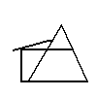

We worked out the number of beams and the amount of m² tongue and groove wood I would need, then he sent me to Volos to see the owner of a wood yard that he knew there. He suggested that I buy quite thick chestnut beams but have them split down the middle with a band saw. This gave me twice as many beams for my money and gave me one flat side to work off. I duly got all that together, loaded it all on one of the Skiathos trading caiques, and had it delivered at the end of our dirt path on the Aselinos road. As related elsewhere, when Mavrika saw this huge pile of wood ready to be transported on her back to the house site, she promptly rolled over and pretended to have colic! We got everything back but it took many days as we could only take two beams at a time per animal per trip, or a couple of packs of tongue and groove.
We borrowed Reese and Pattie’s two horses which helped, but they were pretty big and quite a handful. Only I and one or two others could manage them. At the site, we treated the beams with a sticky coat of creosote (now banned, I believe!), and the tongue and groove was soaked in linseed oil. Paul’s father was an architect (Paul later became one himself) and he knew a bit about laying out foundations, so we drew up a “plan” and started to dig. We discovered many ants’ nests when digging the foundations, and they were rather upset at the intrusion. Ants are very resilient and some 40 odd years later, we are still living with them, as they just moved into the roof − between the planking, insulation and tar paper! The floor plan was simple enough; an open plan kitchen and living room and a bedroom behind the fireplace. That was it. No thought of a bathroom or toilet in those days; the kalivis we were all so used to living in didn’t have them, so it never entered my head. We also had to transport all the sand, gravel and cement from the end of our path and had special boxes made that you shovelled the sand or gravel into, and then released the bottom of the boxes to let the materials out when you arrived at the destination. We brought water up from the streambed in large containers and stored it in old oil barrels.
Needless to say, all this took a lot of time, and we found that we were humping materials for 6 days to have enough ready to spend one day actually building! In the tradition of work parties such as those that had helped to build Reese and Patti’s barn, we did most of the actual construction on Sundays, inviting everyone and anyone to help. Reese always came but Franz, who’d had some stick from local builders while helping Reese, said he would only give advice. Most of the advice was, “Get on with it!” I had some H frames made up, the bottom of which we set into the foundation concrete so that we could then bolt the main beams on to the foundation without the wood actually touching the concrete. This was to avoid the bottom of the beams sitting on potentially damp foundations and thus rotting. I forget whose idea this was (certainly not mine) but it worked very well. We needed around 25 and these were made by a local smithy and metal worker (Felaritos) who didn’t know what they were for (and thought we were, in any case, a bit crazy), but he could make anything from metal, and had them done in the immensely quick time (for Greece) of 10 days. (I still work with his son and daughter who are both civil engineers.) We had to keep watering the foundations so that the concrete didn’t dry out in the sun, but once they had set we started to put up the beams. Everything was bolted together with hex headed carriage bolts (which was a blessing when we came to dismantle the structure later), as the chestnut beams were far too hard to get nails into. In fact, we had to drill holes through some beams and drill starter holes for the bolts in others. All this was done by hand (no electricity in those days) and was quite hard work. Here is an (old) photo of the structure with part of the tongue and groove planking in place.

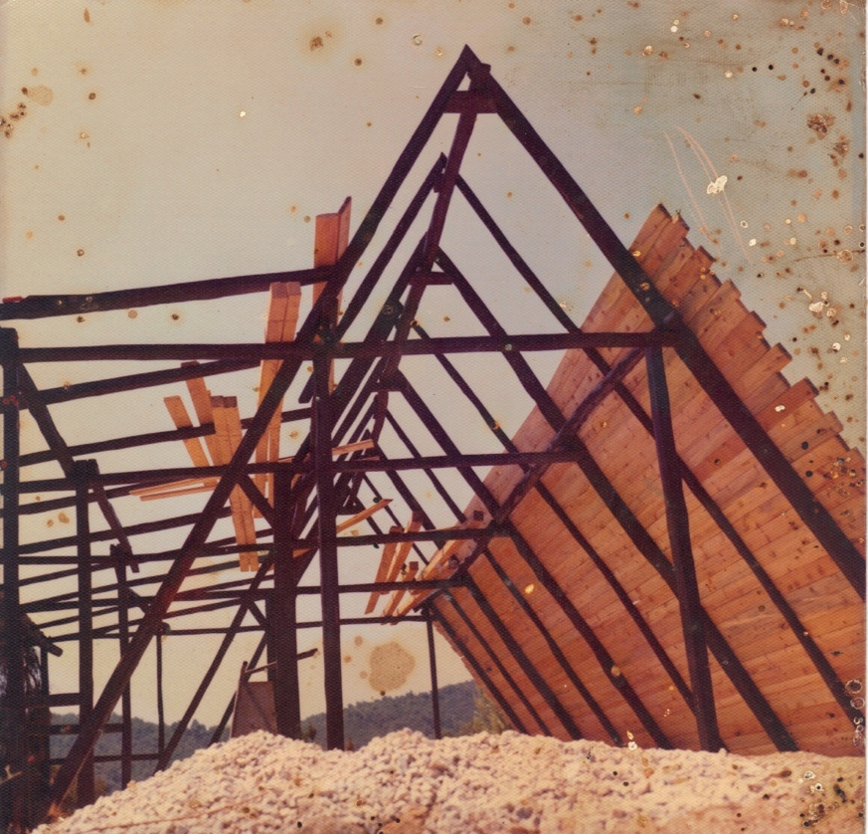

Here is a photo of Reese, Chris, Bob and me, nailing up the planks.

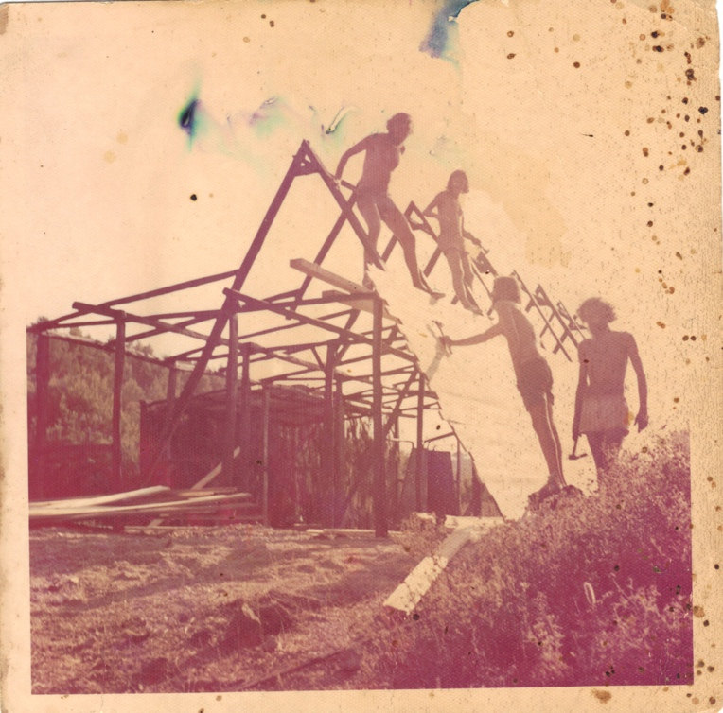

I wanted to have a heat-circulating fireplace, so I got my trusty metalworker Felaritos to make up a metal frame with pipes welded at the bottom, continuing along the back of the frame and then coming out of the front at the top. The idea being that the air was drawn into the pipes at one end, heated by the flames and pumped into the room at the other end. It never worked as well as I had wanted, but did produce a little more heat than just a stand-alone fireplace would have done. Felaritos thought we were a bit crazy when I had asked him to make up the H frames before, now he was totally convinced that I was mad! It took around a month to get the frame up and planked and then we needed to make it waterproof.
While we were busy with building, we were totally unaware of what was going on in the world outside Skiathos. One afternoon, at Koukounaries Beach, where we had gone for a swim, a French friend told us that Greece was at war with Turkey! In fact, the Colonel’s dictatorship in Greece, had overplayed their hand and tried to get the (Greek) Cypriot army to take over Cyprus. Something to which the Turks strongly objected, and which caused the partition of the island. The only good thing was that it caused the downfall of the dictatorship. A wily old Greek politician (Konstantine Karamalis) was called back from exile in France, to form a government. He promised freedom and elections very soon, and the celebrations all over Greece were wild! People who had been politically left leaning, Socialists and Communists had been living in fear of their lives, as anyone who the Colonels were suspicious of simply disappeared. It didn’t make much difference to us, living in our own bubble, but a cloud that I had been unaware of, was definitely lifted from Skiathos.
The house progressed apace but my funds in Skiathos were running out and we needed to get the planking covered before the autumn rains. I could not easily get any money out of the UK so Lida sent some along with a note saying she would be coming out soon for good. YES!
Unfortunately, the only product available was very thin (extremely thin!) tar paper. The Greeks didn’t use any sort of waterproof membrane in their roofs in those days as they put terra cotta roof tiles on the top of any roof and considered this enough. When it rained (but of course, it never rains in Greece!) there were some leaks in every house and kalivi, but that was how life had always been and was reckoned to be just the nature of things! Anyway, we bought all the tarpaper in stock at the local hardware store, and proceeded to layer it over the planking. We hadn’t realised that we needed a much thicker membrane on the very shallow part of the roof in the front of the house, and this was to cause us much grief during rainy nights to come. After we had covered it with tarpaper, Franz said we should add some insulation, and then cover the whole structure with a sort of ferro-cement plaster to add to the waterproofing. We did this, but unfortunately didn’t make a good job of both mixing this plaster and smearing it on, so it didn’t really add to the structure’s rain resisting qualities.
During the course of building, it also became a tradition to go once a week in to Skiathos Town, ostensibly for shopping but mostly to celebrate a successful phase of house building at a local taverna. Our favourite was the Mesogio. It was run by “Mum” and “Dad” (Evgenia and Stamatis) who were so friendly and calm (even when some drunk got a bit out of hand) and provided good retsina and excellent home cooking. (It is still one of our favourite tavernas and is now run by their son, Pandelis). Often, we spent a bit too long celebrating and consumed perhaps a tad more retsina than was good for us. This resulted in a rather badly loaded horse and/or donkey, with us staggering through the valley in the pitch dark to get back to the kalivi. We sometimes found that the margarine and lentils and eggs and (you name it) had coalesced in the bottom of the bags during the trip back home. Things were sold in paper bags then (or even little screwed up pieces of wax paper) and eggs were always sold loose, so accidents were just waiting to happen.
We had windows made by a local carpenter and made a door from the leftover tongue and groove. For the upright side and front walls, we nailed cement and shaven wood insulating material into place. The same kind you used to see on the ceilings in discos to cut down the noise. We then plastered this, but again, didn’t make a great job of it, and eventually had to re-plaster it a couple of years later (when my plastering skills had improved somewhat!). We floored about half of it in wood planks and the kitchen area in Pelion flagstones.
Here is a picture of the finished result.

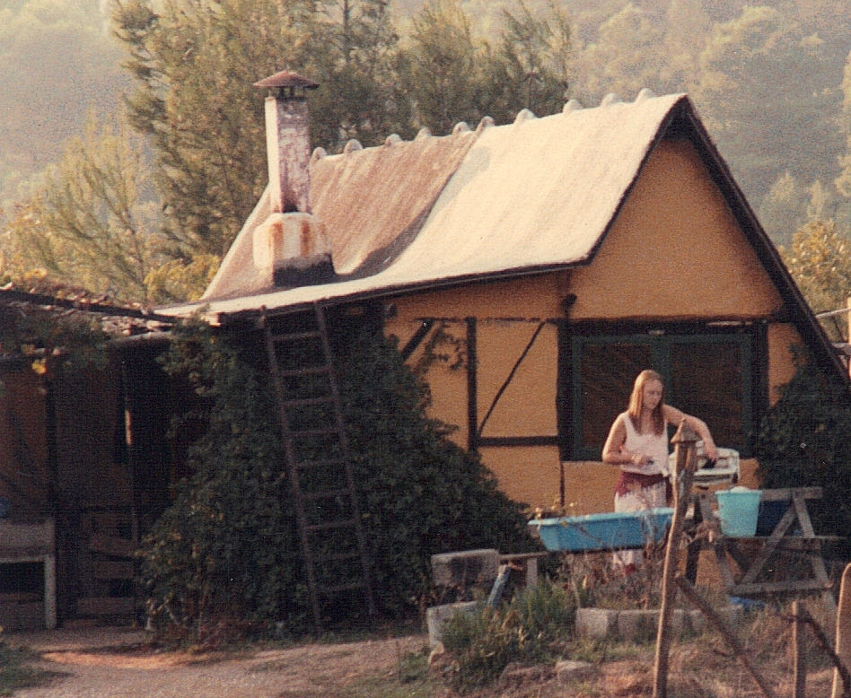

(One of our Australian friends, Karly, is using our wringer in front.)

And here are the proud owners at the doorway.

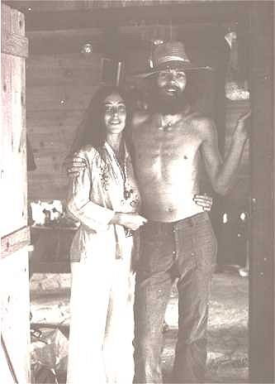

We had no running water (and therefore, no toilet), no electricity, no phone, and − at the end of the project − very little money, but we were happy! We owned some land, which we hoped would sustain us, and a roof over our heads to keep the wolves from the door. We had our youth, no debts and boundless enthusiasm. Life was very good!
We left for Amsterdam that winter to earn some money and left Stuart to look after the property. He had helped us finish the house and we had made a funky main table out of leftover chestnut beams and floor planks, and we still use it to this day. Unfortunately, as Stuart found out in the winter, the roof leaked. It particularly leaked over the bedroom area and for quite a few years, when it started to rain at night, we dragged out the bedding into the living room area and slept in front of the fireplace. We tried all kinds of things to cure these leaks but never quite succeeded until we rebuilt the whole house (more about that later). I can just see the Greek Gods laughing now, “Tarpaper, indeed!”
We inherited a petrol engine pump from Franz and I built a biggish water tank just behind the house, and we pumped water from our well up to that. No more donkey trips with flagons of water, a miracle. I then added a bath house on to the water tank with a tank of water that could be heated by a fire underneath it. This heated water for showers and led to bath nights, once a week. The rule was that as soon as you had finished your own shower, you added enough fuel to heat the water for the following person. Bath nights took several hours and were often supplemented with lots of food and drink. Eventually, we were given part of a solar water heater by a German guy who had stayed on the island for a while. It was just a flat copper plate with copper pipes welded to it. I added a box around it, put a glass cover over it, added an old immersion heater above, and we had hot water whenever the sun shone. I also added a small storeroom on the front of the house as, of course, being a man, had not originally thought of any form of storage when “designing” the house. Here’s a look at the “new, improved” A-frame after all this had been added.

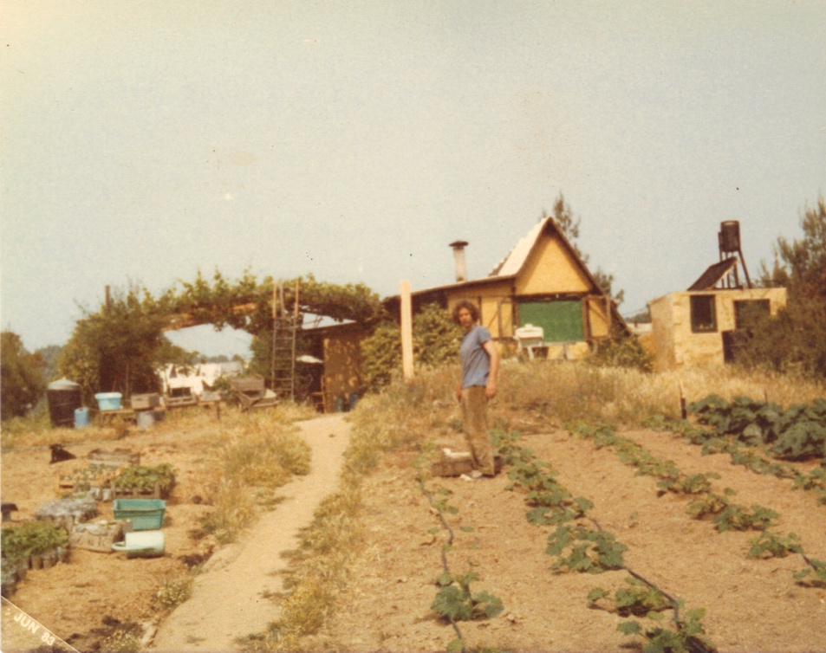

This photo was taken several years later, when we had developed a good source of water, but we still had the wringer and the house and our lifestyle didn’t change for many years.
However, when the children came along our funky little hobbit house no longer proved sufficient. We had to expand it (or abandon it), so we planned to add 2 rooms and a bathroom (unheard of luxury!) behind the house. In the meantime, we’d had our borehole drilled and now had a very good supply of water. We no longer needed the water tank that was right behind the house. We also had more room after a major forest fire had destroyed quite a bit of the forest behind us. With the help of Jacques, a French builder who had come to live in Zorbathes − and with lots of advice from Greek friends (some of it was actually useful!) − we dug and poured concrete foundations at the back of the A-frame. We built double walls in brick, with insulation between them and concrete columns to support them.
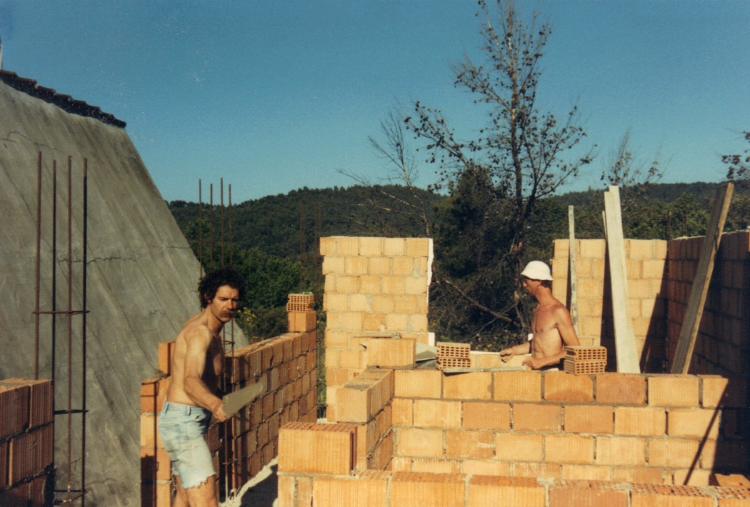
Jacques & I building the extension.

A concrete ring beam was them poured to knit all the walls together and then we rested the roof beams on top of the A-frame and finished the roof. A very bizarre structure indeed.

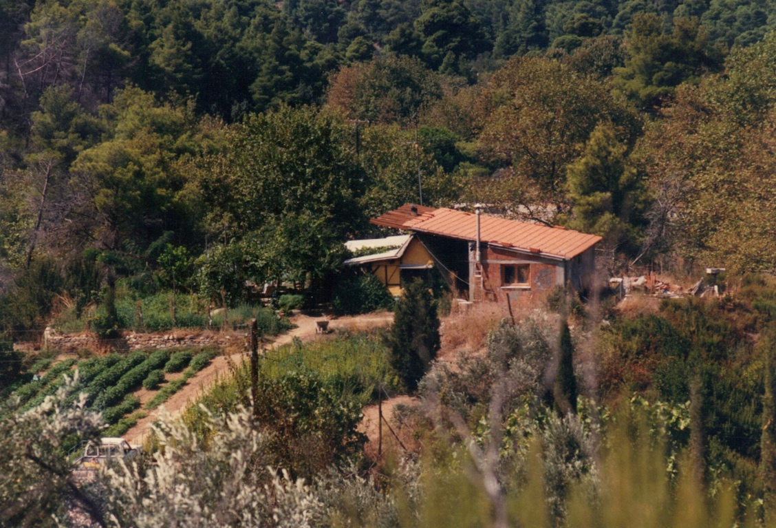

We opened up a hall between the A-frame and finally the girls had their own bedrooms, and we all had a proper toilet, shower, and bath – a great leap forward!
Some time later, we filled in the gap, took the back wall of the A-frame away, but left some of the main supporting beams. This expanded our living area and provided us with a nice upright wall. Other supporting beams were cut and we used them to make an intricate arrangement, which we thought would retain their strength. Other people, notably architect friends of ours, thought otherwise, and used to wince when they came in the door and saw the structure! In the end, we didn’t know if the A-frame was supporting the extension, or vice versa.
In the meantime, with Franz’s and other friend’s help, we had built a barn for Mavrika the horse, some chickens, the hay, and an area for the goats. This building has slowly been transformed into one of the villas we now rent to tourists.

See these pictures to see how it evolved:

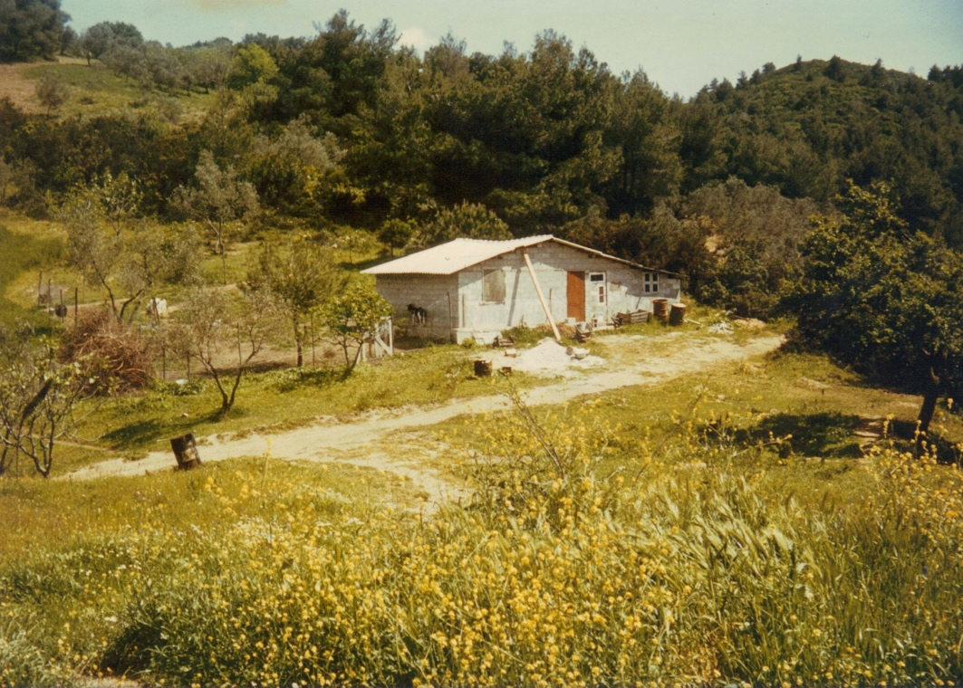

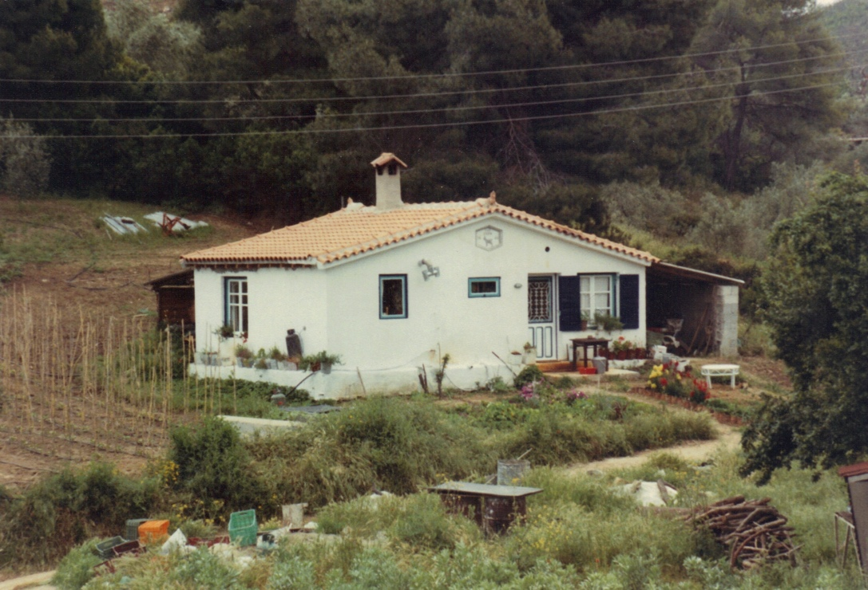

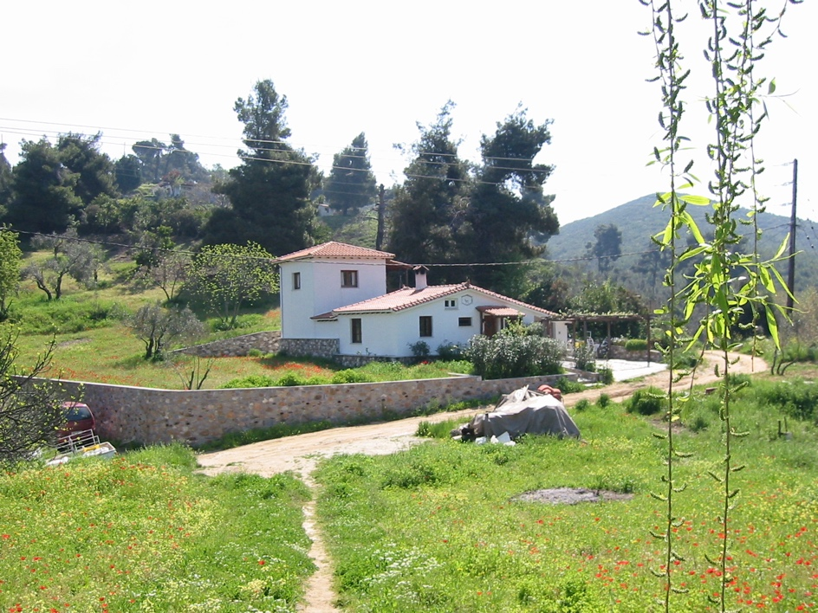

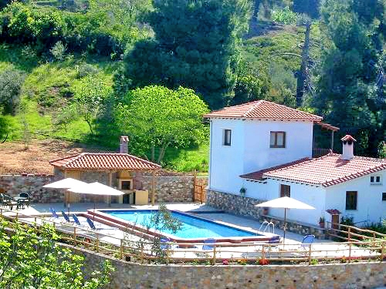

Jacques, since he arrived in Skiathos in the early 90’s, has always been involved in our building projects, and I wouldn’t contemplate any building work without his input. He was always the master builder, while I organised the materials, and then wielded shovel and wheelbarrow to supply him with whatever he needed. He lived in the Barn for several years with his wife, Rose (an old friend of ours from Amsterdam), and improved it immensely. Eventually, they bought some land of their own and built 2 stone houses, where they live to this day.

Here they are on a boat trip with us

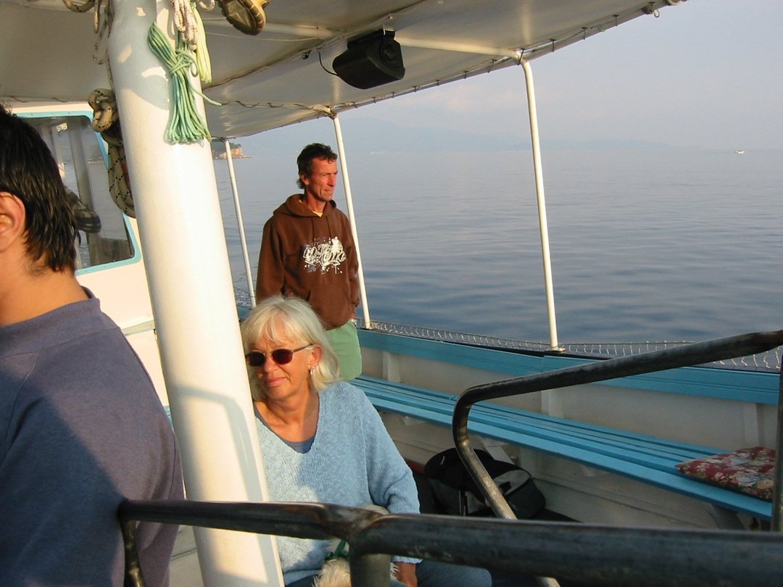

and Jacques with his (then young) son Tommy

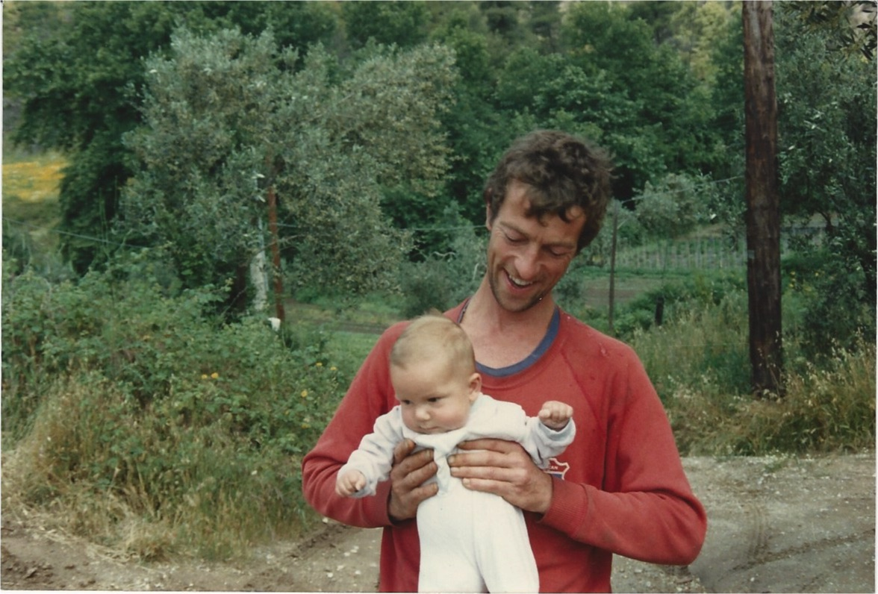

In the early 80’s, we met an English couple who had come to stay on Skiathos. Their names were Geoff and Anne and, despite coming from very different worlds, we became good friends. He was referred to as Big Geoff, and I was young Geof. (Much better than old Geoff and small Geof!) They had worked all their lives with horses, mostly to do with show jumping and eventing, although in between, they had been pig farmers. They had worked in Iran, but left when the Shah was deposed, and had come to Greece to work at a riding stable, and eventually helped to set up the Balkan Riding Championships. They were in their mid 60’s and had the idea to retire on Skiathos. However, as they had no land of their own, they were looking to rent a small plot upon which to put a caravan. I suggested that they could rent some of our land and put the caravan there, and build a wooden pergola shade area over and in front of it to give themselves a nice, outside sitting area. We came to agreement about a small rent and Geoff went off to Athens to buy a caravan. At the same time, he was going to buy a Suzuki Jeep from a Greek friend, who said he would help with all the paperwork, but that Geoff had better be prepared to stay a week in Athens, Greek bureaucracy being notoriously slow. In fact, they managed to buy the caravan and transfer the car papers to Geoff’s name in the course of one morning, with Geoff’s friend shaking his head all the time and saying, “This is impossible, impossible!” We made a concrete base for the caravan and it was delivered and pushed into place shortly afterwards. Geoff spent a couple of weeks making a pergola and roof, and they had a small, but cosy, place to say.

Here’s a picture of Anne with Mara at Vromolimnos Beach

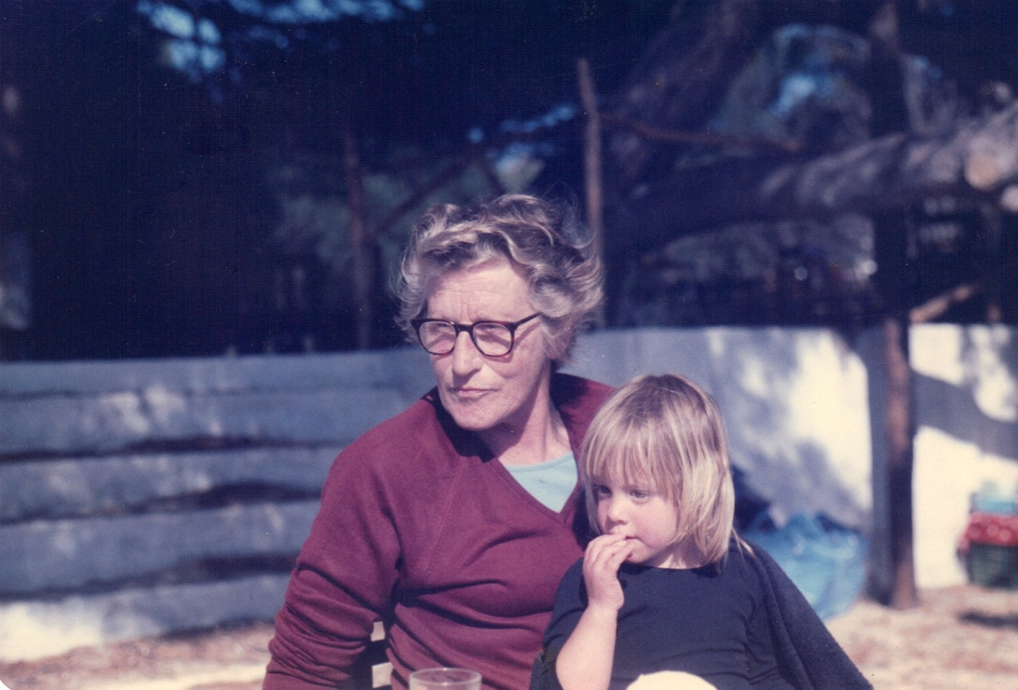

and with Big Geoff and Lida

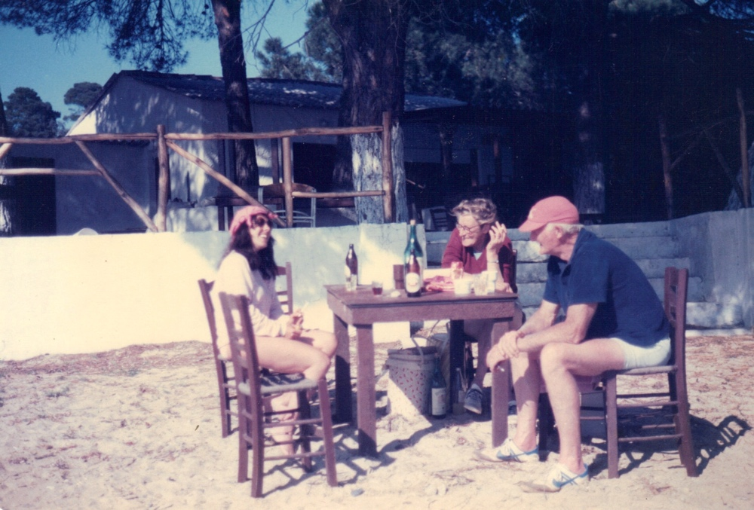

After a couple of years in the caravan, Geoff suggested pulling it out from under the roof, and building a small bungalow under the roof instead. Just a bedroom, living room, kitchen and bathroom, but that would be substantially bigger than the rather cramped space in the caravan. I had no objection, Geoff needed something to do, and it would enhance our property in the long run, so off Geoff went to source materials. It was going to be built all in wood, with a timber frame, cladding on the outside, and a pine plywood interior. We still had no electricity so they ran their kitchen from butane gas, and their lighting and fridge from camping gas bottles. Here is the result.

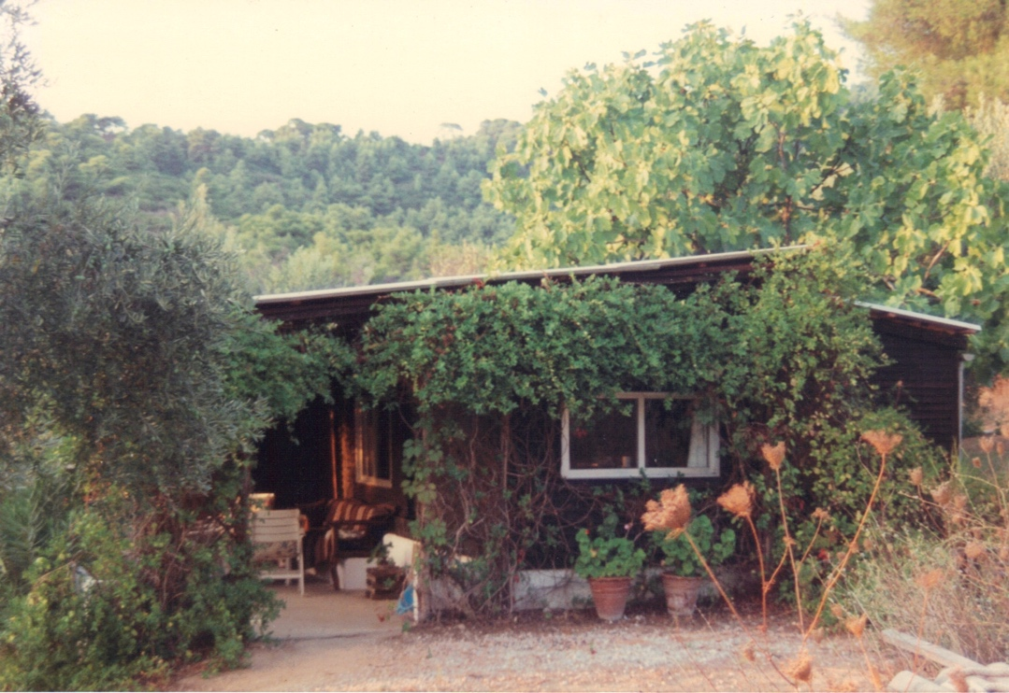

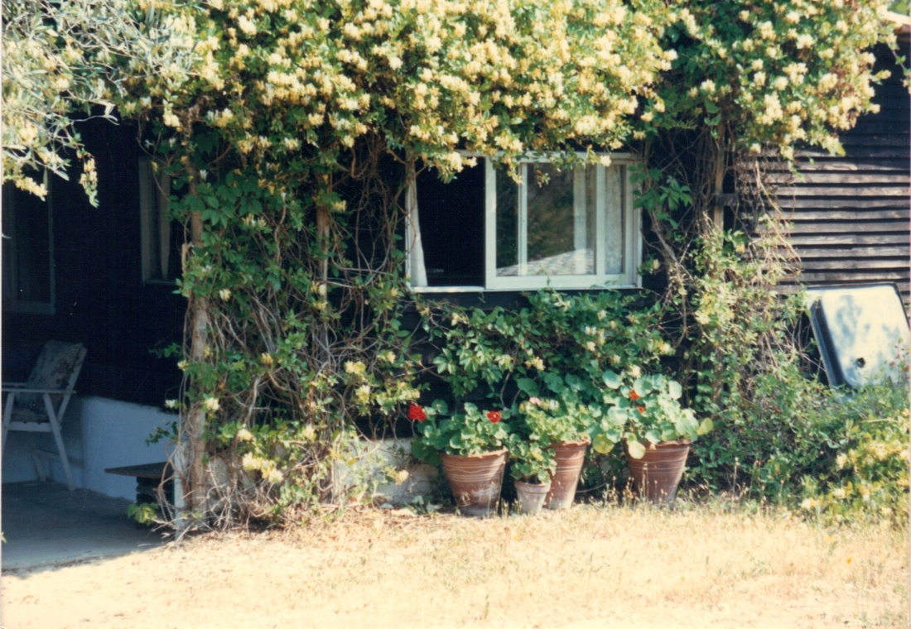

Geoff and Anne spent many happy years with us in Zorbathes, and became surrogate parents to us all, and we benefited greatly from their humour, wisdom and advice. Unfortunately, at a certain point a camping gas bottle exploded and they were both badly burned. More on this in the chapter titled “Love and friends”. Anne so badly that she died 3 days later in the hospital in Athens. Geoff survived with bad burns on his arms and body, but with Anne gone, the heart was taken out of him, and he decided to leave Skiathos. We tried to rent The Bungalow out to friends and were partly successful, particularly with a German family, Wolfgang and Ulli, and their children Nicki and Leoni. They had become great friends as we shared a love of windsurfing. Wolfgang was always better than me, and always had superior equipment, but I learned a huge amount from him. At the end of every holiday (they usually stayed for 4 weeks) I would barter with him, a reduction in the rent in exchange for a windsurfing board or a sail or two.

In the winter of 1992/93, we decided it was time to finish the house, add a front part to complement the rear half and take away the A-frame. We were sad to see it go, but we had outgrown it and it was time to finish what had been begun with the rear extension. We poured foundations all the way around the A-frame, but extended the front out more, to expand the living room and add a decent size bedroom for us. We also added a “granny flat” at the west wing of the new house, as both my parents and Lida’s visited us every year, and the old building was getting rather over crowded. Unfortunately, my parents never got to use the apartment, as they died shortly before we finished everything. We literally built everything around the A-frame, as it was still a main support for the rear half, and when we finally had the new roof structure completed, we proceeded to unbolt the A-frame, to take it away. Jacques and I both held our breath as we undid the last bolt and removed the last beam, because (although we were sure our building work had been correct) we had never built anything in this strange organic fashion before.

Some photos of the house (now known, in grandiose form, as Villa Zorbathes)

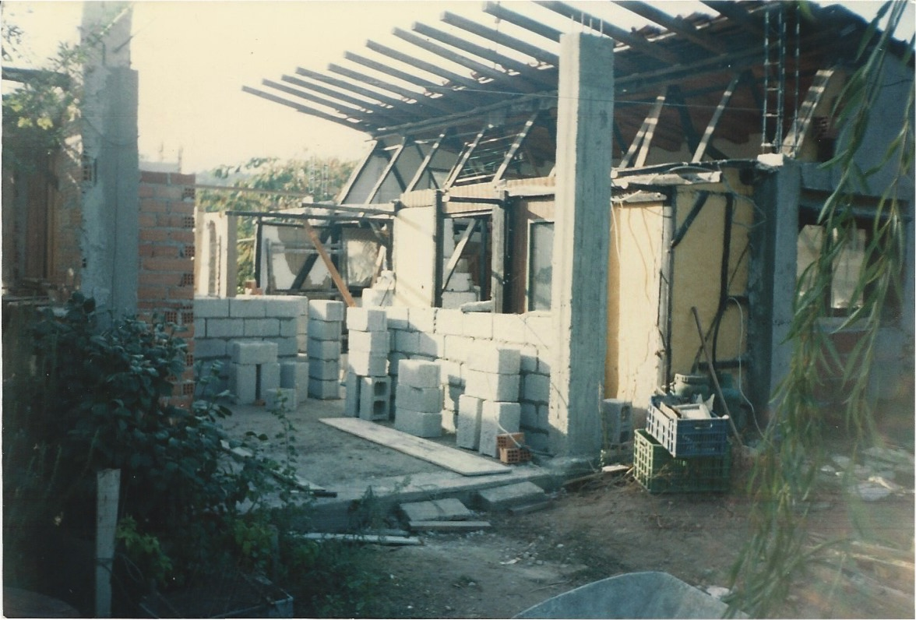

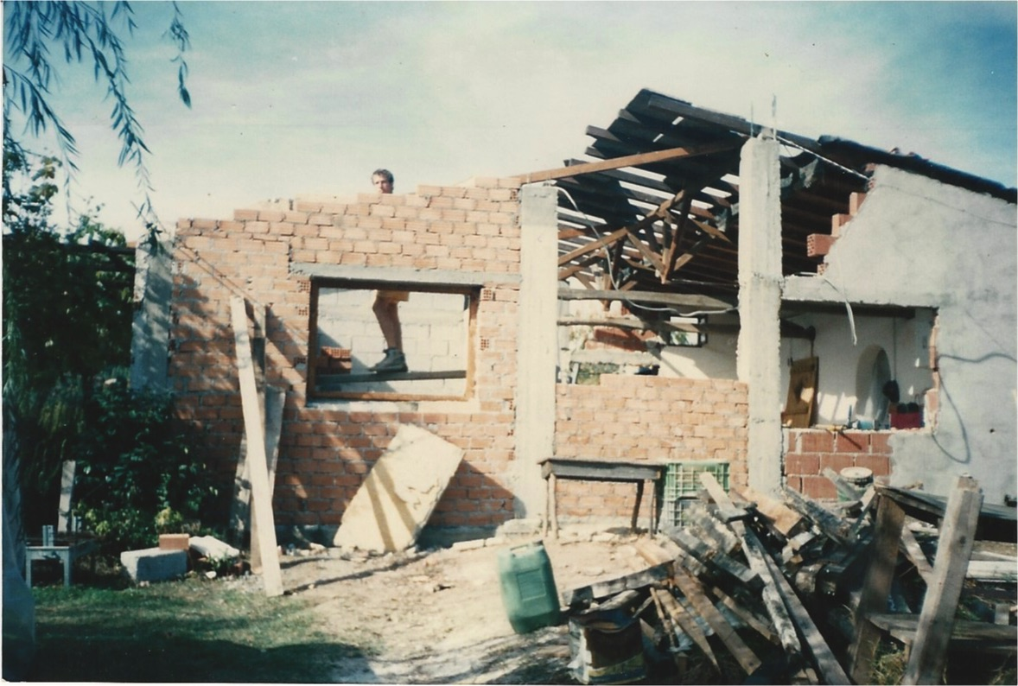

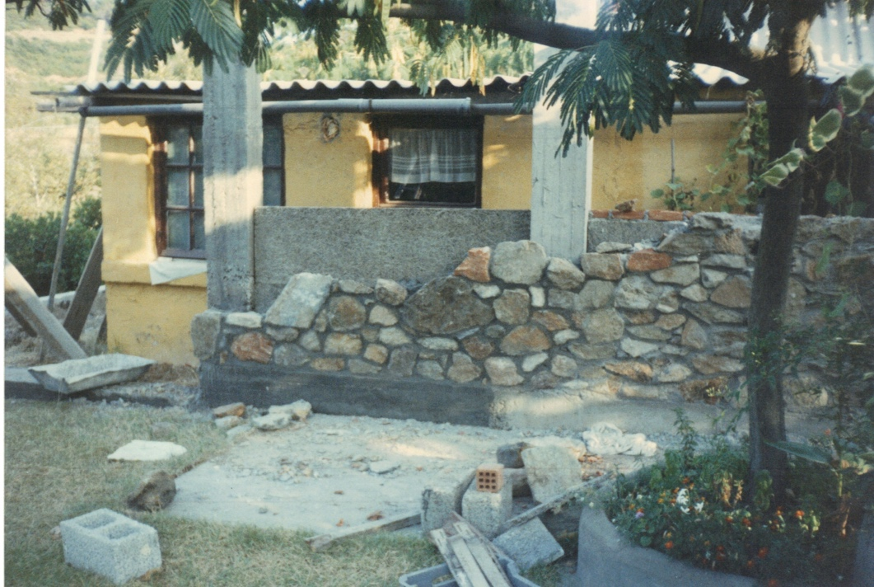

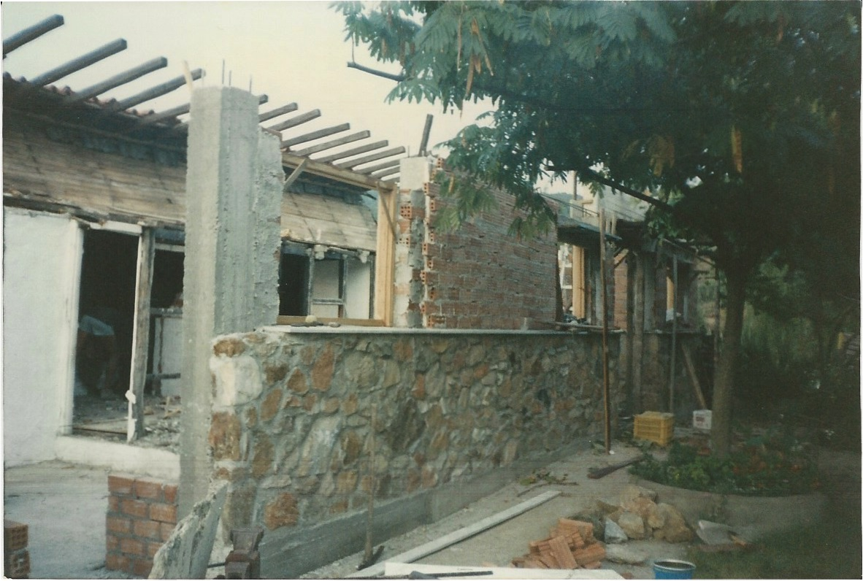

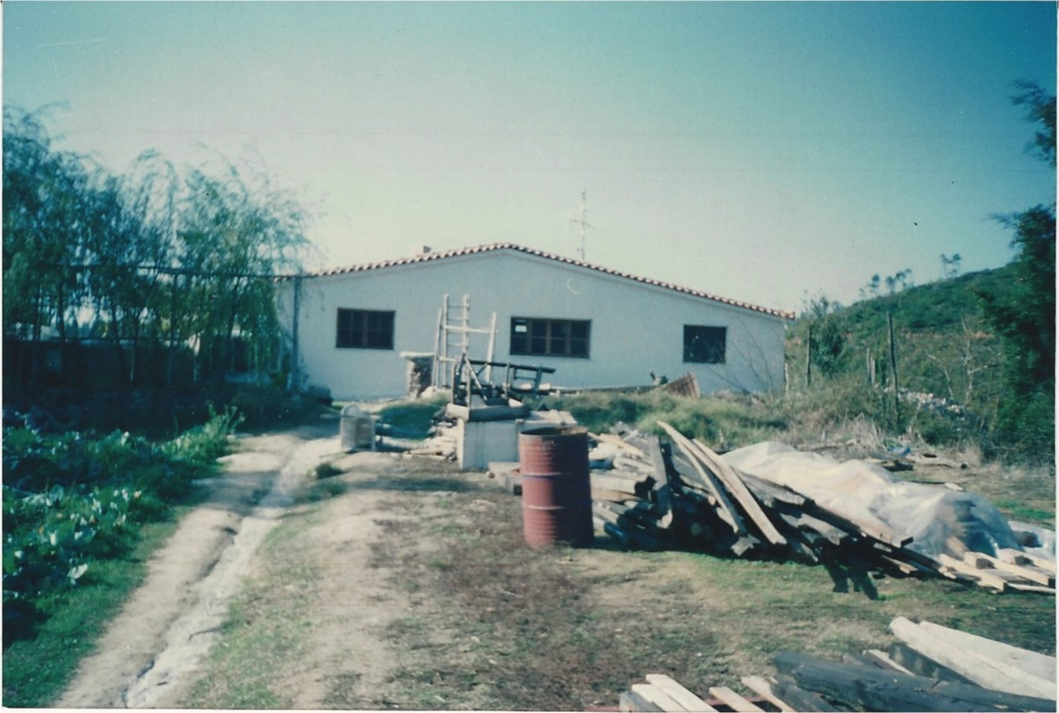

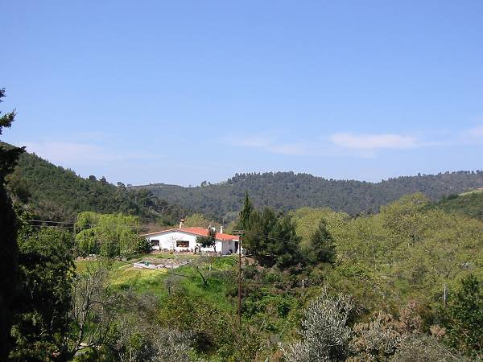

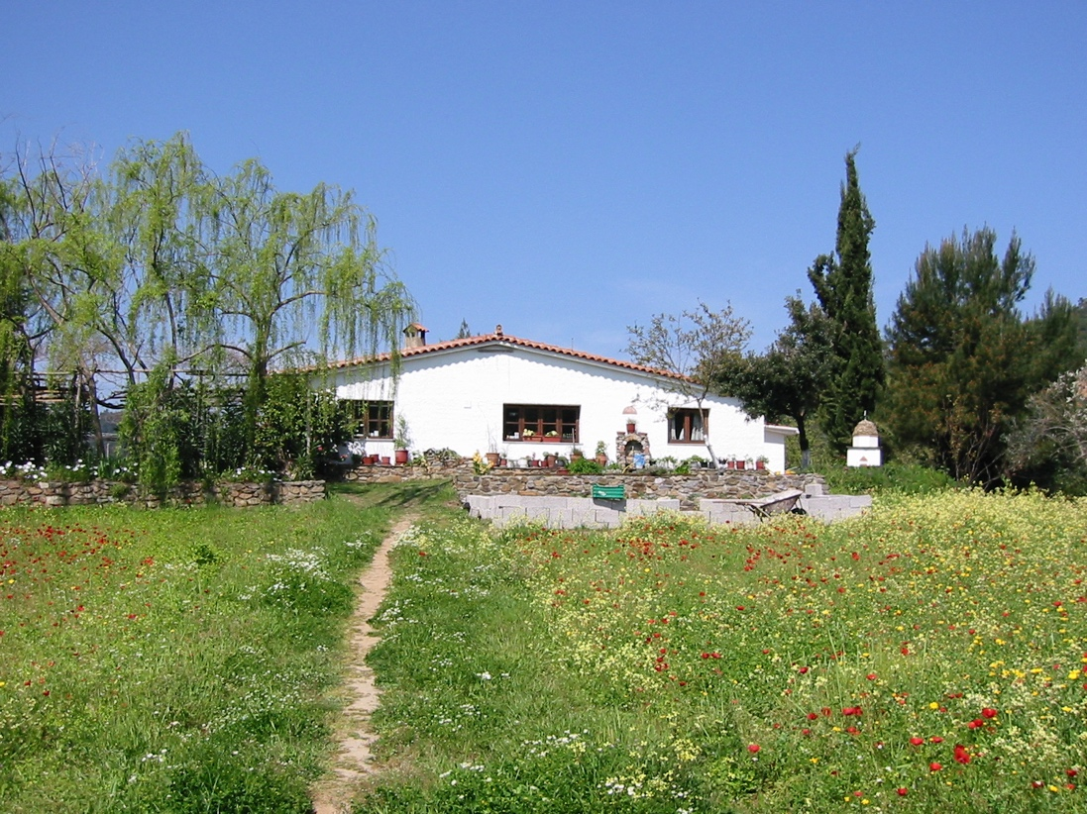

And me, pushing the house up the hill, wheelbarrow by wheelbarrow

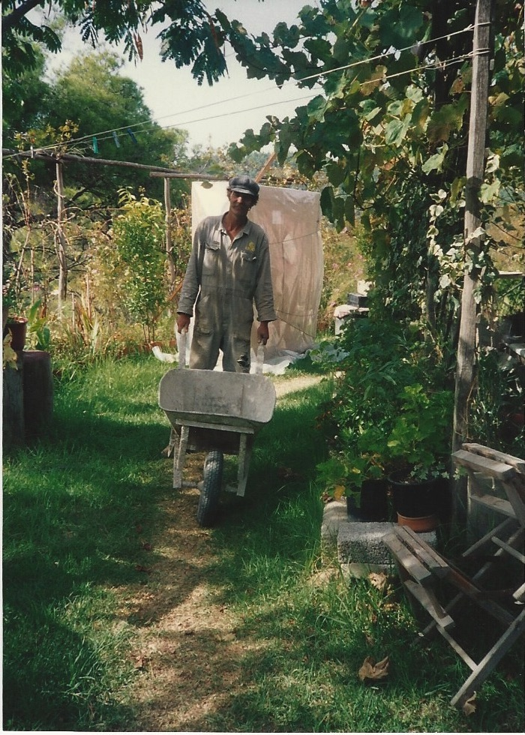

Subsequently, we have added 3 windows in the north facing roof, as the house was still a bit dark, and put in extra insulation on the whole roof surface. We also added a very efficient solar water-heating unit and 42 photovoltaic panels on the south facing roof. We are now very close to being energy self-sufficient. Because of the shallow angle of our roof, and the fact that it is situated on a knoll in the middle of our valley, you cannot normally see these panels at all, which satisfies our aesthetic sense. You can on Google Earth, though! All our buildings now have photovoltaic panels and/or solar water heaters on their roofs.
We heated the house with oil-fired central heating, supplemented by our fireplace. Although it was a pretty efficient fireplace, it still tended to take more heat from the room than it gave. Since we added a heat-circulating, cast-iron, glass-doored, insert into the fireplace, we only use half the wood and about one tenth of the oil!
After my parents died in 1993, and we inherited a bit of money, I made the decision to build a stone house on the site of The Bungalow, which was now in quite a bad state of repair. I had always wanted to build a stone house, but never had sufficient money to start and finish in one space of time. This time, we actually got building permission, with proper plans, etc., something we had never done for our previous buildings (more on this at the end of the chapter). We took down The Bungalow (sadly, I must say), and replaced an olive tree that was in the way of the foundations (we have always transplanted olive trees that were in our way), and set to. Jacques now had a team of skilled Albanian workers working for him, and became the main builder. I managed to put my back out (again – it had happened often!) and stopped doing the hard, physical work. I spent my time organising the materials, and lining up electricians, plumbers, carpenters and the like. We started in October of 1994 and we had already booked some Swedish friends into the house for the summer of 1995, so we had to finish in a reasonable time. The walls were of brick on the inside, a layer of insulation, and the stone on the outside, knitted together with concrete columns and ring beams. Altogether, the walls were 40 centimetres thick and kept the house warm in the winter and cool in the summer. We made a wooden parterre in one half of the house which provided us with 4 bedrooms, a large living room with a kitchen and “snug”, and 2 bathrooms with an extra WC. Outside, a grape vine provided shade for the large patio, and in front of it was the lawn that Geoff had planted when he was there. We finished in late spring of 1995, 8 months in all!

Here are some pictures of our progress

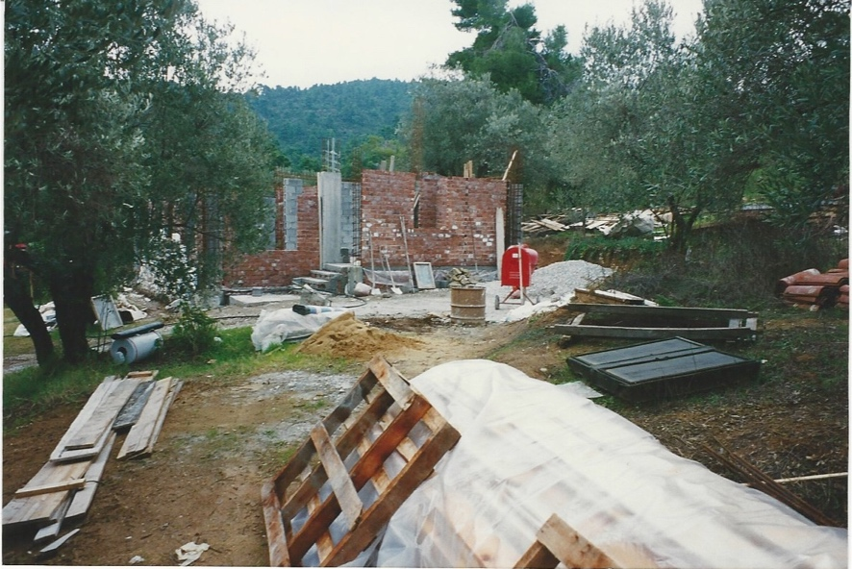
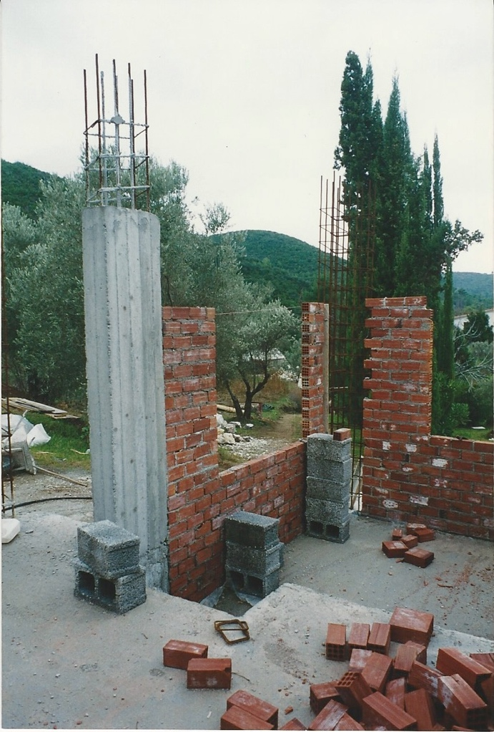

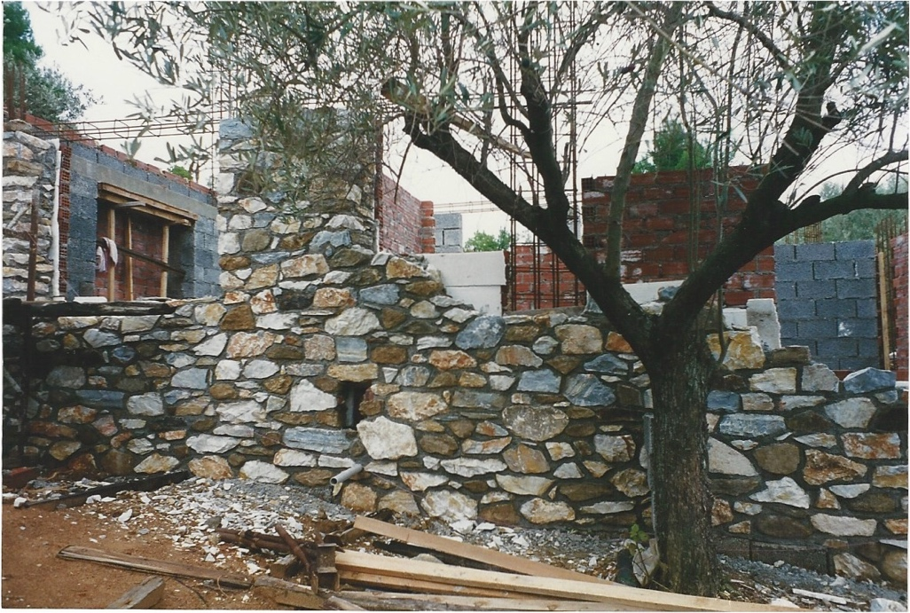

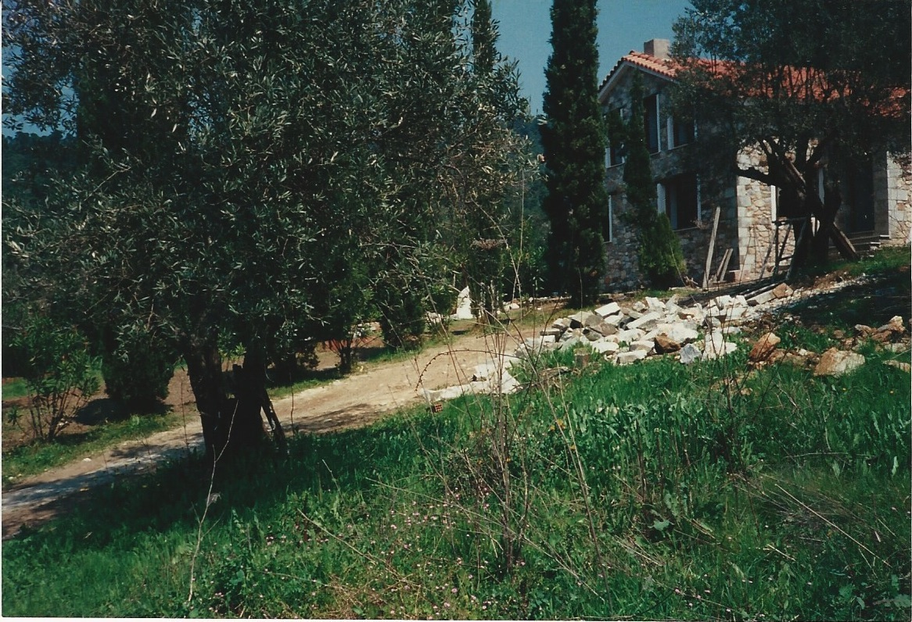

and the building main crew: Jacques, Andreas (the stone mason) and Spiro

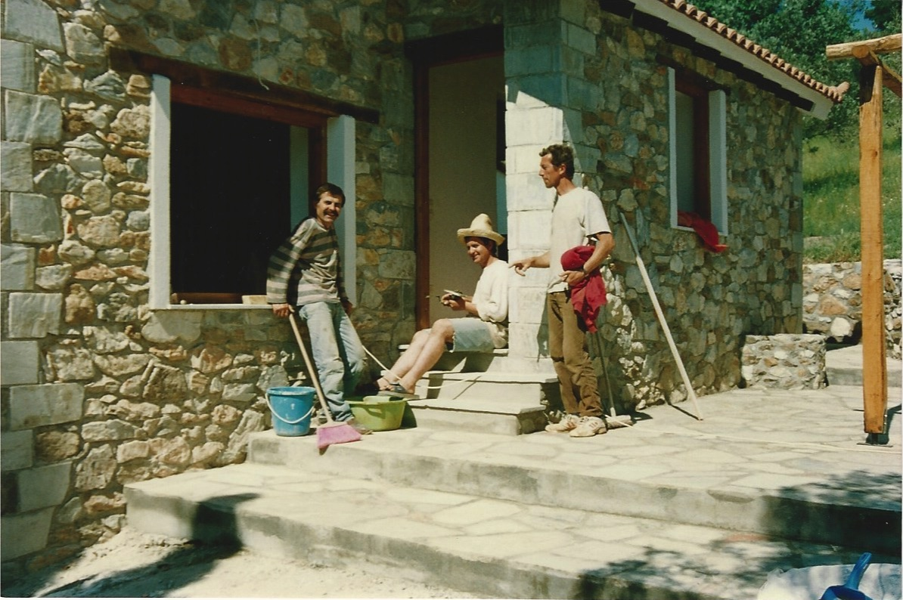

We called it The Farmhouse.

As we had now decided to try to let in a serious way to tourists and try to get a basic income from that, we upgraded the Barn into a proper house, with 2 bathrooms and 4 bedrooms, and gave it and The Farmhouse the grandiose name of Zorbathes Villas (website: http://zorbathes.com). We have been letting them very successfully ever since. One problem was that, as we are about 7 minutes’ drive (or 35 minutes’ walk) away from the nearest beaches, our guests wanted to have a swimming pool. Now, this beautiful island is surrounded by the largest and cleanest swimming pool you can imagine (The Aegean), but to stop losing bookings, we added a swimming pool next to The Barn, which was the only practical place to put it. This is shared between the 2 villas, but now we are receiving requests for a private pool for each villa – people never seem to be satisfied! Our pool is large, long enough to swim lengths and big enough for a couple of large families to enjoy, so at present we have no plans to do this.
A couple of pictures of the pool

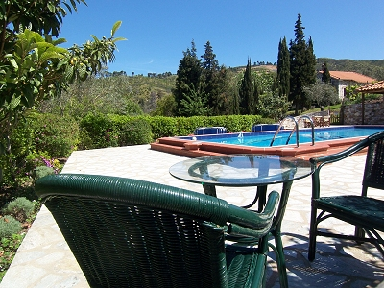
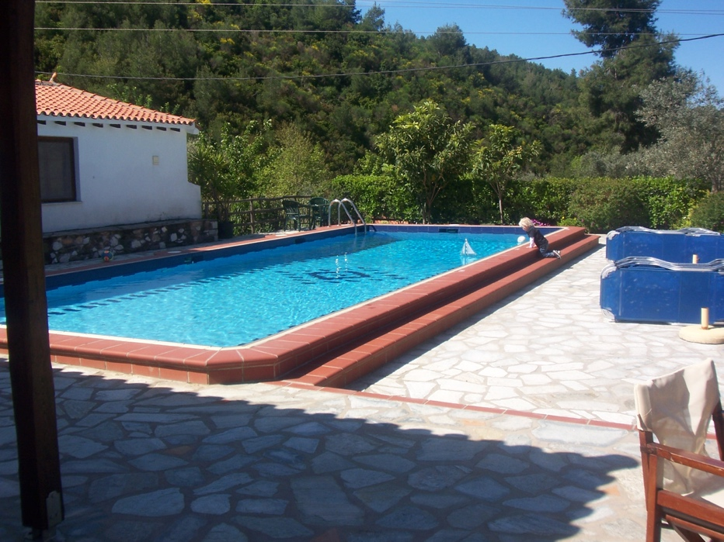

Finally (well Lida says that it is definitely the last house!), in 2005, we decided to build a small house on the ruins of an old kalivi in the one corner of our land that was always left untended, and every year became overgrown with brambles and scrub, and was generally a mess. We wanted to have a house that we could let all year around and have a little income from that. Also, an old friend of ours, Becky, who had lived on the island for 20 years on and off, needed a new place to stay that didn’t have a problem with pets (2 cats and a dog, to be precise). We decided to use the old (stone built) kalivi as a basement for the main house, so built that up to a reasonable level, with some headroom, and then cast the concrete base for the house on top of that. It was a simple house, 1 bedroom, living room, kitchen and bathroom, but with a nice large terrace which projected towards the streambed, and helped keep the house cool in the summer. Becky had quite a bit of input as to the layout and the way the house would work, and it became an ideal home for a single person or a couple. As usual, we employed Jacques, Andreas and their team, and it grew apace. Not only is Andreas an expert stone mason, but he makes beautiful roofs, and the roofs for the Barn extension, The Farmhouse, and The Kalivi (of course we called it The Kalivi), are made with lovely exposed chestnut beams, and tongue and groove planking. Becky left after 5 years to move back to the UK (but we see her here every year) and an English couple, who had decided to retire to Skiathos, rented it. We have become fast friends with Ray and Lorraine, and they have improved The Kalivi and its surroundings immensely.

I think that will be it for our building exploits, but I have hankerings to build a completely ecological house one day. One that would be self-sufficient and blend in with the environment rather than destroying it. However, lack of money, somewhat less energy than I had before, and Lida’s raised eyebrow, have put all that on hold.

A note on building regulations in Greece. Like nearly all the Greeks, in the “old days” we didn’t ask for permission for what we were building. There were several reasons; no one did (anyone that did was considered crazy), and it could increase your building costs by a large amount (especially as you were obliged to pay social insurance for the workers). But the 2 main ones were that we couldn’t afford to pay for building permission, and we would probably not have been granted it in any case! The planned buildings would have been deemed too close to the forest, too close to the borders, non-standard (definitely!), etc., etc. However, in 1983, a law was introduced whereby you could register illegal structures, make some paperwork, have drawings drafted, pay some money (of course!), and the building could become legal. Well, we did that when our house was still just the A-frame, The Barn was a breezeblock structure with a sway back roof, and The Bungalow was basically just a wooden hut. After this, I did get building permission for everything we built: the Farmhouse, the extension on The Barn, and The Kalivi, but I didn’t for our new house that replaced the A-frame, or for the swimming pool. I figured, as all the Greeks did, that there would be another moratorium, with more money again, and I would be able to legalise everything. Of course, (à la grecque) all the buildings exceeded what was on the plans, so they were still, in some parts, illegal. Well, in 2011, the government did bring out a new law and I was able to legalise everything. It helped a lot (and brought down the amount to be paid) that I had declared our previous illegalities in 1983. This time, the government said that anything built without a building permit after 2011, would be knocked down. We will see!

5 - LOVE, FRIENDS AND FAMILY

I have been in love with quite a lot of ladies - but have only ever truly loved one; Lida. Without her, almost everything that we have achieved in Zorbathes would have been impossible. She is the counter weight to my impetuousness, but the one that sees the hare-brained projects I come up with through to the end if we do decide to do them. I can see her now, giving me a certain look as I start to expound on another new idea. The ones she thinks are worth trying, are nearly always the ones that work. When she gives a project the thumbs down, I know it is doomed! However, when she sees that I am really determined to do something, she gets behind it 100%. We talk to each other a lot (and we listen to each other!), we tell each other what has happened in our day, and we are always discussing our life, our choices, our children, politics and anything else that crops up. We also make each other laugh a lot. We share a certain outlook on life that tends to focus on the funny side of things and not on the dark side (although the humour can sometimes be quite black). In other words, we enhance each other’s life, and it is a joy to me to wake up every morning and be greeted by her smile. A couple of years ago, a Canadian friend asked us to define the most important aspect of our relationship in one word. I answered, “laughter” and Lida said, “honesty”. I guess that sums it all up. We always try to be 100% honest with each other, and without laughter, our lives would have been much poorer.
We have made two beautiful daughters who have been our pride and joy, and continue to make us very happy as they get on with their lives. Lida is also a very generous person, someone who would rather give than receive, (probably inherited from her mother) - and she gives of herself unstintingly.
I first saw Lida in Amsterdam Noord at the flat of Pax, an Indonesian Dutchman whose name I had been given by George, an American friend. I had phoned Pax to introduce myself, and he told me to drop by on the following Saturday afternoon when he would have some friends around. I arrived to find his flat pretty full of guys and girls, with fat joints being passed around. I was quite attracted to Annette, a curvaceous blonde girl sitting on her own, and started to talk to her. Pax had disappeared into the kitchen and was preparing (hot) Indonesian food (a tradition on these Saturday afternoon get togethers) when Lida and Adri walked in. Lida was wearing an outfit reminiscent of a gypsy, with a long skirt, short halter top and a bandana around her head. I was immediately attracted to her, but as I was already chatting up Annette and she was obviously with Adri (in fact they were married), I did not attempt to get to know her better. Lida had sown the gypsy outfit herself (I later learned) and was an accomplished seamstress, although for a living she was a medical secretary. I subsequently learned that she was half Hungarian, her mother having arrived in the Netherlands after the First World War as a starving, 9-year-old refugee.
I had returned to Skiathos to find myself the proud possessor of half a valley in the area known as Zorbathes. I had intended to go for a visit to L. A. to see Krista, but then Lida turned up to visit with Adri, Pax and Eva. It became apparent that Adri and Lida were not really that much together any more as he was eyeing up the tourist girls and Lida looked rather lonely. She and I fancied each other, but in the end, it was Lida who made the first move, as I was still somewhat unsure of myself. We spent half their holiday together but then it was time for them to leave. This put me in somewhat of a dilemma, as I had had a great time with both Krista and Lida. I returned to the UK to see a few friends, receive a little more money from my inheritance, and then had to decide if I was going to the States or Amsterdam. Amsterdam and Lida won out. Krista apparently was having some problems with an old boyfriend back in L. A., and I felt guilty about not pursuing our relationship, but Lida was definitely the one for me. I stayed in Amsterdam at Adri and Lida’s flat. Lida and I slept in a small room at the back of the flat, while Adri entertained a series of Danish girls in the main bedroom. Such was hippy life in those days! Lida and I made a quick trip to Denmark to see some friends and then it was time for me to go back to Skiathos. I had arranged with Betsy that I would look after her farm again in the winter of ‘73/’74 so I returned to Athens with The Magic Bus after securing a promise from Lida that she would come to visit for Christmas.
She arrived on Christmas Eve after a harrowing journey involving a bus from Athens to Volos, a taxi to Platanias, and a small fishing boat from there to Skiathos. The sea was pretty rough and she was soaked through by the time she arrived. She was wearing a fur coat and looked like a drowned rat! We went up to Betsy’s and lit the fire and warmed ourselves up by the light of the flames. During our trip to Denmark, we had slept in a few different friend’s houses, and somewhere along the line had picked up scabies, a nasty skin condition that made you itch all the time. When we met again in Skiathos, we were both scratching like crazy, and we looked at each other and said, “What, you as well?” We had some skin lotion to use, but we also had to change the bed linen every day, which was a major task at Betsy’s with no running water and winter rains, which didn’t allow sheets to dry easily. However, we managed. During this time, Keith had his trial for growing the dope plants, and Lida cut my hair and beard for his trial. The result was a bit of a shock to both of us! Lida went back home and I said that I would visit in the spring before I started building the house on my land. After staying with her then in Amsterdam, it seemed like we were really pretty serious about living together, but I was committed to Skiathos and so it was up to Lida to bite the bullet and make the major change. In September, she gave up her job, kissed Adri a definite goodbye, and came to stay in Zorbathes. We never looked back!

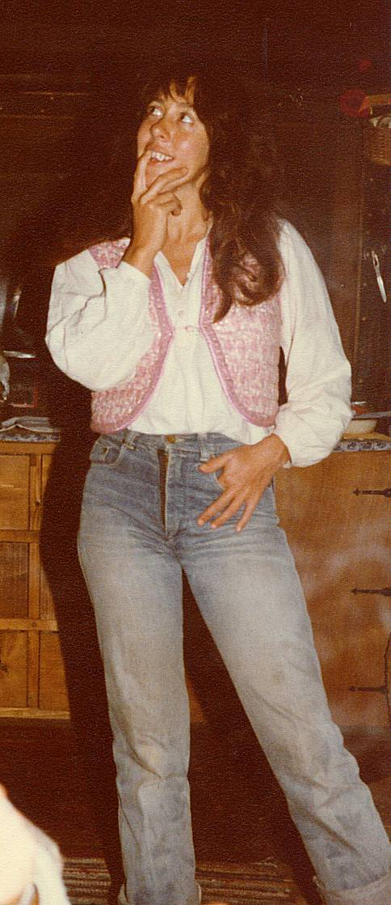

We were almost sure that we would not have children when we decided to start to live together in Skiathos. Lida had a medical history with her womb, and had been advised that it was probably not a good idea to try to have kids. In fact, when she was having an operation in Amsterdam in the 70’s, one of the doctors operating on her thought that they were also going to tie off her fallopian tubes, but fortunately, another doctor disagreed, and our children’s lives were literally saved by a (lack of a) thread. We tried not to have children by using various methods of contraception, but obviously, we didn’t try hard enough :o) At a certain point (actually when my parents were sleeping in our bed and we were “sleeping” in the loft), we seemed somehow to have got around the contraception and Lida became pregnant. Perhaps the fact that Lida had finally become divorced from Adri the year before, had something to do with it, who knows? We went, with some trepidation, to Volos to see a specialist who had a maternity clinic, and explained Lida’s history. He said that he thought there should not be a problem as long as we kept a close eye on progress, but insisted that the birth be by caesarean section to avoid any possible complications. We agreed to this and returned to Skiathos. Lida still had some trepidation about having a child but I was very enthusiastic and managed to allay her fears. It was at this point that we decided that we should get married. If we were going to commit to having a child together (a lifetime’s task if ever there was one), then we might as well go through the usual processes so that our child to be would not have any paperwork problems in later life. Oh, we were so naïve! We tried all avenues to get married but this proved impossible in Greece. Lida was a divorced Catholic and I had never been baptised so neither the Catholic, Anglican or Orthodox churches were interested in marrying us. And there was NO civil marriage in Greece in 1979. As far as the Greeks were concerned, if you weren’t married in a church, you weren’t married! In fact, the Greek Orthodox Church was so powerful then that any children born DID NOT have a name until they were baptised! You could not register a name for your child unless you had the baptismal certificate. Fortunately, all this changed when the Socialist Government of Andreas Papandreou came to power shortly afterwards, but it wasn’t early enough for us. We eventually got married in the UK, at the Registry Office of my home town, Hounslow, with Zoi (then 18 months old) running around the office. Unfortunately, it did all make for a paperwork mess. Although I was the one who registered her birth at the Volos Registry Office and was mentioned as the person who made the registration, I was not mentioned as the father, and the birth certificate said that the child (Zoi) was born out of adultery! It has taken us quite a few years to get everything sorted, even up to when Zoi was 33 years old and still needed a British birth certificate from the British Embassy in Athens. I had to sign (once again) that I was her father so that she could get it. (When Mara was born, everything had changed and it was easy to register her normally.) During the pregnancy, I had to get rid of the aging Land Rover, which (with its British plates) you could only keep in Greece for a maximum of a year. When you entered Greece, the date was stamped in your passport. I drove down to Athens a few days before the year ran out and attempted to sell it, but without any success. I drove back overnight to Volos with a raging headache from a dose of flu and arrived at the Volos Customs House on the morning of the day when the car was due to leave the country. I asked one of the officials if he would give me a few months extension, as I couldn’t possibly leave at that point. He, like all Greek bureaucrats when reacting to anything that might involve some work, said gruffly, “No. You and the car have to leave Greece today, or we will confiscate it.” I was at my wits end but remembered something our friend Christo had once said, “When all else fails, cry!” So I broke down in front of the bureaucrat, and with tears in my eyes, said, “I’m sick, my wife’s pregnant, the car needs repairing, the goats will die, there’s no way I can leave today.” He put up his hand and said, “Wait! Give me your passport.” and disappeared with it behind a door. 25 minutes later, he returned all smiles and said, “You have two more months.” and, “Please to look after your wife.” I could have kissed him! I was lucky enough to get most of my return journey to Britain paid for by some villa owners who had just sold up and wanted some furniture taking to France. I left when Lida was starting her seventh month of pregnancy, but as I waved goodbye from the ferry deck, I had never seen her looking so healthy and beautiful. On the trip back through France, I visited Adri and his new lady Linda, who had bought a goat farm high on a hill in the middle of France, looking down on Tarn River. It was a beautiful spot but very remote.
Reese had met an American in Athens, whose name was Ed, who used to act in Greek adverts and who was looking to stay on an island for a few weeks. Reese suggested that he stay in Zorbathes and give Lida a hand while I was away. The biggest task, which Lida could not manage, was starting the old, single cylinder diesel engine with which we used to pump water. This involved a special technique with a starting handle and, if you didn’t disengage the handle quickly enough, it could be a little hazardous. I showed Ed how to do this and it seemed he had learned the technique. However, the first time he tried it after I had left; the handle got away from him and eventually spun off the engine at speed and banged into his shin opening up a nasty wound and bruising his shin bone badly. So, instead of Ed helping to look after Lida, Lida ended up looking after him! Fortunately, Kevin a short but energetic South African who was living up at Betsy’s agreed to come and help out. He was extremely practical and while he stayed, he made a really nice changing table and set of drawers for the baby to come. Luckily, on the road, I was completely unaware of all this. Communication was still basically by letter as none of us had a telephone. In fact, we still had no electricity. When I returned, having failed to sell the Land Rover in the UK (I think my brother eventually sold it very cheaply, but gave me more than he had sold it for), Ed had left and Kevin then moved back to Betsy’s. We tried to sort ourselves out and prepare for the “onslaught” of children. As transport, we still had a Honda moped that we had bought for Lida to use. However, she never liked it, and after falling off on her first time on it, she refused to have anything more to do with it. A moped in the winter is not very practical and, in any case, it would not take the two of us and a baby. I had been eyeing a small, articulated tractor in Volos but we could not afford to buy it. Denis (the man that had bought Paula’s land from her after we had split it up) offered to become a part owner, and so together we bought the tractor, a cultivator attachment, a plough and an old trailer to pull behind it. Lida still looked incredibly fit and well and pregnancy seemed to suit her. A couple of weeks before we were booked to go to Volos for the birth, she happily walked up the hills opposite our side of the valley to go and visit the matriarch of the goat herder family that lived there. We went to Volos on the 6th of January, which is the day of celebration of the Holy Cross being thrown in the sea and retrieved by youngsters diving for it. We were very naïve about Greek hospital conditions not having had to use them before now. We didn’t realise that (even though this was a private hospital that we would be paying quite a lot for) there would be virtually no infrastructure, nursing, etc. and that relatives were supposed to be there 24 hours a day to look after patients and buy necessary medicines, etc. On the 7th, Lida was taken into the operating theatre for the caesarean. I waited nervously and about one hour later the nurse came out with what looked like the world’s smallest baby virtually cradled in one hand and said that the baby would have to go into an incubator. However, a huge smile spread across my face and it was love at first sight! I had a quick flash that made me think about my mother, and now that Zoi is a lot older, we can see that she bears a similarity in looks with my mother that is quite striking. Zoi’s head was not really round but almost banana shaped. This was explained to us later by the doctor who said that Lida’s womb was really very small (the result of previous operations) and that Zoi had not had much room to develop towards to end of the pregnancy. Therefore, she was so small and her head had been pressed into a banana shape. He assured us that everything would come right now that she was born but that Zoi would have to stay in an incubator for at least two weeks. This was a bit of a blow as we couldn’t afford to stay in Volos (in a hotel) for two weeks, so as soon as Lida was fit enough to travel, we came back home – with no baby! It was very strange! We would go to Town almost every day and phone the hospital to learn of Zoi’s progress and, although they said she was developing fine, they kept saying that it would be another ten days or two weeks before she could be released, as she hadn’t put on enough weight. Eventually, around three weeks after the birth, we got fed up with this and went back to Volos to claim our baby. At the hospital, Zoi looked fine; a bit small but full of life (so she is well named as Zoi means life in Greek). They said that we could take her home as long as we accepted total responsibility for her and would feed her every two hours with the special formula they gave us. Also, we had to make sure both Zoi and our house were kept extremely warm, and they were horrified to hear that we had no electricity! I promised to keep the fireplace and the wood range roaring at all times, and they finally let us take her with us. Zoi was fast asleep as we got on to the ferry for Skiathos. We had some hot water in a flask and mixed up some formula milk for Zoi, as it had been at least two hours since we had left the clinic. Of course, the warmth of the ferry and the throb of the engines had a soporific effect on Zoi and she was happily fast asleep. All the local women on the ferry were looking on with expressions ranging from amusement through contempt, as we tried to wake this blissfully sleeping baby. We eventually got her awake but she wasn’t really interested in drinking, so we let her go back to sleep again. Returning to the house, I stoked up all the fires and it got so warm that Zoi had beads of sweat on her forehead. People who came around to see the new little one would come inside and rip off most of their clothes because it was so hot. Of course, we had no idea what we were doing, and as we had no one around (mother, grandmother, etc.) to guide us, we were susceptible to all kind of worries. We realised that it wasn’t necessary to feed Zoi every two hours as she drank very well whenever she was awake, and that probably it had just been the clinic’s routine that had determined that. Also, she started putting on weight immediately and we understood that she hadn’t really been getting anywhere near as much attention as we were giving her. Luckily a Dutch acquaintance turned up (she had 6 children of her own) and reassured us that we shouldn’t pay too much attention to the doctor’s instructions, but just play it by ear and follow our instincts. Babies are hard things to kill, she told us and, despite our best efforts, she proved to be correct. Zoi inherited Lida’s toughness and my own basic good health and thrived. In fact, she hardly ever gets sick and cruised through all the kiddies’ normal diseases, like chicken pox, with hardly a day off school. It seems that, if babies have to struggle hard to survive in the beginning, it makes them a lot tougher for the rest of the journey through life. We did discover, one day when I read the label, that the formula the hospital had given us and insisted that we use, was almost 45% sugar! We switched Zoi over to our own goat’s milk and she grew even faster. Having a child changes your life. It all gets a bit more serious and you have to start thinking about the future. There’s a bit less fun and a bit more worry about getting bread on the table every day, and you cannot just live from day to day as we had done up to then. Mind you, the compensations were more than enough, and the sound of Zoi chuckling with some toy or on Lida’s lap made up for any sense of losing our freedom.
We went to the UK in 1981 to finally get married (to each other!). We took a 6-week trip and announced the banns as soon as we arrived (ostensibly living at my brother’s house) and then went travelling for 4 weeks. We ended up at a friend’s house in the South of France, had a great trip, and returned to my brother’s for the wedding. At the wedding ceremony, Zoi, then 18 months old, was running around having fun with a friend’s daughter, but it never occurred to us that we should have registered her as being our daughter at the same time. This caused us endless problems later, when we tried to get British nationality for her. We were just so naïve about paperwork, really. The next day, we were due to fly back to Athens around midday, when Zoi suddenly appeared from my brother’s bedroom with an unlabelled pillbox, saying proudly, “Sweeties!” We tried to contact my brother’s then girlfriend, who was from the Philippines and had arrived back from there 2 days before, but had no luck. We had no idea what the pills were and how many Zoi had eaten, so we rushed her down to the local hospital where they gave her an emetic. She threw up 3 half-digested pills and the doctor said that they were probably travel sickness pills and, as she had thrown up most of them, it would be OK for us to continue on to Heathrow to catch our flight to Athens. By this time, we were getting well behind schedule and my father drove us at breakneck speed to the airport. They had just made a last call for us, but we managed to check in and get on the flight. Unfortunately, our bags didn’t make it to the plane and we left the address of our friends in Athens − where we would be staying for a few days − so that they could let us know when the bags arrived. I was actually quite relieved, in a strange way, as we had been dragging suitcases, a stroller, and all the paraphernalia of a small European family, and I was happy to be rid of them for a day or two.
Upon our return to Skiathos, people told us about an American couple with a young daughter (Katy) who were looking to meet up with us. My heart sank, we’d had had an eventful trip, and all I needed at that point was some gabby Americans! Well, we met Bill and Lori one day on the waterfront and fell instantly in love (with the exception of Zoi and Katy, who would occasionally fight like tigers!). It’s been the same ever since, even though we may go some years without seeing each other. While we were visiting them in California last year, Lori died of cancer on the day we left. So sad. We shared very many beautiful times together over the years, and she lives on in our hearts.
Mara’s birth was also “interesting”. After Zoi’s birth, the doctor had advised us (again!) not to try to have any more children as Lida’s womb was now a mass of scar tissue and maybe couldn’t handle the stretching that was required. Despite our best efforts not to get pregnant (except avoiding sex altogether!), Lida again discovered she was pregnant in the winter of 1981/82. We knew that it was very easy to arrange an abortion in Greece, in fact the doctor in Volos had told us so, so we thought that this was the only solution for Lida. We had struck up a deep friendship with Bill and Lori, who were looking after an American’s property for the winter. They had a daughter, Katy, who was just a little older than Zoi and the two of them (mostly) played quite happily together. Meanwhile we could relax with Bill and Lori, drink wine and tell each other our life stories. Bill was a minister in a very liberal church in California but never mentioned God or religion unless we brought the subject up (which we didn’t often). Some years later, Bill went to El Salvador to act as a human shield for civil rights workers there. The theory was that the death squads (trained and supported by Reagan’s regime) would not risk killing an American, while trying to assassinate someone opposed to the dictatorship then in control. I cannot imagine the courage and strength of will that this took, and it was very hard for Lori as well, not knowing if Bill would return from these trips. Bill is an excellent writer. He wrote a book, “When the dogs ate candles”, about his experiences in El Salvador. We discussed Lida’s situation with them, and other friends like Reese, all of whom were against the idea of abortion, but totally behind Lida if we decided to go that route. We went to Volos with heavy hearts, thinking that we would arrange and have an abortion carried out during the course of the trip. Zoi stayed with Bill and Lori. However, the doctor, seemed to have changed his mind, told us that he thought it would be no problem (watch out for those Greek, “no problems”!) for Lida to have another caesarean, especially as it would be in the middle of summer, but it would have to be at the beginning of the last month. This put us in a quandary, as we hadn’t really contemplated having a second child. We went to a nearby Kafenion for a Greek coffee and thought about what we wanted to do. We both realised that we didn’t want to abort this child and that, given the doctor’s new opinion, we should try for the birth. After all, we already had a thriving child, Lida was a very fit woman, and we would just have to be a bit careful. When we returned to Skiathos and told people of our decision (they were all expecting us to come back, having had an abortion), everyone was overjoyed! As it happened, Lida had no problems during the first months (she was never sick in the mornings with both the pregnancies), and not until 6 to 7 weeks before the projected birth date did things start to go (slightly) pear shaped. Lida woke up one morning to find that the bed was wet. “Oh dear’” she thought, “I’ve wet myself.” However, Rose, who was staying with us at the time and had had two children herself, told her that probably her waters had broken and that we should get to Volos on the next ferry. We phoned the doctor only to find that he was on holiday in Skiathos (!) but that he would return to the clinic the following morning. We left Zoi with Reese and Gillie (who were staying in the barn), and caught the afternoon ferry to Volos. Our doctor’s partner, examined Lida and told us that she should have an immediate caesarean section, but Lida insisted upon waiting for our doctor to return as she was not feeling any contractions and, apart from the waters having broken, was feeling very well. The partner gave Lida an injection of something, which would delay the birth and help the baby’s lungs to prepare for oxygen. It seems these are the last parts of a baby’s body that get ready for birth as they are unnecessary until the baby hits fresh air (as it were). We spent a restless night at the clinic and, early in the morning, our doctor turned up and Lida was immediately wheeled into the operating room. Sometime later, she was brought out, still under sedation, and the doctor called me in to his office and told me that there were some possible complications. It seems Mara’s lungs (she was now Mara to us as we had only ever had girl’s names ready, we couldn’t think of any boy’s names), had not totally formed and she was having trouble breathing. They had sent for a paediatrician who would advise us. The paediatrician arrived, and having examined Mara, told us we should get her to the hospital in Athens that specialised in handling these sorts of cases. I just had time to see Lida, who was still very woozy from the operation, and tell her that the baby was a girl (“Mara”, she murmured), and that I had to go down to Athens with her, but would try to be back by that evening. Mara was put into a portable incubator and a taxi(!) was called for. It appeared that there was no ambulance available but that this particular taxi driver had taken many patients down to Athens and was very reliable. I was flabbergasted, but not having any choice, acquiesced to going in the taxi. The doctors told me to watch her breathing (her little chest was heaving up and down trying to get enough air into her lungs), and if anything changed, to get the taxi driver to have a look! Some 80 kilometres out of Volos, Mara’s chest suddenly stopped heaving and I screamed at the taxi driver to stop as I thought she had died. He stopped and had a look and then told me that Mara’s lungs had suddenly started to work properly and that is why her chest was now acting normally. On closer examination, I could see that this was true, and that she was sleeping peacefully. I collapsed on the back seat and let the adrenalin work its way out of my body. We arrived at the hospital in Athens in the late afternoon. The taxi driver was brilliant as he pushed past all the people shouting and waving bits of paper in the reception, carrying the incubator over his head, and had Mara registered and in the correct ward in no time. We then started our journey back to Volos. However, it was now night-time and he started to drop off at the wheel. I kept talking to him, which just annoyed him as my Greek was atrocious, but he also realised that I was trying to keep him awake. However, he was in denial of the fact that he was dropping off, and he kept muttering curses at me for accusing him of doing so. We finally made it back to the clinic, with my nerves now in total tatters, and I went up to see Lida. She was awake and in fairly good spirits despite the pain from the operation, and when I described everything that had happened since she was taken into the operating theatre, said, “Oh, poor Geoffie.” Still, we agreed that we already had one healthy child, and that whatever happened with Mara, we were already blessed. After Lida recovered, we returned to Skiathos (again without a baby!) and were congratulated by one and all. Zoi was somewhat disgruntled as we had left her behind (very hurriedly) and had at least expected a baby sister as some kind of compensation. So the telephone calls to Athens started (as often as we could get to Town) to find out what progress Mara was making. It seemed she was doing well and that we could probably come to get her after a few weeks. When it was time, we took Zoi with us, as we didn’t want her to feel left out again. Pru, a friend, had given us the use of her small flat in Pangrati, so that’s where we stayed. We were given Mara − who was still tiny − by a nurse, but Lida thought that they must have made a mistake as she had ginger hair. However, the nurse assured us that this child was indeed, our baby. My grandmother on my mother’s side had auburn coloured hair so this is probably where Mara’s hair colouring came from. The first time we changed her nappy, we found that she had a bright purple bum, which freaked Lida out a bit. We discovered that the hospital had put permanganate of potash on her to stop Thrush and that there was nothing to worry about. In general, it was easier to look after Mara because we now had some experience with child raising and were much more confident. We fed Mara goat’s milk as soon as possible and she grew and grew. Both Zoi and Mara were raised on goat’s milk and they both did very well on it – just the occasional “baa, baa” every now and then ;o)
Zoi always managed to look smart whatever she was dressed in, whereas Mara, didn’t care at all and was usually a mess. In this respect, Zoi took after Lida and Mara took after me. Mara looked so like Lida that there could be no doubt whatsoever of her maternity, whereas Zoi looked more and more like photos of my mother when she was young. Zoi ate all her food very neatly but Mara slopped everything all over the place. The cats would wait under her high chair at mealtimes knowing that they would get lots of good stuff that dropped off her plate or fork. Mara loved this; she would often deliberately throw food on the floor for them. One day, for no reason that we could see, she upturned her plate over her head and started chuckling as the food slowly dripped down her face. Both our daughters have been happy children and a delight to be with. We never tried to discipline them into doing what was right, but always explained why they could or could not do exactly what they wished. They grew up spending some hours on the beach every day in the summer, as we worked in our market garden in the early morning, and again in the evening. They met kids from all over Europe (and some from further afield) and quickly understood that not everyone spoke the same language. Being used to English, Greek and some Dutch, it was easy for them to communicate to other kids who spoke only Italian or French or whatever, as they were used to listening and using the words that these other kids were using. When we got to the beach, they just ran off to look for friends that they had made or to make new friends when the previous ones had left at the end of their holidays. They were constantly coming back to us with new friends and we got to meet the parents of these kids, share a beer and a chat with them. Some of these (particularly the ones that returned to Skiathos year after year), became good friends of ours as well. Wolfgang, a German judge who I learned most of my windsurfing skills from, and his family, eventually came to stay in one of our villas every summer for years, and we still see them either in Germany or Skiathos every couple of years. There was one problem with the girls being on the beach and meeting all those parents. This was that the parents would offer to buy them ice creams (I mean, this is the way to any kid’s heart, right?) and we would find that they were not eating their evening meal because they were stuffed with chocolate cones and the like. We had to do something (but didn’t want to ban ice creams completely) so we discussed it with Zoi and Mara and we all agreed that they would only accept one ice cream on Wednesdays, Saturdays and Sundays. This meant that they would often turn down the offer of an ice cream telling the person making the offer that it was “not an ice cream day”. This flummoxed some people and delighted others, but taught the girls the importance of self-discipline.

Over the years in Skiathos we have made a huge number of friends, and said goodbye to many of them when they left and went back to where they came from. We now wish we had kept a guest book so we could look back and remember all the names and faces, but we had considered that all too bourgeois when we were hippies, and never started one. I am not going to attempt to list all the people who enhanced our lives and gave of their love and friendship. Those of you reading these memoirs will know who you are, and you will also know that we keep all of you in our hearts. Of the initial people who were on my list, Keith and Paula became the closest, and, although they split up, they finally came back to Skiathos a few years ago and we renewed our love for each other. Sadly, Keith is now dead. Unknowingly, he’d caught hepatitis C in India before he arrived in Skiathos and that, along with his love of Dutch beer, finally beat him. He had a great life in Amsterdam and made friends all over the world. Paula had several relationships and has a daughter by one of them, who she cherishes. Krista her sister still comes to visit us in Zorbathes. Reese became one of the most important people in my life. He was my first partner in the market garden, my guru by turning me on to good literature and good music, and by never letting me get away with bullshit. He taught me to be honest with myself, the first step in learning to be a real person. Always a man to fully appreciate women, he had several relationships before he finally settled down in New Zealand with Miriam, the love of his life. Before they retired, they worked as counsellors in Auckland. Miriam counselled battered women, and Reese counselled men who battered women! Neither of these tasks is easy but I am sure that Reese and Miriam did a great job of it. Reese (with Miriam) returned for a visit to Skiathos some 23 years after he had left. It was great to see him again and meet Miriam. He hardly looked older, still trim and slim but with just a bit more grey in his beard. He also still spoke better Greek than me! Franz, the huge South African, helped us negotiate the purchase of the land, gave me advice about building and finally helped me build The Barn walls in one day. He told me, “I can only give you one day’s work, so get all the materials together and be prepared to run your butt off.” I did just that, getting all the sand, cement, lime and cinder blocks in place. He then turned up early in the morning and proceeded to shout at me for dagga (South African for mortar), blocks, more dagga, more blocks. This continued all day until we had four walls, 2 metres high and 28 metres long (in total). I had more blisters than I knew what to do with and Franz just looked as if he’d been out for a stroll.
Irini (who explained to me the real political situation – dictatorship! - when I had been here for a few months), is still a great friend. She married John, an Anglo-Irish architect, and moved to the UK. Together with Richard − a friend of John’s, originally from Rhodesia − they set up an architectural practice in Eton High Street. They had two children, Alexis and Phaedra, who became fast friends with our daughters (and with us), and they now have 4 grandchildren who play with our grandson. Irini is Zoi’s godmother and Zoi is godmother to one of Irini’s grandchildren, so our families have now become inextricably intertwined. They have a villa here that Irini built in the first year I came to Skiathos, so we see them often throughout the year. John gave me the use of his 6-metre sailing boat some years before, which helped me to teach myself to sail. Sadly, John died recently and is sorely missed.
Jacques became my third partner in the garden. I worked together with him until the year after my parents died. He has also played (and still plays) a hugely important role in my life. He has a wonderfully positive outlook on life and a great sense of fun. When asked to describe him, I can only say, “He’s magic!” He still lives on the island, with Rose, and they had a son together, called Tommy. Rose is an old friend from the Amsterdam days, who was originally married to Chris, my old hitchhiking companion. Jacques, Rose, myself, and Marcia − an American friend − play bridge once a week whenever Marcia is here (she only comes with her husband, Bruce, in the winter months). We always have fun whether the cards are good, bad or indifferent.
Both my parents and Lida’s were hugely supportive of our efforts in Skiathos. Originally, all of them were bemused by the very idea of living in Greece (“so far away”), in a little wooden hut with no water (let alone a toilet!). However, they helped us as much as they could by giving moral support and the odd injection of money, when possible. Lida’s father (Nol) was a very conservative Dutchman who had trouble showing his emotions, but underneath loved his 4 daughters and all his grandchildren and great grandchild. Her mother, Moeder Valeria or Moeders, was the classic earth mother, always giving and loving everyone. She had more than 8 sons in law by her 4 daughters, and every one of them was welcome in her house, whether they still had a relationship with one of her daughters, they had split up. They would come every year and stay for up to 6 weeks, initially near Troulos Beach and then with us, after we had built our guest apartment. Moeders always arrived from Holland with a stash of little goodies that she knew we liked; Dutch mayonnaise, strong Dutch liquorice, mints, cheeses, and smoked sausage. Nol never allowed her any say in the finances, but she used to stash away some of the shopping money she received from him, so that she could treat us and other family members. In retrospect, we are sure Nol knew she was stashing money and probably always gave her a bit more than was needed for the shopping. However, this was a way of maintaining proprietary! Moeders eventually succumbed to Alzheimer’s but retained her sweet aspect until her death in 2002. Nol lived until he was 96 and was still physically fairly strong until the end. However, his hearing and eyesight were going and at the end he lived, more or less, in his own little world. Lida went to visit him in spring and autumn and timed these visits to be with her youngest sister, Julia, who came to Amsterdam from southwest France. Julia still had the use of an apartment in Amsterdam, which made things easy for everyone. Trudy, the eldest sister, still lives in Holland, so in those times, 3 of the 4 sisters were together. Liesbeth, (between Lida and Julia) lives in New Zealand so her visits are only every few years, but when she and her family come to Europe, they try to stay for a year and visit their many friends there. They usually come to us for a month or two and we greatly look forward to those times. John (Liesbeth’s man, and one of my former partners in the market garden) and I catch up with all that has happened in the meantime, and we finally managed to visit them in NZ in the winter of 2016.
Of family on my side, we are now very few; I just have a brother and one cousin who I keep in touch with. My parents came to visit us almost every year we lived in Skiathos until their untimely deaths in 1993. The original “seed” money, which enabled my life in Skiathos, was inherited by my mother (Eve), her sister, (Winnie) and her brother (Eric), from a fairly wealthy great aunt who I had only ever met once. She had verbally instructed them to give a percentage to their children, but my mother was reluctant to give me my share. Under the influence of my Aunty Winnie, who thought that I was a complete drug addict and “waster”, she tried to determine what I would do with it. Invest it wisely, perhaps? She should have known better, never one to accept instructions from anyone; I told her that if this money came with strings attached, I didn’t want it. Of course, I did want it, but not at the expense of my freedom and the freedom to choose what to do with it. Eventually, her heart won out over her head and she gave me the money. I am sure that she realised later what a wise decision this was as, otherwise, my life would probably have dissipated into drugs and general degeneracy.
My mother became chronically ill with rheumatoid arthritis – during my first year in Skiathos − after receiving the shocking news of her brother’s death in a plane crash just outside Paris. It became progressively worse over the years and the only things that kept her alive were strong drugs and her formidable will. She could never enjoy the “physical” side of Skiathos; swimming, walking, working in the garden, but she did love being with us, and subsequently with the children too.
My father (Jim) was a very physical man. He loved to walk (all my childhood holidays were spent walking in Britain), loved gardening, swimming and roughhousing with the girls. The first thing we would do, when they arrived and had settled in, was go for a long walk, during which he and I would catch up with the previous year’s happenings. We had a relationship that was more like friends than father and son; we worked together in the same factory for some time after moving to the country. I was 15 then, and we lived in a very small, parochial village on the south coast of England. We know anyone there, so we became our own friends, and I cherish that to this day. However, there were some things (emotional or very personal) that I could not discuss with him. Those I discussed with my mother.
Jim and I would enjoy the outside together and I learned a lot about gardening from him. My parents had worked hard all their lives in a shoe repair shop that Jim had inherited from my grandfather. As they approached retirement, life became financially easier for them but Jim was always restless and Eve (perforce) was very sedentary. Jim used to go off for 6 to 8 weeks every summer and lead guided walks over hills and dales and, I am sure, had a few little sexual escapades at the same time. However, he was always faithful to my mother in other ways. When she could no longer manage on her own, he stopped the summer adventures. He became the housekeeper and an accomplished cook. He made great apple pies from the windfalls picked up in the orchards that surrounded their village and became a dab hand with “the Sunday roast”, the best of British cooking!
I stopped calling my parents Mum and Dad sometime after we had the girls and referred to them as Jim and Eve from that point on. With the girls, I refused to be called Dad, or any other similar epithet and would only answer to Geof. When asked by people why they referred to me by name and not by some title, I explained that just because I had become a father, my name hadn’t changed. In conversations with others I was quite happy for them to call me Dad, Father, The Old Man, The Old Fart, etc., but when they talked to me, my name was Geof!
My parents helped us with a little bit of money whenever they could afford it, especially if it was to help us enhance our lifestyle. The purchase of a tractor, for example, or the costs of building another “wing” on the house. I lost them in 1993 when Jim was 77 and Eve 79. They had come to visit with my Aunty Winnie (who I also loved dearly despite her disparagement of me those many years ago) and it was apparent that Jim was not his usual self when we went for our yearly walk and chat. He got out of breath very easily and I had to wait for him several times, which was not like him at all. The following evening, while we ate, he had some kind of “episode” and the next day he stayed in his bed. The day after I insisted he came to the Health Centre with me. There they examined him but could not find anything really wrong. They said that we should go to Volos for an examination at the General Hospital there. We picked up a few things in Zorbathes and then caught the afternoon Flying Dolphin hydrofoil to Volos. He walked on OK but by the time we arrived one and a half hours later, he had collapsed and had to be carried onto the quay. I called an ambulance and we were taken to the emergency department at the hospital but they couldn’t find much wrong either. They kept running tests and asking me to ask him if he was feeling any pain. “No pain, no pain”, he kept telling me. He was taken up to a ward and I was advised to stay in a hotel for the night and come back in the morning. I wish I hadn’t done so! I told them which hotel I would be staying at and left Jim in the ward. (he was still saying, “No pain, no pain.”)
At around 06:00 I received a phone call from the hospital telling me to come quickly, but by the time I arrived, Jim had died. It turned out that he had had viral pneumonia and because of that (according to the doctors), all his organs had failed simultaneously. I was devastated and burst into tears. For the next few hours, I just kept crying, even while on the phone to Lida, and subsequently to my brother, to tell them the awful news. Lida told me that my mother was not well either and that she would take her to the Health Centre. I was running around Volos trying to arrange a coffin and tickets back to Skiathos (you have to pay for a body, dead or alive!). My mother was diagnosed with the same viral pneumonia and, as I was going back to Skiathos, Lida was taking my mother to Volos. She had told Eve that Jim had died, but it didn’t seem to register with her. I arrived and got the coffin taken to the Church of Aghias Triada, where funerals for non-orthodox people were held, and contacted Stathis (of Stathis Taverna fame) who helped arrange the paperwork and a priest for the ceremony. They bury people quickly in Skiathos, as the heat is too much to keep a body above ground for long and there are no refrigeration facilities.
The next day, while Lida and my mother were in Volos, we held the funeral service for my father. Aunty Winnie, Zoi and Mara were there and a few of our friends came, but the church was packed with local Greeks who had heard about the death, and had come as a mark of respect for Lida and me. I was overwhelmed. I had kept the coffin closed (the Greeks always leave it open), but when the actual burial took place, the priest removed the coffin lid before it was lowered into the ground, and I saw my father for the last time. I hardly recognised him. He looked so wizened and old. Zoi and Mara were devastated. They had been looking forward to seeing Jim and Eve and suddenly, everything seemed to be upside down − hospitals, absences, funerals and general chaos. It was their first brush with death, and at 11 and 13, they just couldn’t really understand what was going on. Winnie was a tower of strength, taking over the running of the household and being as cheerful as possible under the circumstances.
Meanwhile, in Volos, my mother had been left in a bed, more or less unattended, with doctors saying that there wasn’t much wrong with her. She and Lida decided to return to Skiathos. After a couple of day’s bed rest in Zorbathes, Eve was showing no improvement, so I took her to the Health Centre, where she was put on a drip. Once again, she received little further help. We were getting nowhere until I mentioned that she had a health insurance (part of their flight price) and the local doctors then told me she could be flown by a medical plane to a private hospital in Athens. This was arranged and I went with her on this plane, along with a private doctor, to a hospital near the coast in Athens. During the course of this flight, I thought Eve had fallen asleep, but in fact, she had gone into a coma. I stayed for two days in Athens watching her, but there was no change. A representative of the insurance company contacted me and told me she could be sent back to the UK in a medical jet, to be hospitalised in Hastings, which is close to the village where they lived. I agreed to this as, even though the private hospital in Athens seemed to be very good, I thought it would be better for Eve to be back home. This was duly arranged and I saw the plane take off the next day.
I returned to Skiathos and arranged a flight to England. Winnie took her return flight back and we arranged to meet at my parent’s house in a few days’ time. It was at this point that Denis, my neighbour and a rather wealthy man, turned up to pay his condolences. He also put half a million Drachmas (then about 2,000 GB Pounds) on the table and said, “Use this, you will need it. Pay me back when you can.” This was a marvellous gesture and extremely useful, as I didn’t know where I would find the money to travel and support Lida and the girls at the same time.
I went back to Athens, flew to Heathrow, and then went by train to Hastings. My brother Ken had been down there to see my mother (who was still in a coma) and met me at the station. We fell into each other’s arms and hugged. We have never been that close but this brought us together. We stayed that night at Wickham Brook, our parent’s house, and the next day the hospital telephoned and told us that Eve had woken up. We went to see her in the intensive care ward, she smiled at us, and I nearly burst out into fresh tears as all the emotions from the past days welled up. She then cracked me up by saying, “You know, these Greek nurses speak remarkably good English!” Her last memory had been getting into the plane from Skiathos to Athens and she thought she was still in Greece. We explained the situation but it was difficult for her to grasp everything.
Ken went back to London and Winnie came down to stay for a few days. We went every morning and evening to the hospital and sat with Eve. There wasn’t a lot to say so we just spent the time smiling lovingly at each other. Although she seemed to understand that Jim was dead and that her life had changed radically forever, she didn’t seem to really get it, and talked about going back home when she had recovered. She had not been able to look after herself for some years with Jim doing all the housework, cooking, etc., but she didn’t want to hear about anything other than returning home. Although physically quite frail, she still had her strong will and that was what was keeping her going.
After a week, I had to come back to Greece but promised to return in a month’s time. Hopefully, she would then be strong enough to leave hospital and we could move forward to the next stage of her life. However, Ken phoned me about three weeks later and told me that Eve had died in the hospital. This came as a complete surprise as, until then, she had seemed to be getting stronger. I suppose that she finally understood that she could never go back to live in Wickham Brook and that Jim was truly gone, and her will just gave out. They died within 39 days of each other.
I travelled back again for the funeral service and cremation, and stayed a couple of days while we tried to sort out some of our parent’s belongings. Winnie, as ever a tower of strength in her own quiet way, helped us pack up things and sort out papers. There seemed to be no wills, so we agreed that my brother would sort out any inheritance (he being in the UK and me not). The day before I left, I travelled up to see John and Irini in Windsor as it was conveniently close to Heathrow. It was the day that they had arranged their annual office outing, which was a day at the races at Ascot. I accompanied them, and as I was not drinking at the time (it just didn’t seem appropriate), I became the designated driver. An evening at the pub followed the races, and I eventually drove around 11 people back (we lost count) in Irini’s VW estate wagon. As most of the men were ex rugby players, it was quite a squeeze!
I flew back and arrived in Skiathos to be greeted by Lida, Zoi and Mara, and was so happy to be back in the bosom of my family. We missed Jim and Eve, of course, but we’d had so much quality time with them over the years in Skiathos, and they live on in our hearts. In Greece, people are buried for 3 years (there is still no cremation in Greece), and then, unless you pay to keep the plot, the body is dug up and the bones and skull are put in a box and kept at an ossuary at whatever church the family is associated with. Ken had brought Eve’s ashes to Skiathos in the meantime, so we had Jacques build a little shrine to them both and put Jim’s bones and Eve’s ashes in there. I see it and think about them every day, especially in the summer when I am watering the flower garden around the shrine. Here is a photo:

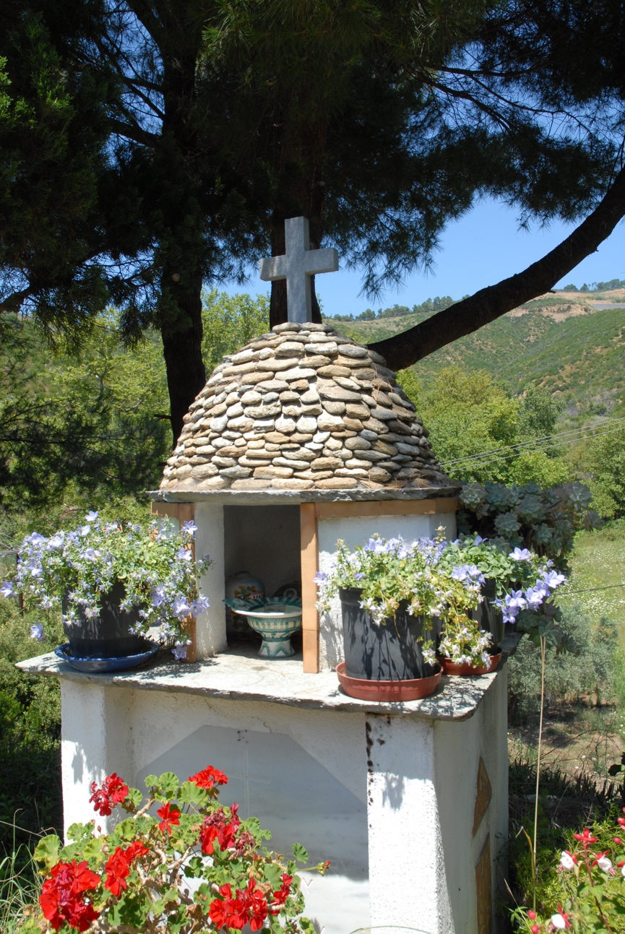

When Moeder Valeria died, Lida added a photo of her in the top of the shrine.
Me, I would be happy to end up there as well - or maybe under a newly planted olive tree.
Another elderly couple who played a large part in our lives, became surrogate parents − but whose sojourn in Zorbathes ended tragically − were Geoff and Anne Chandler. They had come to Skiathos as guests of villa owners who were heavily involved in show jumping. Big Geoff, as he was known to us (I was Young Geof – as opposed to Old Geoff and Little Geof – thus we all kept our dignity!) had been working with horses and show jumping for much of his life. They had worked in Iran until the Shah was kicked out and then had come to Athens, where they worked at a stables and show jumping school. He designed and laid out courses for show jumping and had designed the course for the Balkan championships, which was won by the owner of the villa they were staying in.
They fell in love with Skiathos and were looking for a place of their own to live in, but could not afford to buy a property. They had two dogs that they had adopted in Tehran, one a short fat, pudding-like thing called Paddington Bear (or Paddington for short), and the other a larger mongrel called Podger. He could be bad tempered and would snap at people he didn’t know or who trod on his tail by accident, for example. Because of the dogs, it was hard for them to find a place to rent, as (especially in those days) the local Greeks were quite averse to dogs and thought they should be permanently chained up. We talked, and Geoff suggested that maybe they could rent a small plot of land from us a little bit up the hill, where they could set up a caravan and build a wooden pergola over it, to protect it and give them a shady patio outside the caravan. This seemed a good idea to me and Big Geoff went off to price some caravans in Athens. Having found one suitable, he asked his Athenian show jumping friend to help him with the paperwork and with the paperwork for transferring a Suzuki Jeep from his friend’s name to his, as they had decided to buy this car as well. His friend agreed but said it would take many days as Greek bureaucracy was (and is still) notorious for being slow and laborious. The initial reaction of any bureaucrat is, “No, this is not possible!” or, “You are in the wrong department!” (no further instructions given …..). This is so that they do not have to do any work. Big Geoff and his friend started by buying and registering the caravan, which only took two hours. His friend could not believe it. They then went to the office that deals with the transfer of cars from name to name, and achieved that in even less time. They did it all in one morning with Geoff’s friend muttering all the time, “This is impossible! Impossible!” Geoff had the caravan delivered to Skiathos and then towed it (with great trepidation) up our very narrow dirt track to the designated plot. We got it in place, dug a small cesspit, and attached it to our water system, and they had a home!
We still did not have electricity then and they used camping gas to cook on, for refrigeration, and to light the caravan. This was to prove their eventual undoing! Big Geoff built the wooden pergola over the caravan, made a small retaining wall in front to raise the patio level to that of the caravan, and proceeded to settle in. This was in the year that Mara had been born, and Reese and Gillie had left for Australia. Geoff and Anne became our main advisers on raising children. They helped us in many ways and entertained us with their stories of exploits in Iran and Athens, and farming in the UK (they had raised pigs at one time, as well as always being involved with horses). They smoked a lot and enjoyed a good drink, although never getting “out of it”, and we were glad that we had invited them to share part of Zorbathes with us.
After a while, when the caravan was starting to feel a bit cramped (especially in the winter when it could rain for days on end), Big Geoff suggested that maybe they could pull the caravan out from under the roof and build a small wooden house there instead. We would pay for the materials, he would do all the labour and then they would stay for several years rent-free. It seemed like a great idea as we would eventually end up with a wooden house when they decided to leave (it had always been their intention to go back to Britain when they started to feel too old to stay abroad). The caravan was pulled out from under the pergola on to the parking lot we had provided, and Geoff went to work. He made a doubled skinned cabin with a plywood interior, external lapped siding, and insulation in between. It comprised a kitchen, a small dining area, a “snug” living room, a bedroom and a bathroom with a bath (an unheard of innovation in Zorbathes at that time). They sold the caravan to a local man after having moved in to what became christened, The Bungalow. We installed an old Ascot, Calor Gas-fired water heater, and had bath nights once a week, when we would all go up to The Bungalow and take turns having a nice hot bath… pure luxury!!
Geoff and Anne would entertain us with food and drink, stories for the girls, and evening-long games of Scrabble for us oldies. Geoff cleared and “tamed” the plot in front of The Bungalow and startied planting a heat resistant grass that had initially been brought to Skiathos from Rhodesia by a South African woman. This grass makes a great lawn, soft and springy, but can be very invasive. He told me, as he was planting it, “You are going to curse me for this!” It is a lot of work, especially to keep it within the bounds of the lawn area, but we now also have it in front of our house, and I remember Big Geoff every time I mow the lawns. I do not curse him! Their daughter, “Diz”, would come every year, usually with her friend Mary, and the two of them would enjoy the nightlife in Skiathos as often as possible. They were both girls full of life and were a pleasure to be around.
Geoff and Anne’s stay was cut tragically short by an accident with a camping gas bottle. None of us had electricity at that time; they lit their house and ran a small refrigerator with camping gas. One evening in the middle of summer, when a gas bottle used for lighting had run out, they tried to replace the empty one with a full one. In the process of screwing in the lamp section it became cross-threaded and didn‘t screw in properly. Realising this, they left the process for the next day. The following afternoon, outside on the terrace, Geoff and Anne tried to unscrew the lamp section from the camping gas bottle with Geoff holding the bottle and Anne the lamp section. Unfortunately, what happened was that the valve of the camping gas bottle unscrewed instead of just the lamp section, and suddenly all the gas from the bottle was released. Their little gas refrigerator which was outside on the terrace had a small pilot light and when the gas reached that, it caught fire. Both Geoff and Anne’s clothes had been permeated with the gas and they both started to burn! Geoff managed to put out the flames on his clothes by rolling on the lawn but Anne, who was in a state of shock, got very badly burned. There was no telephone (and no mobile phones in those days), and we had gone to the beach for the afternoon, so they had no way of communicating what had happened. Geoff put Anne in a bath of cold water but could see that she was really badly burned and was at his wit’s end. Fortunately, a horse-riding friend happened by and found them. He got them to the local Health Centre in Skiathos Town but the doctors there were not equipped to handle such serious burns. They called for a medical plane or helicopter to take Geoff and Anne to the KAT Hospital in Athens, which specialised in such cases.
In the meantime, we were riding back from the beach with the girls on our tractor and trailer. As we got close to Zorbathes, one of the doctors (we called him, Ooch, aach, because he complained more than his patients) driving in the opposite direction stopped us. He explained in Greek that an accident had happened and that “The two old folks were burned”. Our Greek wasn’t quite up to this as we had never come across the words for “burned” and “third degree” before. However, when we got back home and I went up to their house, I could see that there had been some kind of accident with fire, as the entire front porch including the flowerbeds was singed. I jumped on my moped and went off to Town. I stopped at Stathi’s Taverna on the way as I knew Stathi fairly well and wanted someone who spoke Greek and good English to accompany me. Stathi, bless him, dropped his work (with a completely full taverna and people waiting for tables), and came with me to Town. We saw Anne who was in a very bad state of shock, but not feeling any pain as all her nerve endings had been burnt, and was more worried about being naked in front of us than anything else. Big Geoff was not so badly burnt but was in a lot of pain and extremely worried about Anne. We helped to get them to the airport as a medical plane was on its way. As there was no ambulance then, they were loaded on to the back of a flatbed truck, and driven to the runway. I tried to reassure Geoff that everything would be OK, but he knew that Anne was in a very bad way and was very worried (much more for her than for himself). They flew off and I returned to Zorbathes to bring Lida and the girls up to date. They were all very upset, especially Zoi and Mara who couldn’t really understand what had happened, but knew from our demeanour that it was something very serious.
I can’t remember who informed Diz but she came to Athens two or three days later with Mary. I went to Town every day to phone the hospital and was told after two or three days that Anne had died. I don’t remember if Diz had made it in time to see her. I went to Athens after 5 days (once we had arranged for someone to take over my duties on the farm and selling the vegetables), met up with Diz and Mary and went to see Geoff. His first words to me were, “Bloody gas bottles!” He was covered in second and third degree burns and could only half sit up in bed. He was in great pain, something the drugs could not totally alleviate. The hospital had discovered a “new” treatment for burns, which was to do nothing (!) so he still had grass and earth mixed up with his scabs! He was comparatively cheerful (for a man who had just lost his wife and had his life changed forever) and, like many patients, spent his time trying to cheer up all the people who came to see him. Among these were many wealthy Athenians from the show jumping world, plus many other friends they had made during their time in Athens. I commiserated with Diz and we all had a good cry about Anne. I could only stay for one night, as (in the middle of the season) things were just too busy back at home.
About a week later, Geoff flew to Britain with Olympic Airways and entered the specialist burns hospital at Stoke Mandeville Hospital in Aylesbury. They were horrified at the “treatment” that he had received in Athens, and he was immediately put into solitary confinement, as he was too toxic to be allowed near other patients. He later described to us how burns treatments are the worst as the pain just keeps going. Firstly, there are the burns themselves, followed by the pain when dressings are changed, during which scabs sometimes come off, and finally when skin grafts are taken. Both the area where the skin was taken from and the burnt areas have to heal again. I experienced all this some years later and can testify to the truth of this (more of this in the chapter called Fun).
Geoff recovered and came back the following spring to gather their things together and say a sad farewell to Skiathos. He couldn’t bear to live alone in the place that had afforded them so much happiness, but had eventually ended in tragedy.
We have made so many friends in Skiathos, and it would be tedious to try to describe them all here. As mentioned before, they know who they are, and they also know that despite not being mentioned by name in the book, we love and treasure them all. We recently went on a trip around the world – UK, USA, NZ, OZ, and Malaysia, to visit some of the friends we made here. Even though we hadn’t seen some of them for over 30 years, our friendship was as deep as ever, and we had great times reliving our adventures in Skiathos and catching up on all the latest doings.

6 - Water

“Right,” said Paul, (one of my many brothers in law), “Are we going to start this well you’ve been talking about, or not?” (I say one of my brothers in law because all three of Lida’s sisters had at least 3 relationships and brothers in law were mounting up! Lida has been the most conservative, having only been married twice! Paul was Dutch and then living with Liesbeth, Lida’s younger sister, and they had been staying with us for some time.)
Until now, we had been getting all our water (including drinking water) from one of the vouthanas (pools) in the streambeds that bordered our land. However, this was an easily polluted source of water (not that there was much to pollute water tables and streams in those days), and I really wanted a stable, covered well, from which we could definitely drink the water safely.
Paul and I went down to the point where the two streambeds met, at the west corner of the land, and decided that this should be a good spot to dig a well. (Wrong, as it turned out!) The first day we got down about 1 metre and had a small hole (2.5 metres wide), a small pile of earth and lots of blisters to show for our work. It was a start! In the following days, we went deeper but still didn’t find much water, even at the 3 metre mark. One of our neighbours saw our efforts and put in a few hours work − he could dig and shovel twice as hard as both of us put together − and we got to 4.5 metres (with some slightly stronger trickles of water) much quicker. However, we were now into rock, (sandstone fortunately) but still hard going. Our neighbour suggested getting some digging equipment like a pneumatic drill (jackhammer) to get through the rock, but that we should think about lining what we had dug so far with breeze-blocks. I couldn’t see any way we could get the equipment up our dirt path yet, but it was obviously a good idea to line what we had dug so far to avoid the walls collapsing. It took several days to get the necessary blocks, cement and sand to the wellhead, as we were still bringing everything by horse and donkey from the main Aselinos road, but the following week we organised a “well lining party”. Mike and Phil turned up; they had been working on Koukounaries Beach for Christo and Gail helping to rent out canoes and giving water ski lessons, and were happy to have a day doing something else. (It might seem strange to some people that they wanted to get away from being on the beach every day and all day, but when you have to do it for a living, it loses some of its appeal.) Mike and Phil went down to the bottom of the well and bailed out what water was in it. Paul and I mixed the mortar and started handing down breeze-blocks and buckets of cement mix. They lined the well, row by row, leaving sufficient gaps between the blocks to allow water to seep in. As they built upwards, we arranged temporary scaffolding for them. Neither of them had done any similar work before, but it all went very smoothly with much joshing and only the occasional curse when a finger got trapped under a block, or a bucket of mortar hit the side on the way down and spilled over one of them. The well became 2 metres in width and 5 metres deep (as we built it up above ground level) and took us a day to line. At the end of the day we all had a feast washed down by copious amounts of wine and revelled in a shared job well (sic) done.
We checked it the next day and there was about half a metre of water in it, rising very slowly. We knew that this would not be enough water to be able to have a garden and (dream on) running water in the house, but (once we had covered the well) at least this was safe for drinking, and we could still get general use water from the vouthana.
The way we brought water up to the house was in 10 litre jerry cans (for drinking) or 30 litre “square buckets” designed to be loaded onto a horse or donkey saddle. We would fill up the “loading buckets” with bucketful’s from the vouthana – switching to the other side after each bucketful so as not to unbalance the load. If some spilled on to Francine the donkey, she would growl and attempt to kick us. She also had the knack of moving slightly just as you were pouring the bucket in, causing you to miss the tank and pour it down your leg! Once full, we went up the hill to the house and − with hoses from the bottom of the loading buckets − we let the water run into the two 50 gallon barrels we had. To fill the barrels and enough jerry cans for a week, took about a day of sweating, swearing and (in most people’s case) avoiding Francine’s hooves. From these barrels, water was taken as needed for washing, washing up, etc. We re-used any washing water for our tiny flower garden, which brought a little natural colour into our lives. It took the best part of a day to fill up the two barrels and we would empty them within a week at least. When friends were staying, and asked us how they could help, we often asked them to bring up water; it was a long, boring job and we were glad to have a break from it. Unfortunately, Francine hated being led by anyone other than me and could be hard to handle. Once, fully loaded, she kicked Kees (another Dutch brother in law and built like a brick shit house) into the bushes, much to our hilarity!
A year later, after our neighbour had bulldozed a very rudimentary dirt road from the Aselinos road, through our land and up to his, we managed to get a pneumatic drill and a cement mixer (which had a hoist on it), back to the wellhead. These were both diesel driven and made lots of noise! The operator of the pneumatic drill and our neighbour went down the well and started to drill through and break up the rock. Up above, we used the hoist system on the cement mixer to bring up large buckets full of pulverized rock and dump it nearby. With one day’s work, we went another 1.5 metres deeper and found a few more small trickles of water but, all in all, it was pretty disappointing. We didn’t line this bottom part of the well as it was all rock and we were not afraid that it could collapse. In fact, it never has.
Although we now had a bit more water, it was still very limited, and although I put in a small vegetable garden near the well, it was a struggle to keep it alive and producing anything like edible veggies.
The next project to try to get more water was to build a large tank behind our house, which could gather water from the house roof. Franz also donated an old petrol operated water pump which just had enough strength (when it felt like it) to pump water up to this tank (and a tad higher). This alleviated the donkey trips but the pump was so temperamental − causing me many a skinned knuckle trying to start it − that sometimes I wished we were back in the days of the donkey. Eventually, we added a shower room on to the side of the water tank and put the two barrels on its roof so that we had enough gravity to have something like a decent shower. The temperamental water pump would sometimes decide it had enough power to fill the barrels – but not every time – so we often had to fill them by bucketing up by hand, water from the water tank. The water was heated by a wood-fired boiler at the back of the shower room and we had “shower nights” where everyone took their turn for a shower, provided they stoked the boiler at the end of their shower ready for the next person. This was done via a fire door in the room itself, which also helped to heat the shower room and was very welcome in the winter months.
We finally managed to put a tap in our house with the water running from the two barrels. Just one cold-water tap over a simple sink. However before we managed to sort out a drain for this, an American friend came by with some lettuce for us and proceeded to clean them in the sink – which promptly deposited the wastewater on to his feet! We lived like this for a few more years, heating water for washing on the wood range or gas stove and I well remember washing nappies over this sink when Zoi was born. We used what was called a “Pressure Wash”. This was a smallish drum, with a lid that you could screw down tightly, and which could be rotated on its axis by a handle. We filled the drum with washing, poured in hot water and soap, and rotated the drum some 50 times before opening it again. It was amazingly effective and saved as a lot of time compared to scrubbing the wash by hand.
Originally, we had done the weekly washing as the local Greeks had done for hundreds of years. We took a large, galvanized washing kettle down to the vouthana, filled it, and built a fire underneath it. Once the water was hot, sheets and clothes were washed in it, scrubbed in a wooden tub, and then rinsed with cold water in the tub. The washing was then draped over bushes to dry. When we installed our first washing line, this was looked on as quite a novelty for the neighbours, but it didn’t take them long to realise the benefits, as often the washing came off the bushes dirtier than when it went on! We also brought an old hand wringer from Holland to wring the clothes out, and our neighbours viewed this as a huge technological advance! We felt that, with our running water in the house and our “Pressure Wash”, we were now quite the sophisticates!
It was still to be quite a while before electricity came to the valley so we used this system of washing for most of the early years of our daughter’s lives.
I started to get really fed up with the temperamental water pump and was looking for a better substitute when Christo (who comes from the Peloponnese) mentioned that all the farmers in his home village were becoming electrified (not electrocuted!) and there were plenty of old diesel driven water pumps going cheap. He was due to take a trip down there to see family and friends and check up on some property he owned, and suggested we go with him to see if we could find a good engine. He had a Land Rover and said we could drive down and then bring an engine back with us, if we found one suitable. We jumped at the chance to see somewhere new and maybe mix business with pleasure. Christo was always entertaining, so we knew we would not have a dull trip, even though it would take a couple of days to get there and a couple back again. Once we arrived at his village, he spent some time with his family and tending to business, and then we went to see an engine that was for sale. It looked and sounded good, so we agreed a mutually satisfactory price with the owner, and humped it into the Land Rover. The ex-owner grew and sold mandarins for a living and insisted on giving me a bag to take with us on our journey back to Skiathos. However, we walked past row after row of mandarin trees before he finally came to one surrounded by goat manure, where he picked loads of fruit. When I asked him why he hadn’t taken them from a more accessible tree, he said, “Ah, those trees are for selling, this one is for the family.” The commercial trees were fertilised with artificial fertiliser and sprayed against various diseases and bugs, but the one that they ate from was “pure”.
The engine was an old, Italian made, single cylinder diesel engine, which made slow, “doug, doug, doug” noises as it turned over, but was simple and strong. It was called a “Malkotsi” and was the staple engine for pumping water and driving small fishing boats as it was so reliable. Once it was started, it would run forever, but starting it could be fun! There was a starting handle with which you turned over the whole engine, and a decompression handle that was held open until one had got sufficient revs up. As the flywheel spun faster the decompression handle was dropped, and the motor kicked in. However, you had to get the starting handle disconnected quickly or it would (literally) fly off the handle, and could be most dangerous. Also, to get the compression up sufficiently to get it started, we often poured a little engine oil down the exhaust vent and when it did finally start, huge clouds of black smoke would be emitted for the first few moments. The engine was water cooled, so a barrel of water− with an inlet and outlet hose to and from the engine − had to be next to it. The water in the barrel slowly warmed as the hours went by (if we were pumping a lot) and would gently “steam” during the winter months.
Once we had it back at home, we cast a concrete base for it, hooked it up via an old belt system to a pump, and suddenly, we could pump to our heart’s delight. Unfortunately, we still didn’t have much water to pump and this was becoming a real problem. I had seen people putting in boreholes via an antiquated drilling rig that belonged to Margaritis, who had come from Volos on the mainland to work on the island. It didn’t drill but literally pounded its way through earth and rock and was slow but very effective. I had told him many times that I would like to drill to find more water but that I couldn’t afford the cost. Eventually (probably just to get me off his back) he told me he would do the drilling work for the cost of the diesel if I could pay for the lining pipes and any other associated costs. I gratefully accepted his offer and he came to the land to see where he could drill. I wanted him to drill next to the existing well (stubborn fool that I was), because that is where I had set up the diesel engine, but he said it would be very difficult to get the rig there and the plane trees surrounding the stream beds would get in the way. Was there anywhere near the road that had water? I knew that Denis Magill, one of the very first villa owners, had discovered he had a talent for dowsing and so I asked him to come and see if we could find water at a more convenient spot. Just inside the land and right next to the road, still close to the stream but not bothered by plane tree branches, he found what he described as “a considerable amount” of water and not too deep. This turned out to be an underestimate, as I shall tell you anon. Margaritis was happy with the position and brought his rig the next day. It took a while to get everything set up and then he started it pounding away. He brought a barrel of water with him as the pounding action needed water to be efficient and until we hit a source, he had to add his own. Unfortunately, within the first metre, he found only sand and this kept collapsing into the hole and filling it up. He said he would have to put a larger diameter pipe down for one or two metres to stop the sand from running in and this would be an extra cost. By this time, I was determined to have more water whatever the cost and told him to go ahead.
He sunk a lining pipe, then made his drilling (pounding) bit a little smaller by simply cutting off a few edges with a welding torch, and proceeded to pound away again. As the rig pounded up and down, he would occasionally grab the wire hawser and give it a twist so that the teeth were not always pounding on exactly the same spot. (Fortunately, we had no “Health and Safety” officers around then!) Every so often, using the welding torch which ran off a generator run by the rig’s engine, he would weld new “teeth” on to the bottom of his “drill” as they wore away grinding the earth and rock to dust. To get the ground refuse out of the hole, he used a long, thin, “bucket” with a simple valve on the bottom, allowing water and refuse in but not back out until he released it on the ground a short distance from the hole. At 5 metres, he found a little water but at around 12 metres, there was a deluge! He continued to drill to 18 metres but then told us we wouldn’t find any more, and that he was sure what we’d found was more than enough. Also, he told us that we seemed to have hit an artesian source and the pressure was raising water up to within a couple of metres of the surface. This sounded fantastic as some people have had to drill to well over 100 metres to find a good source and then install quite an expensive, electric pump deep below the water level. He brought galvanized pipes to line the hole, which he welded together as they went down. We then shovelled fine gravel around these pipes to keep them stable and to help filter the water as it flowed into the borehole. Margaritis used his “bucket” to try to measure the flow into the hole by simple filling it up and emptying it as often as possible. He said that he could not keep up with the amount flowing in, so that we had at least 12 cubic metres of water per hour. That is 12 tons of water per hour!!! An absolute abundance! I owed our borehole driller friend a great debt of gratitude and was able to pay a little back when he bought land near us and I could supply him with water until he developed his own source.
Plentiful water changed our lives!
It may not be obvious to people living in the so-called developed world just how precious water is. You just turn on the tap and there it is, and usually drinkable as well. It is, in fact, the second most important thing in our lives (after air) and access to clean and sufficient water is a true luxury and should never be taken for granted. We are and will always be absolutely in Margaritis’s debt for drilling at cost for us. I was able to pay a small amount of that debt back by helping him when a few years later he brought a plot of land very close to ours.
We transferred the Malkotsi and water pump to the borehole, made the belt system a little more sophisticated, and now we could pump water (seemingly) forever. I bought an old 5 cubic metre plastic water tank, installed it at the top of our land and ran a 2 inch diameter plastic pipe up to it. From there we ran a 1-inch pipe down past The Barn to the house, and we then had plenty of water with good pressure everywhere. The possibilities opened up; a flower garden and a large vegetable garden (and even a lawn!) were within our reach. A flushing toilet (instead of the “Long Drop” hole that we had been using) was an option, but I would first have to build a toilet to be able to install one.
As the years went by and electricity came to the valley, our pumping system became more sophisticated. We eventually built a solid concrete water tank (faced with stone to blend in to the scenery), had a float switch installed so that we did not have to keep switching the pump on and off up by hand, and put in automatic drip systems to water the flowers, vegetables, lawns, and trees that we planted all around the houses.
I am still careful with our water even though we seem to be blessed with more than we could ever use, and a dripping tap will still annoy me as I remember how precious every drop was to us in the early years.

7 - Earning a crust.

After buying the land and building the A-frame, I had pretty much worked my way through the money I had inherited from my great aunt, and it was time to think about earning some more, so that we could continue our life in Skiathos. In theory, we were tourists in Greece. We were not allowed to work, and we had to renew our Tourist Visa every 3 months. Although we could get odd (black) jobs here and there, we knew it would be barely enough to live on, and we knew that we could get much better paying jobs in Holland. We drove back in the autumn of ’74, in the Land Rover, with our friend, Angie. She and her boyfriend had returned from India and stayed with us to help build the house, but her boyfriend had subsequently left. It took us 5 days and nights, and we slept in the back of the vehicle each night (with Angie on the seats in the front), as we could not afford hotels. Bread and cheese, and the odd hot meal cooked on camping gas, sustained us throughout the journey. The Land Rover had no power steering, and Lida was reluctant to do much of the driving, so by the time we arrived, my shoulders were aching badly.
When they had still been together, Lida and Adri had bought a house in Zaandam, just outside Amsterdam. It was mostly a wooden “dike house”, up on the road above the lower land below. (If you want to know how the Dutch reclaimed land using “dikes and polders”, I recommend looking it up on Wikipedia. Fascinating!) Lida still owned half the house and we went there to stay. We found work even though all our friends said that there was almost no work in Holland, at the time. The fact is, that if you want to work (and knew that it was only for a few months), you could always find something. Lida worked as a medical secretary again, and I found work loading and unloading lorries. I didn’t mind what work I found, as long as it was mostly outside in the fresh air, even though it was winter time. We could live off the money I made and stash Lida’s income (which was considerably better than mine) to bring back to Greece. We worked for three and a half months, and managed to save quite a bit. Adri had a Danish girlfriend, Susanne (Suzy), and we slept in 2 bedrooms in the attic of the house. Angie slept in the cellar. The attic roof had no insulation, and snow was sometimes blown through the gaps in the roof tiles, so you can imagine how cold it got. Definitely a sex killer! The main room had a gas heater, which was very efficient, but the heat didn’t get up to the attic. We also helped Adri and Suzy redecorate the house. They had only recently moved in and there was lots of old, dingy wallpaper everywhere. Under the wallpaper were good tongue and groove planks, which we exposed, then sanded down, and finally painted. A much nicer result.
Soon it was time to think about getting back to Skiathos as spring was on its way. Angie decided to stay on in Zaandam, as she didn’t fancy returning to the UK. We did this every winter for the next 3 years, and finally one last time in the summer of ’78. That was a mistake as it rained almost non-stop for the first 22 days that we were there! I didn’t feel like I’d had a summer at all. Lida always managed to get a well-paid job, and as always, I did whatever was necessary to put food on the table. My criterion was always fresh air! For the rest, I didn’t mind what I did. Keith ended up staying in Zaandam after he got out of Greek jail so for a couple of winters we spent a lot of time together. He eventually moved out (as did Angie) and bought a houseboat in Amsterdam on the Amstel River. The last time we were there, in the summer of ‘78, Adri and Suzy had gone to the south of France, to visit old friends there, Hans (Dutch) and Linda (English) and their daughter Sammy. We are not sure what happened but Adri returned with Linda and Sammy, and Suzy remained with Hans. It was the end of the “Zaandam phase” of our lives, as Adri wanted to sell the house and move to France with Linda and Sammy. It had never felt like Lida’s house to us, and we had our own house in Zorbathes, so Lida said that when they finally got divorced, she would not make any claim on their joint property. They had discussed divorce and started the paperwork, and the decree nisi came through after we returned to Greece. The lawyer wrote to Lida saying that this was the most amicable divorce he had ever been involved with. We still have contact with Adri – he is on his third wife now.
Back in Skiathos, we worked on our land, which still needed a lot of clearing, built the barn, and added to the house. We worked for the wealthy villa owners, me labouring and Lida cleaning, and we were able to live on this income. We used the money saved in Holland for building and general investment in improving our life style. We never borrowed money; if we didn’t have any, we didn’t do anything. When we had money, we used it for further building. See the chapter entitled “Shelter from the storm” to read about our building exploits.
In 1980, Greece joined the Common Market (now called the EU), and I thought it was time to try to become registered as a farmer. We had around 100 olive trees, 15,000 m² of land, were growing most of our own vegetables, kept chickens, etc. and I was fed up with still being registered as a tourist. I went to the Town Council with Dimitri − my Greek friend from Volos − and after some enquiries, met the lady who was in charge of the Agrotis (Farmer or Peasant) Department. Dimitri explained that I wanted to be registered as a farmer and to live here full time. “Ah!” she said, “You want the farmer’s free medical insurance and pension, don’t you?” “No,” I said, “I just want to be a farmer and to be allowed to live here full time, which is my right as a person from a member country of the Common Market.” “Yes, yes,” she said, giving me a knowing look, “Of course, of course. But what you really want is the farmer’s free medical insurance and pension, eh?” “Look,” said I, “If I really have to accept those terms, I’ll go for it.” “Alright then,” she said, and registered me! This started to make our life a bit simpler, and instead of going every 3 months to the police to renew our “tourist” status, we only had to go every 5 years to renew our resident’s status. By this time we had acquired some goats (see “Animals”) and I was now free to sell the milk, cheese and yoghurt we made, and to sell the kid goats in the springtime. A little extra income. I still wasn’t registered at the Greek tax office, and that caused some minor problems. After a few years, they called me in and told me that I should have been paying tax on any income. I gave them the old “Greek shrug” and told them that no one had informed me, but what do I owe you? After some hours of questions, they said that I should pay a paltry sum and then make a tax return every year. I paid the money and went to consult an accountant. He told me that my status as an Agrotis was worth gold, and that I should never change it. Apparently, farmers and peasants in Greece get quite a few good deals (like the free medical insurance), but a lousy pension. Still, seeing as, at that point, I wasn’t paying for a pension (and being a pensioner seemed so far away), this didn’t bother me. His advice was, indeed, very good and I am a peasant to this day, albeit a retired one. Some years later, farmers had to start paying for their pension, and I did so willingly. I am now receiving the pension. It is, indeed, quite small, but it helps getting food on the table and, at a (severe) pinch, we could probably live off it.
I discovered in Greece’s hot climate that land without water was of very little use. We tried to grow a few vegetables and planted some flowers outside the “A” frame, but it was a struggle without much result. After we had developed our own water source (see the chapter Water) things changed dramatically and we started to make a larger vegetable garden. We initially sold any spare produce to villa owners and friends, but then decided to try to do it commercially. Once I had become registered as a farmer, rather than a “tourist”, we could sell our vegetables, etc. I also needed a paper from the Mayor stating that I could sell my produce on the streets of Skiathos, but that proved relatively simple to get, as I was now a registered “peasant” farmer. We needed a steady income and the goats just didn’t provide enough, so I thought about starting a market garden. I had the land, the water and the tractor and had acquired some knowledge of growing things during the years of trying to be self-sufficient. However, I could foresee that it would be a lot of work for one person so I approached Reese and asked him if he would be interested in a partnership. He and Patti had gone their separate ways some time before and he’d had a series of partners since. He was also in need of some income so we agreed to try it and see what happened. “See what happens” has more or less been my motto for life. I am always trying new things – it’s the Aries in me - and I then go with what works. Luckily, most of the ventures I have been involved in have turned out fine. I think that the spirit of Skiathos has somehow helped me with them, although there is no way to define that. Lida cocks an eyebrow whenever I moot some new – seemingly crazy – scheme, but always gives her support and comes along behind me, mopping up the messes while making sure that I don’t go totally “over the top”.)
Reese and I started planting around 2,000 m² of my land in the spring of 1981 and we soon discovered what a lot of work was involved. It was not necessarily so physically hard but we had to be in there every day making sure the weeds didn’t get a hold, staking and tying up tomato plants and a hundred other small jobs that consumed many hours. The biggest job was watering the garden and a section had to be done every evening. The traditional Greek way to do this was to have trenches along the rows of plants, with one main trench coming down the rows. Opening and closing small earth dams directed water into the rows, one after the other. This was very time-consuming and my mind sought ways to get around this. Eventually I developed a system using a pipe with holes at every row trench that filled the rows slowly at the same time. This was a precursor to the drip system we eventually used a year or two later. It meant that we didn’t have to be there in person to direct the water, but could spend the time doing other work instead. We were the first to use drips on the island and later on, the first to use (reusable) black plastic mulch.
We planted everything that grows well in this climate: beans, tomatoes, courgettes, peppers, aubergines, etc. Once we started to harvest the vegetables, we thought it would be a good idea to try to sell them at the corner of the road leading to where most of the rich villa owners lived. This didn’t work very well (and also upset the owner of a small supermarket in the area) and we brought much of our vegetables back home. At this point, Lida and Zoi (our first daughter) and I left for the UK in our quest to get married. Reese decided he would try selling in Skiathos Town and drove the tractor and trailer to near the Health Centre at the top of the town and started shouting our wares. This proved more successful and the local women took nearly everything. From that point on, this area (know as Aghias Triada) became our starting point for all sales. Occasionally, there would be one or more of the local Agrotees already there with panniers on a couple of mules and they would treat our arrival with surly looks. We always immediately moved on, as we didn’t want to upset them and we respected the fact that they had been doing this all their lives while we were just “hippie newcomers”. After a while, when they realised that there was enough business for all of us and that we were not trying to do them out of a living, they would ask us to stay. We then got along famously and they taught us quite a lot about raising vegetables commercially here, as they had a wealth of experience. Over the years, they stopped as old age caught up on them and we eventually became the main supplier of vegetables to that top area of Town. We always grew our vegetables organically using natural sources of fertiliser: compost, manure and cotton seed waste. We never sprayed or used artificial fertilisers. I am not sure that the local women really believed that everything was organic but they did know that the vegetables tasted better and lasted longer than what was offered in the shops, so it was not often that I brought much back from market.

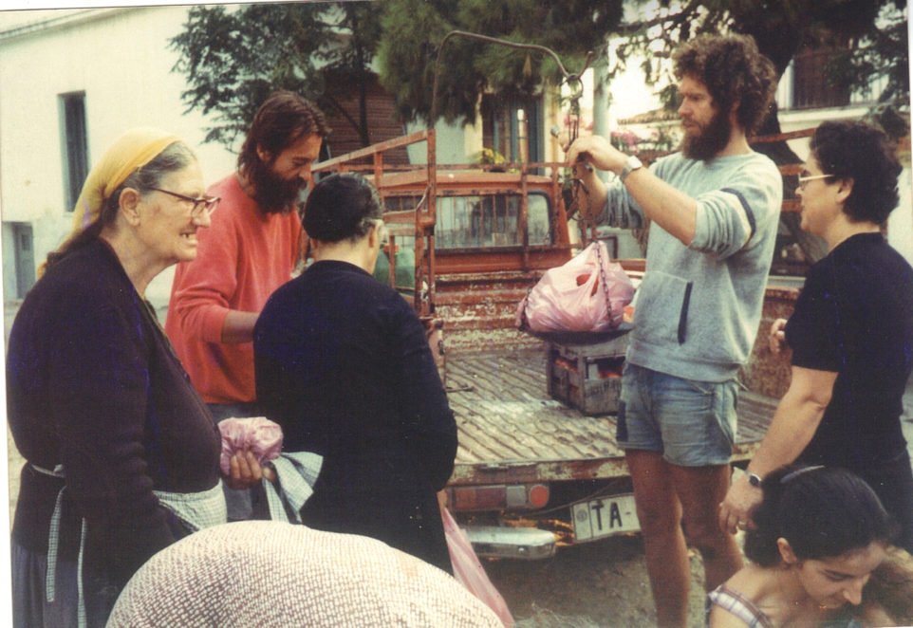

Our vegetables became famous on the island. The women would sometimes fight for the fresh green beans, and the men loved our cucumbers. We pioneered small cucumbers and sold them by the kilo rather than by piece. Changes like this were always greeted by lots of criticism from the locals, who like all small communities, liked to have things done the way they were always done. However, as the vegetables were so good (and we were foreigners, who really didn’t know any better), they accepted the changes, and after a while, were proud to be part of them. When we weighed the vegetables, we always threw in an extra tomato or handful of beans and this kept the local women coming back. An older gardener, who used to weigh his vegetables and charge for every gram, was known as Pharmakis, because he weighed like a pharmacist. It wasn’t an affectionate nickname!

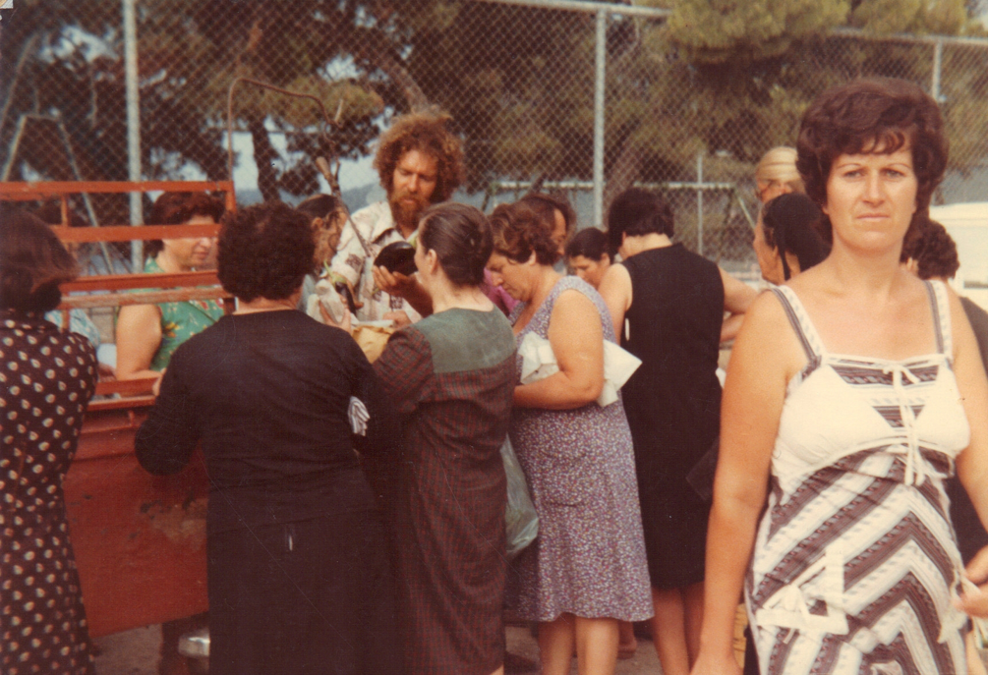

Reese was then living with a lovely Australian lady called Gillie and their intention was to move to Australia. He had sold his land to an unscrupulous Greek but never received the full amount of payment for it. John − a Scotsman he’d met the winter before, in London − turned up one day to see what this island was that Reese had been raving about. John was introduced to me oby Reese and, after getting to know him a bit better and liking him immensely, I suggested that he might be interested in doing the garden with me the following summer, as Reese and Gillie were definitely leaving in the autumn. He said, “Why not?” and a relationship was started that continues to this day. He eventually hooked up with Liesbeth, one of Lida’s sisters, and they now live in New Zealand and have a son and daughter. Both John and Liesbeth talk in their sleep. One time − before they got together − when John was sleeping in the little loft of the A-frame and Liesbeth was crashed on the couch, it sounded like they were having a conversation, as both of them were mumbling away.
John and I ran the garden business for several years but he would always go back to London to work in the winter. He introduced me to windsurfing, as he had the use of someone’s board at Troulos Beach. I fell in love with it and − although I was initially not at all good − I had found a way to relate to the sea, which I otherwise thought was pretty boring. I didn’t like swimming at all, but being on a plastic plank that couldn’t sink, suited me perfectly. Our daily schedule was to start work in the garden as soon as possible, before it got too hot, and then go to the beach from around 12:00 until 17:00. We would then return and continue in the garden until it became dark. This gave us an excellent lifestyle with the girls being on the beach almost every day, meeting kids from all over the world. Lida swum and John and I windsurfed if there was a good breeze blowing. The best winds used to blow from 11:00 until 13:00 when they started to drop. If these winds were blowing, it was a mad panic to get the garden work done and get to the beach before it was too late. I would go into Town on Mondays, Wednesdays and Fridays to sell the veg we’d picked the evening before. This left us Saturday as a day off, but there was always something that needed tending to. It was a great lifestyle but didn’t really earn us much money. Still, we weren’t here for the money, we were here to be able to choose our own lifestyle and we had certainly found a good one. After some years, John decided he couldn’t keep living just drifting along having a good time and, with our encouragement, he decided to stop and try to find something a bit more permanent. When he left, he ran into Liesbeth at Athens Airport, quite by chance, and they flew back together to Amsterdam. They never looked back! The previous winter, John had been working painting a friend’s house when he met Jacques, a Frenchman who was working for a builder doing skilled renovation work on the same house. They got on really well and John told Jacques about Skiathos. Jacques came to visit the following spring for a week and loved the island. He was looking for a change, having worked in London for a year honing his English, and asked if there was any work on Skiathos. As he was a skilled builder, tile layer, plasterer (and much else besides), I suggested he took John’s place in the garden the following summer and that in the winter months, I was sure I could find work for both of us (with Jacques as the master builder and me humping the cement behind him). This is the way it worked out. It was strange, but all my partners introduced me to my new partner before they left. Jacques never left Skiathos and didn’t introduce me to a new partner, but eventually bought his own land with Rose (an old friend of ours from Amsterdam) and built his own house.
In all, we ran the market garden for 13 years, refining our production techniques all the time. We built small plastic greenhouses to bring our seedlings on earlier, refined the watering systems so that it didn’t take so much of our time, used tomato varieties that didn’t need tying up, and generally found ways to produce more with less work, while making sure we did not deplete the land.
The time when Jacques and I went our (amicable) separate ways, was also the time my parents died, and with the money that they had left me, we changed our lifestyle quite considerably, not putting in a commercial garden any more. I switched my moneymaking activities to the Internet (which was just taking off in 1994) and we started letting the two villas, which we had managed to build over the years.
We are still very involved with our land, are constantly improving it by planting trees, and always keep a small organic garden for ourselves. The land has taught me patience, taught us that you have to give to get, and taught us that some of the best things in life may take time, but are well worth waiting and working for. Although we “own” the land, all we really own are some bits of paper. We have always felt that we are but stewards of our piece of the beautiful Zorbathes valley, and we are obliged to treat it well, and hopefully, leave it in better heart than when we found it.
On every trip to Volos, I had coveted a small, articulated, vineyard tractor. Hiring a tractor and driver to prepare our garden plot was always fraught, and I never got the result I wanted. The tractor cost 300,000 Drachmas (about 3,000 GB Pounds, then) and with help from my parents, Auntie Win and a villa owner, we bought it. I subsequently had a dispute with the villa owner about how the tractor would be used, and we bought him out. This gave me the freedom to start contract ploughing and cultivating for the local Greeks. I only did small, garden sized plots, as the tractor was not made for larger areas, and there were many of these plots in and around Town where the locals grew their vegetables and vines. This didn’t bring me into any conflict with the other tractor owners whose tractors were much bigger than mine. And, as usual, I worked on the principle that it was their island and they had first rights to everything. (We always found that if your respected the islanders, they would, in turn, respect us.) In the spring and autumn, I would be chugging around on the tractor, and every summer, busy working in the market garden. This worked fairly well for several years but I was starting to get quite severe back problems from sitting on the tractor, half turned around, and being bounced up and down. At this point, Jacques turned up to become my new partner in the garden, and subsequently my partner in building, renovating, and tiling for other people during the winter months. This was also hard on my back but was nowhere near as bad as the tractor had been.
Our first job was to help a team of plasterers, plaster a new building. The boss had heard that I was touting Jacques as a master plasterer, and offered us 4 days’ work, Jacques plastering and me on the concrete mixer. When we started, Jacques was plastering the way they did it in France, which is totally different from the Greek method. The boss came to me shouting, “He doesn’t know what he is doing!” I placated him and said, “Just show Jacques what you want, and he will do it.” He did, and Jacques got on happily with that technique. We worked incredibly hard that day, and it was a struggle to get up for day 2. However, we managed and spent the 2nd day working even harder! At the end of the day, the boss told us that the job was finished, he wouldn’t need us anymore and paid us our wages. It was just as well as there was no way we could have turned up for another day! In retrospect, we realised that they had all worked really hard to push us, and test whether we really were good workers. We passed the test and our reputation was made! The following work we received was from a cousin of the boss who needed some tiling done. It was much easier, and confirmed our reputation as good, skilful, builders.
After this, we worked hard, but in our own time, turning up for work a couple of hours after the Greeks normally would, but then staying on much later than they did. As I was the Greek speaker (at that time, Jacques now speaks good Greek), I organised the jobs. Although I knew a lot about building, Jacques was the master builder, and I was the “humper”; making the mortar, supplying him with tiles, passing him the necessary tools, etc. We specialised in tiling work as we were paid by the square metre, and could make quite good money once we had our teamwork down pat. We had an excellent working relationship and spent as much time laughing as working. My idea of what work should all be about. In the end, Jacques and I managed not only to make a good living and save some money, but also to (eventually) build the four houses and swimming pool we now own. Jacques found a good plot of land at a reasonable price and slowly built 2 houses on it.
After a long and mutually happy partnership, we went our separate ways. My parents, who had died within 39 days of each other, left us some money. This allowed us to do 3 things: send the girls to a good school in Athens where they were taught in English, build a house of stone (The Farmhouse) − something I’d always wanted to do − and gave us a year out to see which way we wanted our lives to go. The last one was a luxury most people do not get. We are usually too busy trying to earn a crust, feed the kids, pay the debts (mostly mortgage), and all the other things that keep noses to grindstones. I wanted to steer away from hard physical labour, which was starting to take its toll on my body, and I had discovered the Internet. Lida discovered tennis, which helped fill the hole that the kids had left when they went to Athens. I also wanted to buy myself a sailing catamaran and went to the UK to get myself a computer, a book about the Internet, and a sailboat. I managed all three and you can read more about the catamaran’s adventures getting to Greece in the section Fun.
Jacques teamed up with an Albanian builder and they made an excellent name for themselves, specialising in renovations. They built our swimming pool, and they had to organise the big pour (the entire shell of the pool) in one day. They organised 17 workers (mostly Albanian) and 3 concrete mixers. Because we couldn’t bring ready mix concrete lorries up our narrow road, they also arranged for small lorries to turn up at regular intervals − bringing the materials of sand, cement and gravel − as there also wasn’t enough room to put all the materials in one place before the pour. A logistical nightmare, but one that they handled very efficiently. It was their first pool project and they took great pains to make sure that they got it exactly right.
We started to rent out the two villas, The Barn and The Farmhouse, to tourists as an alternative income. I had been exploring the Internet and thought that it would be a good idea to make a web page to advertise the villas. This was at the beginning of the World Wide Web, and almost nobody on Skiathos had heard of the Internet. I made one very simple web page in MS Word (believe it or not), as it had a simple converter from word processor to html code. I made a connection to a provider in Volos, on the mainland, and published the page. I would have to dial up to Volos, with an extremely slow connection of 14,400 bits per second, to check email or update the web page. It was very expensive, and there wasn’t yet an awful lot of information available, but I thought it was brilliant! I could sit in what I consider one of the most beautiful places in the world, access any information I wanted, and ignore all the rest. I started to get some email inquiries for information about Skiathos, which I always answered. It occurred to me that it might be a good idea to get a domain name and make a proper information site about Skiathos, which I hoped would bring more guests for the villas. Some canny Canadian had already taken the domain name skiathos.com, so I decided to register the name, skiathosinfo.com. I started adding pages of information to the site and watched as the hits slowly climbed. “How can I make some money out of this?” I thought. “Perhaps I can advertise (make web pages for) other accommodation on the island, advertise businesses and property for sale as well.” Although most people on the island still didn’t really understand what the Internet was (“Does it appear on the TV?”), they understood the principle of advertising, and as I wasn’t asking much per web page, a few accommodations and businesses paid me a yearly fee for a page. This slowly grew as the islanders started to understand that they were getting more bookings by having a page on my site. Slowly, emails replaced fax numbers, and it started to take off. The island had its own Internet provider by this time, and it was starting to work at faster (but still slow) speeds. The only group of people who weren’t interested in paying for a web page, were those who wanted to sell their property; land, town house, or villa. They were used to real estate brokers (and every Greek and his mother was a “real estate broker”) finding buyers and taking a commission once a sale was completed. “OK,” I thought, “why don’t I do the advertising and if I make a sale, I might make some decent money via the commission.” In this way, I got into real estate brokering, although it had been the furthest thing from my mind. Real estate agents and brokers, like lawyers, had (probably well-deserved) terrible reputations, so the only thing I had to do, to be better than all the rest, was to be honest. Not very hard for me, as I had always tried to be honest and straightforward in my dealings with everyone. I also had the great advantage that I wasn’t Greek. The Greeks do not trust each other (even though I think they are, overall, pretty trustworthy), and being English helps as well, as for some (definitely mistaken) reason, they think that all Englishmen are honourable!
So, we suddenly found ourselves with 3 businesses, letting the villas, making web pages, and selling property. As I wanted to keep my Greek Farmer status (as a peasant!), Lida made a small, personal company to cover all the other aspects of our work, even though she was only involved in the letting of the villas. This is very common in Greece, and the local hardware store, smithy, mini-market, etc. will often be registered in the name of the wife, but be run completely by the husband. This is not a tax-dodging wheeze, but often the men of the family are doing two jobs, running their business, but also working in the building trade or with tourism in the summer. A note here about so-called lazy Greeks, I have never seen people work so hard as the Greeks (which is why most Greeks abroad are very successful), but when they stop work, they completely stop. Then it is time for good company, good food, and good wine or tsipouro.
The real estate work started to become very successful, but I still found time to expand the Internet business. There was plenty of work in Skiathos, as the economy was doing very well, and the website was expanding apace. The hardest work in Greece is getting paid for what you produce or labour for. I was spending many hours chasing up people to pay their yearly fee for their web page, and this was becoming very tiresome. I made another website for all the properties for sale, and www.skiathosproperty.com was born. On the advice of some close American friends, I decided to open an office and take on a junior partner. I had known Gigi − a beautiful half Dutch, half Greek lady − for some years, and thought that she would be an asset to the business. She was fed up with the café that she was running, and we agreed to see if we could work together. We kitted out the office and got stuck in. The real estate business was taking off and the Internet business was ticking over nicely, but what I hadn’t realised was that an office ties you down to regular hours. People expect someone to be in the office to answer questions, etc., and I found myself sitting at a desk far too much. Of course, I could share these duties with Gigi, but it started to rankle a bit. After a year or two, it also became apparent that most people who came to the office were time-wasters, and that the really serious people had already contacted us via email or through our website. We probably only sold a very few properties to people who just walked in the door. Things were going well, but then I had my accident with Merlin, the catamaran. I spent weeks in hospital in Athens, and then quite a few more at home recuperating, before I could get back to work. Gigi and I had thought about employing a secretary come office manager and we had talked to Jacqui, an English lady who had left similar work in the UK to come to live on Skiathos. She said she was willing to work for us, so I told Gigi to take her on, as it would be impossible for Gigi to show properties to prospective buyers, and man the office at the same time. This worked very well and for 3 years, all three of us were earning a good monthly wage, with a bonus at the end of the year. Then 2008 came along and the whole system was screwed by the banks. We struggled on for a bit but then in 2010 came “the Greek crisis” − when all the dodgy shenanigans by the banks, Greek politicians and rich Greeks came to light. It was obvious that the real estate market was plummeting and Gigi and I decided to split up. She was thinking of moving to Athens in any case, and I certainly couldn’t afford to have an office, a partner and to pay a secretary. Gigi had always wanted to get involved with letting high-end villas (something that didn’t attract me at all), so we agreed that I would stay in the real estate business, and she would try her hand at letting the villas. Jacqui did a couple of summers as a waitress but then opened a shop selling beautiful driftwood art that her husband Ray was making. I am happy to say that it went very well.
I spent the slump years ticking over. There was the odd sale of a property here or there. I advised people about how to make their property legal (a requirement that hadn’t been necessary before!), and I sold the skiathosinfo business to the son of an English villa owner. The villas were still renting well so, although we had to tighten our belts a bit, we were OK. The rest of Greece (except the islands) suffered immensely, and the Greeks found themselves ground down by austerity so that profligate banks could get their money back via ever higher and higher taxes. I discovered that I didn’t need an office at all. I did most of my computer work at home and met potential buyers at cafes on the waterfront that had Wi-Fi, so almost every café became one of my “offices”. This suited me much better as I had never been one for fixed hours in a working schedule. I liked the fact that sometimes I didn’t go to Town at all, or other days was away for the whole day. Lida and I had never really had a fixed routine, so it worked pretty well.
In 2015 (7 years after the crash, 7 years seem to be important!), the real estate market started to take off again. Nothing yet like it was until 2008, but there was light at the end of the tunnel. However, I was by then 67 and wanted to start to think about doing other things with whatever time I had remaining to me. Write this book, for example. I had sold some houses for a very nice Greek couple, Thanasis and Eleni. They were a civil engineer and architect respectively, and they had built a complex of houses with fantastic views. We had worked well together in the past and they had mooted the idea of working together. Their daughter Lila, another architect, was moving to Skiathos and we all discussed the idea of the three of them taking over the real estate business. We came to a mutually agreeable arrangement and I started to plan my retirement. I have been “retiring” for the last few years, but now I am determined to stop, while still giving Thanasis, Eleni and Lila any support they might need to keep the business going successfully. It seems to be working well, and I hope that by the end of this year (2019), I will be a “lazy Greek”!
People say that I will be bored, but I am sure that Lida will find lots of things for me to do, and besides, we would like to travel more and see as much of the world as possible before we pop our clogs. I still find the Internet fascinating (at least those parts that haven’t been hijacked by big business), and there is so much to learn and grow from. I cannot imagine not having an organic garden, although if we start to travel more often, this may become more difficult to sustain. I still love sowing, planting, weeding (not so much), and finally picking something fresh and having it on the table within minutes. Not only has it saved us money, but also we know that what we are eating is fresh, natural, and free of pesticides and other dodgy chemicals.
Both Lida and I now receive (smallish) pensions, perhaps enough to live on at a very simple level, but that is how we lived for many years, so we don’t really see a problem with that. We also have an income from our photovoltaic system and the villas, and I am sure I will find some way to squeeze a bit more from the Internet. We (finally) have a house that is so well insulated that it is very easy and cheap to keep warm in the winter and cool in the summer. We produce our own wine, tsipouro, whisky, fresh food, wood for heating and electricity for everything else. Somehow, we have come full circle and are now pretty much self-sufficient. But now we have all those “mod cons” that make life comfortable in this day and age.

8 - Fire and energy

Virtually all energy comes from the sun in the form of fire. It has usually been stored in everything from plants to trees, coal, oil, gas, and (in some form or other) radioactive materials. We “burn” these fuels to liberate the sun’s energy stored in them. No wonder our ancestors worshipped the sun – much more logical than most of the “gods” that we are offered nowadays.
Fire, however, is a double-edged sword; it can heat us and it can burn us. From the beginning of my stay in Skiathos, we have used wood for heating. Originally, we had a fireplace with a few pipes welded on to the back metal frame of the firebox that (sort of) circulated warm air, which was taken in from the bottom and then expelled above the firebox. The principal was sound, but (as with all our early projects) I had no real knowledge of how to do it efficiently, and only a little warm air trickled out. When I asked the king of the metalworkers in Skiathos, Filaretos Filaretou, to make the metal back and welded pipes, he looked at me as if I was mad, but nevertheless made it up. On the island, you could get anything made, or repaired, by the carpenters and metalworkers, and it was only recently that we became members of the “consumer society”. Before then, everything was re-used and fixed until there was no possibility of use left anymore. We have a cast-iron wok that had cracked, having been put in very cold water when it was still very hot. We had been told by various experts in Holland to throw it away and buy a new one, as it couldn’t be repaired. However, Filaretos told us there was no problem, and welded it up with some special welding material. We are still using it to this day, in fact it’s our main cooking utensil. But I digress. The back of the fireplace was filled with concrete and rocks and this acted as a heat sink and exuded warmth all night long. It was right next to our bed, which was exactly behind the fireplace in a separate area from the living room. Lida used to snuggle up to the fireplace on cold nights rather than snuggling up to me.
We also had a very basic cooking stove, fed by wood too, with which we did most of our cooking and baking. It was a mini version of an Aga but nowhere near so well built and efficient. Nevertheless, it lasted us for many seasons. It did get hot cooking over it in the summer and eventually we invested in a gas cooker for the summer months, which we kept just outside our door to minimise the heat in the house. The cooking stove kept us toasty warm in the winter months and, as all the Greeks did, we led the pipes through the house for a few metres to garner more heat from the stove. The problem with this was occasional smoke leaks, but more often the pipes would get blocked up and then leak a tarry residue on to the floor (much to Lida’s disgust). It was an art to clean the pipes shortly before this happened, but required a sunny (or at least not rainy) day, so timing was of the essence. The house was small, and often it could be too hot if Lida had been baking bread all day – but better too warm that too cold, I say. Wood was readily available, as we had to prune the olive trees every couple of years (with some small pruning in the intervening years). We also took the odd overhanging branch off the plane trees that lined the streambeds bordering our land. We husbanded the wood supply and made sure that we never killed a tree by our heating needs. This we have continued until this day and we have actually planted many more trees than we have pruned, so that we should always have a steady supply. To supplement this, we planted 50 Ash trees last year on the land that we used to use for the market garden, but which has lain fallow for some years. Ash is renowned for its fast growth while producing a hard wood, which is among the kings of wood for burning. It can also be coppiced, thus growing more wood for a steady supply. Ash wood is also used as handles for diggers, spades, hammers and the like and maybe this will provide us with some small future income. One potential problem is the disease known as ash dieback, which has travelled throughout most of Europe, destroying many old (and new) ash groves. I am hoping that − as we live on an island − we will not be affected by this, and may even be able to re-introduce disease-free stock back up north – but that is probably a pipe dream. Anyway, I always work on the principle of, “If you don’t try something, you will never know if it works or not.” Subsequently, we have also planted “Empress Trees”, also known as “Princess Trees”, which are supposed to be the fastest growing hardwood tree in the world. One of our Albanian friends told us about them and has a large plot of land in Albania devoted just to them. The Latin name is Pawlonia Tomentosa but they got the name Empress Trees, or Princess Trees, because, apparently, when a daughter was born to a Princess in China (who could eventually become an Empress) some were planted at the time of birth. By the time the Princess came of age at 21, the trees were huge and could provide enough wood to make all the furniture the Princess would need to fill her entire home once she was married. That’s a lot of wood!
While we were rebuilding our house (around and on top of the A- frame), Christo offered us his old wood burning central heating stove, which he was replacing with a more modern, diesel burning system. I was happy to accept this and Jacques, Christo and I manhandled it into a small truck and put it in place next to the house. The thing weighed a ton but with levers, ropes and lots of cursing (“ella malaka”, and the like), we got it in place. We had built a small boiler room for it at the rear of the house and, initially, just had a few radiators in the main room, the bathroom (luxury, luxury), and the girl’s bedrooms. This stove took quite a lot more wood than we had used before (but it was heating a considerably bigger volume) so we had to cut more wood than before. There had been a forest fire above Koukounaries and Troulos the winter before and there were many burnt pine trees, there for the taking – if one was prepared to scramble about in the forest with a chain saw and rope to drag out the trunks! Pine wood is not good for burning as it creates a lot of tar and has a lot of natural resin. This would slowly clog up the central heating stove and chimney and it was a major job to clean it several times per winter. Once, when I was too late with doing this, we had a chimney fire, which frightened the life out of us. Fortunately, the chimney was on the far side of the boiler room and there was no danger of the house catching fire, but it did make me rethink the pine wood burning process, and eventually we also switched to a diesel (oil) burning system. It has always been against my hippie principles to use materials that cannot be replaced, so we still tried to heat with our fireplace as much as possible. Jacques and I had made a fireplace that was built to specific measurements (high with sloping sides and back, and a narrow throat). It had been developed by a certain Count Rumford two centuries ago. It was very efficient (for a fireplace) but, as we discovered, like all fireplaces, it actually took heat out of the room with its updraft, so the central heating was working harder than it should have been. We have finally fitted an enclosed cast-iron insert, which has a double wall. It circulates hot air around the body of the cast iron and (assisted by a fan when wanted) throws it out into the room. As it has a glass door, we still get to see the flames, but it is not drawing hot air from the room and throwing up the chimney. We hardly ever use the central heating now and are finally close to becoming carbon neutral with our heating systems.
For three months of the year, heating is not the problem, cooling is! In June, July and August, it can get very hot in the house and all the extra insulation that we have added to the roof over the years keeps the heat in at night, which we definitely don’t want. We have an A/C unit installed but I hate using it as again, we are using fossil fuels, and I suspect that it is not very healthy for us. So, I am trying to come up with a way to introduce cool air (from underground?) into the house and create a chimney-like effect to somehow draw all the hot air out. The Internet is great for finding out things like this, but at the moment this project is still in the planning stage.
As I mentioned earlier, the other side of fire is its destructiveness and we have seen (and experienced) the effects of that. Shortly after we moved to Zorbathes and built the first house, the Town and County Councils decided to open a rubbish dump in the forestland in the hills above us. It started on a very small scale and we were not bothered by it at all – until it caught fire! Spontaneous combustion happens in all landfill-type rubbish dumps, particularly if the rubbish is not being covered very regularly. True to form, after a couple of years, it burst into flame and continued to smoulder until it was finally shut down some 30 years later. Fortunately, this fire was small and did not get into the forest. However, we did have three large fires subsequently, all of which started in the dump, got into the forest, and − driven by strong winds − burnt various parts of our valley. The worst was the first one in 1986. It burnt all around our land, up the forest next to our house, and singed the side of the house badly. How we didn’t lose the house we will never know, as the chicken coop that was only one metre away from the back of the house burnt completely to the ground. This all happened so fast. I was out on a windsurf board when I first saw the flames, the girls were with some friends and John (my then partner in the garden) was off at another beach. Lida had been asleep in the house but left as soon as she saw the first pine trees explode into flame. It had been so hot that day that I had gone down to the beach in only my beach shorts and not even a pair of sandals on my feet. By the time I had laid my hands on some clothes and shoes, the fire had long passed our land. When I got to the house, everything around it was blackened and burnt. Not only the forest at the back of the house, but all the vines, trees and shrubs growing around the house were burned to the ground. It was like Mordor! At that time, we didn’t know the resilience of nature; the forest, the vines and some of the trees grew back from the roots and it only took a couple of years for the valley to start to look almost as green as it had been before. I had always wanted to clear some of the forest behind the house as a protection against exactly this happening, but the Forestry Department had always wagged a finger at me and told me I couldn’t touch it. However, after the fire, the then head of the Department told me to clear a bit around the house. Needless to say, (in true Greek fashion) I cleared a much larger area around the house while I had the opportunity. (For years, the local Greeks had been saying. “Just clear a metre or two every year. The Forestry will never notice.” But I, being an Englishman, more or less used to obeying the law, and not wishing to cut down trees and scrub, had not done so – more fool me!) I did keep any surviving pine trees though and quite a few of the more beautiful of the wild bushes whose colloquial name is “Strawberry Tree” as it does not catch fire so easily. We have had two more fires since then when we were actually at the house and I can tell you that there is nothing more frightening than a wall of fire being pushed along by 6 to 7 Beaufort winds. Luckily, the last two fires didn’t get close to our house but the very last one came to within one metre of the diesel tank at the back of our Farmhouse Villa. I was in a wheelchair at that particular time and couldn’t walk. If it hadn’t been for a few of our Albanian friends running back and forth from the swimming pool with buckets of water to dowse the flames, we would have lost the villa. Bless them! So, as you can imagine, we have a very ambivalent relationship with fire!
We have long heated our water from the sun. Starting with a very basic collector, consisting of some copper pipes braised on to a copper plate, which circulated water into two black oil barrels. We have worked through ever more sophisticated systems, and now we probably have the most efficient kind. It uses vacuum tubes and sensors that circulate only hot water through an exchange coil to heat up a water boiler. Since the advent of solar electric panels (photovoltaic panels) I have always wanted to try to generate our own electricity. We had looked into the possibility of wind generation, but being in a valley with rather erratic winds, it didn’t seem economically viable. A photovoltaic system was eminently possible, particularly as our roof faced almost due south, and was at the right angle for good production. However, I could never afford the initial capital to put a system up and didn’t want to borrow money to do so, as I hated the very thought of being in debt. In the early spring of 2011 my beloved Aunty Winnie died at the ripe of old of 94. She left a modest inheritance, which was split up between her three nephews and nieces, with some of that passed on to great nephews and nieces. It wasn’t a great deal of money but it was enough to let me put up a photovoltaic system on the roof. Fortunately, the Greek government were giving subsidies at the time (in the form of a premium feed in tariff) to encourage homeowners to develop solar power. I signed up to a 25-year contract with the main power producer, and proceeded to have an expert install a 10 kw system – some 42 panels – on our roof.
Dimitris had been involved with solar electric projects for many years, installing small systems in remote areas for weather and geological information gathering, and what he didn’t know about these systems wasn’t worth knowing. He and his sidekick did an excellent job, and within a few days we had turned our house into an electricity generator! We now produce more than we use, but sell it all to the grid and then buy back (at normal prices) whatever we need. As our roof is not very steep, you don’t see the panels so we have satisfied our need to keep everything as aesthetic as possible. We plan to put more solar water heaters and solar panels on the roofs of our two rental villas as soon as we can afford it. If I can manage to afford an electric car as well, I will be totally happy. Then we will have achieved not just carbon neutrality but should be on the plus side of the equation. Both Lida and I feel strongly about the damage that we (as a species) are doing to our (finite) planet and we have always tried to do as little damage as possible to our environment and even, if we can, enhance it by planting trees and bushes and generally working with nature, and not against it.
Addendum: Some years later, we now have solar water heating and photovoltaic panels on all our roofs, producing hot water and electricity for our three main houses. We have also invested in a hybrid, electric car, which has cut our petrol bills down by at least a half.

9 - Wind (sea, weather & light).

Wind is strange thing, you can feel it but you cannot really see it, you can only see its effect on water surface, trees, etc. It can cool you on a hot summer’s day, or cut you like a knife in the middle of winter. In fact, the Greeks talk about “lazy winds”. They do not go around you but go straight through you! Those are the chilling winds. Wind can also provide you with so much pleasure on the sea, but can also stir the sea up to become an extremely dangerous place. I never really thought much about wind until I learned to windsurf and sail. It was then that I found this wonderful place between the wind and the water where, with your skill (and good equipment, but mostly skill), you could spend a hugely enjoyable time scudding across the water.

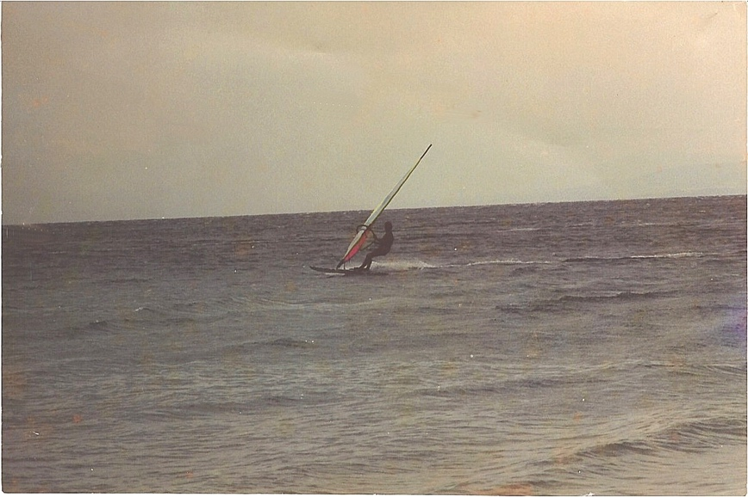

The light in Greece is amazing. We do not get very many “grey days”, as you do in the UK and Holland, because there are very few days with complete cloud cover (and then it is usually raining like hell!). After strong west winds, it is possible to see over 60 miles (100 Km) north over the sea to Mount Athos, The Holy Mountain. In the winter, it is covered with snow, and if you get a clear day with a sunset, it appears to be a pink fairy wonderland emerging out of the sea. The light is constantly changing in Greece, and the sea reflects the colours, making almost no two days the same. Artists have come to Greece for hundreds of years to capture and paint that special light. Strangely enough, there are very few well-known Greek painters, only El Greco, who lived in Spain! However, Greeks are very tactile (they love to touch), and have been tremendous sculptors and woodcarvers.
During the summer months, with the almost eternal blue sky, the light doesn’t change so much. Just at sunrise and sunset. But in the winter, spring, and autumn, you can get tremendous sunrises and sunsets, as the sun plays peek a boo with the clouds. Some sunsets will go on for well over an hour with the colours changing from a strong red, through pink and vermilion to dark clouds tinged with threads of purple. The west end of the island, Banana and Eleni Beaches are the best place to see the sunsets, but also Vromolimnos Beach, which faces west, gets some stunning sunsets too. During the day the sea changes from the classic “wine-dark sea” to clear bright blue, where sand lies underneath, and to an incredible turquoise as the sun dips towards the horizon. The colours on the land in Greece are also amazing. We have a thousand different shades of green, from the dark leaves of Arbutus (Strawberry tree) and citrus fruits, to the ever-changing silver green of the olive trees. We don’t have many deciduous trees, so we don’t get huge swathes of autumn colours, but the grape vines, the plane trees, the various varieties of poplar trees, and the fruit trees provide enough contrast to delight the eye. The ubiquitous pine tree, which covers most of the island, provides a green backdrop to everything. But even these, in the spring, acquire a yellowy orange tinge as the baby pine cones form.
Greece is a place of extremes, especially where weather is concerned. We don’t get drizzly grey weather in Greece, it is either full on sun, or full on storm. The locals (and we are now considered locals as well) leap from shade patch to shade patch in the summer. The idea of spread-eagling oneself to bake for hours at a time just seems crazy to us. However, when you come from sun starved Northern Europe, I can imagine that you want as much sun as you can get, in the (usually too short) vacation time that you have. We, who must work in the heat, avoid the sun as much as possible. When it storms in Greece, IT STORMS! We have thunderstorms that can sometimes seem to come from nowhere, where the lighting is all over the place and often crashes into the sea, and winds that whip up the sea in no time. Sailing here can sometimes be interesting. Usually the thunder and lightning are followed by torrential downpours, but thankfully, these are usually short lived. In the winter however, the rain can piss down for a few days at a time, and our streambed becomes unpassable for a day or two! We also get snow. Always on the highest point of Skiathos (some 440 metres), but every few years we will get a dump even down to the beaches.
Here is one winter when Zoi was just three and Mara not even one year old. Liesbeth, Lida’s sister, is on the left.
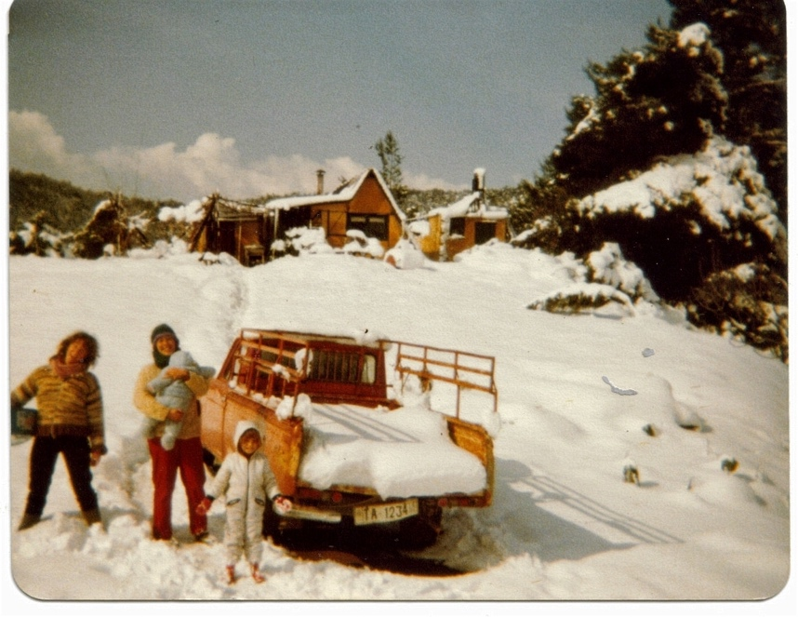
Here is another, more recent, picture as the snow fell on The Barn and the Pool area.
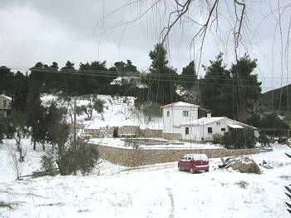

and here is probably our worst snowfall of 2000/2001

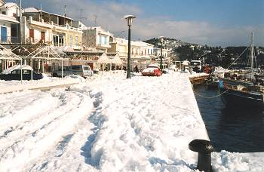

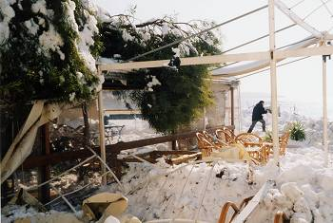

We love the summer, the autumn, the winter, and the amazing renewal of life in the spring. I don’t know of any other place where you get these definite different seasons, and we love the contrasts. Having spent now over 40 years in one place on Earth, being involved with growing plants and trees, and harvesting everything from lettuce to olives, we definitely see a change in the weather. The sun is much hotter than it was, the storms are often more severe, the plants are often confused as temperatures vary wildly, and in general, it is quite disturbing. We all know (though many deny) that our consumer lifestyle and our over consumption of carbon-based energy, is changing the planet, and making things harder for the next generations, but we seem to be at a loss as to what to do about it. Well, we all can make a difference. I am not going to list here all the things we can do to make a change; you can find it all on the Internet. The main thing is that you have to accept that we must change our ways, research it, and then get on with it.

10 - ANIMALS

My lifestyle in Skiathos was to become inextricably caught up with animals of one sort or another.
At Betsy’s, I had to feed and look after chickens, rabbits, cats, dogs and her donkey, known (semi-affectionately) as Donk. I would take her down to the road to carry back my weekly shopping and use her to carry the drinking water that I dipped from a spring in the trunk of a plane tree. She was possibly the slowest donkey in the world and, if I was daydreaming or got wrapped up in the fabulous views from the donkey trails, she would go infinitesimally slower until we had almost ground to a halt without me being aware of it. She loved the spiky tops of a type of thistle that grew along the paths and would suddenly swerve off to harvest a particularly large one. I never really felt that I was in control of her; she just let me use her occasionally.
The second time I stayed at Betsy’s, during the winter of my second year, I also had my own donkey called Francine. I had “inherited” her from Reese and Patti (via American Jeff and Keith and Paula) as they no longer needed her once they had acquired their horses. Francine belied the sweetness of her name by being the most vicious donkey in the world. I had never heard a donkey growl before, but Francine did, and meant it! She was also one of the quickest. She only accepted me as “the boss” after I had lost my temper with her and kicked the shit out of her. After that, she was fine with me but attempted to kick anyone else who got into range. She booted both Adri and Lida’s brother in law (big Dutch men and certainly not midgets!) into the bushes off the trail when she was fully loaded.
I had to gather firewood to heat Betsy’s through the winter and often went down a steep path to the nearest beach to pick up driftwood. Coming back up the path, I either had the choice of having Francine in front (going at a rate of knots) and Donk behind (going virtually backwards) or vice versa. I would either be stretched between the two or crushed between the two, and I sometimes wondered if they weren’t getting some malicious pleasure out of the whole thing.
A little digression here to praise the Greek donkey and horse saddle. It is not great for riding on, except side-saddle, but once you have learned how, you can load almost anything on to one of them. We have carried everything from sand and gravel, bags of shopping and even six-metre-long chestnut beams on our animals. In fact, all the materials for our first house were brought to the site by this means.
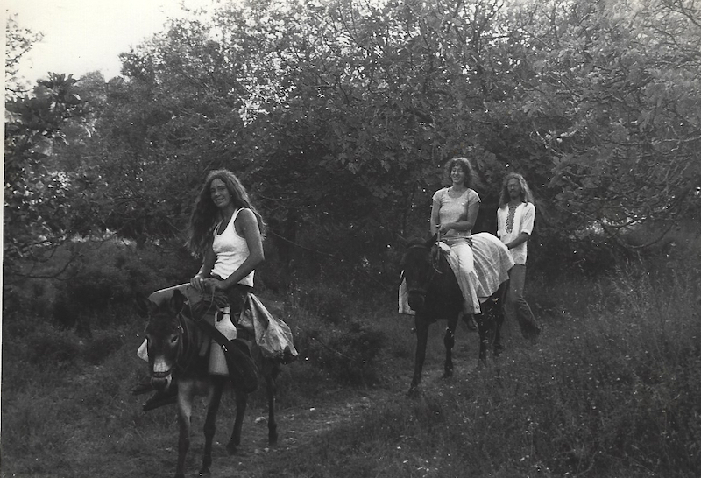
Unknown on Francine, Liesbeth on Mavrika with Paul behind.
By the time I was building this house, I had inherited Keith and Paula’s old horse called Mavrika (“little black one”). She was a sway backed, reasonably sweet natured old nag of indeterminate age, who had an aversion to work and snakes. When she first saw the pile of chestnut beams and pine planks that had to be carried 1 kilometre from the road to the place where we were going to build our house, she rolled on her back and whinnied, “Colic!”. Because she was prone to getting colic, particularly if she ate figs, I believed her and spent the rest of the day walking her around in circles so that her guts could clear. When a horse gets colic (the stomach swells with gas, making it impossible for the gas to escape, with potentially fatal consequences) you have to make sure that they don’t lie down because there is then no possibility to clear the blockage. So, we walked Mavi around and around until, with incredible wet farts, she finally vented the offending (and offensive smelling) contents of her stomach. The following day she tried it on again but this time I didn’t believe her and she carried poles and planks all day without mishap. Whenever she saw a stick or bit of rope on the path, she would refuse to budge until I had taken it away, (therefore proving that it wasn’t a snake) and assured her that everything was OK.
Her true nature was exposed when, returning from sampling (rather a lot of) retsina with a local goatherd, I loaded her (with great trepidation) with 2 sacks of cement totalling 100 kilos. The goatherd said, “What just 2 sacks?” and threw another one on top. I expected Mavi to collapse, but when he clicked his tongue at her, she realised she was dealing with a Skiathitee (and not a bunch of soft foreigners) and ran all the way home.
She used to suffer dreadfully from horseflies during the summer and there was not much to do about them except immerse her in salt water, i.e. the sea. She was not awfully fond of this and, taking her one day to Aselinos (the nearest beach), we provided much amusement for a group of tourists who were sunning themselves on the beach as we struggled to get her into the water. However, when the flies were deprived of their supply of blood as we and Mavi sank slowly into the waves, they decided to head for the nearest alternative source. The last we saw of the tourists was them running down the road being pursued by a cloud of thirsty horseflies.
Francine disappeared when I lent her to one of our neighbours for the winter while we were away in Amsterdam. Upon our return, we were told that she had been lent to my neighbour’s mother on the mainland but would be back soon. Needless to say, she never came back and after some months, I just stopped asking about her. That winter a very basic dirt road had been bulldozed through Zorbathes and we didn’t really need 2 animals any more. In fact, we hardly used Mavi for work anymore, and she spent the last few years of her life eating and relaxing until she finally got a bout of colic that we couldn’t shift, and she died. She had had a good retirement and we missed her, but it was the right time for her to go. I can’t say we really missed Francine as she made Lida and all our friends and guests extremely nervous, to say the least.
At one time or another, most of our neighbours have kept pigs. “Kept” is a euphemism, as they often didn’t have sufficiently strong pigsties to keep them in, particularly if they hadn’t bothered to come and feed them. Our nearest neighbour, who had helped us tremendously in our first years and had become quite a good friend, was driving a taxi one summer and therefore just didn’t have time to look after his pigs (some 30 of them). They were constantly breaking out and often I fed them with grain intended for our goats to lure them back inside. One night, we came back from a party to find that the pigs had broken into our home and had spilled (and drunk) our homemade wine, our olive oil and eaten our homemade bread. There were even trotter marks on our battery-operated record player, and it was obvious that they had been partying too.
I fetched the neighbour the following morning to show him the damage and his only comment was, “Never mind” followed by the Greek shrug that means, “What can you do”. He offered to pay for the damage but never did and our relationship started to deteriorate from that time. It finally reached the point of me threatening to take him to court because his goats (he was into goats by then) were destroying our trees and plants. It seemed to work as his goats disappeared, but we barely nodded to each other for quite a while. You do not threaten someone with court action lightly in Greece! Probably in a few more years we will be talking again and maybe even reminiscing as that is often how things go here.
For several years, we kept a pig ourselves, fattening him up for Christmas with the waste from the organic garden and a supplement of bran, so that we had a source of good, chemical-free meat for the winter months. Two local Greeks had started a pig farm next to our land (fortunately downwind) and, because they had no water, they took water from our old well. In exchange for this, we got a nice piglet every spring. Our pigs always enjoyed a great life, were treated well and became our pets. They are at least as intelligent as dogs and probably more so. We gave them a lot of room to move in and, contrary to popular belief, they are extremely clean animals using only one section of the run as a toilet, and never fouling their food or the rest of their area. Only when man confines animals do things get out of kilter - and then we blame the animals! A bowl of bran was given to them at slaughtering time and they hardly noticed as they were killed.
One of our pigs was constantly bothered by one of the neighbour’s chickens. It used to hang around and pick out the odd bits of bran from his feeding bowl when he had finished. The pig used to watch the chicken with a scowl on his face until finally one day, it all got too much for him, and with one snap of his jaws, he grabbed the chicken and ate her whole, feathers and all!
Some years ago, we had around 140 litres of wine happily fermenting away, and we were licking our lips and rubbing our hands in anticipation, but that was before another of our neighbours 2 pigs decided that they would have a "wine tasting". What happened was that the pigs had escaped and were obviously very thirsty. They arrived on our lawn and were rooting about in the wettest part (where the sprinkler overlaps), when one of them discovered the wine fermenting on the patio and managed to put a neat hole in one of our 25 litre demijohns with its snout. Lida arrived home some time later to find 2 completely sozzled pigs lying on the doorstep! She managed to drive them up the hill to the upper neighbour’s house (with the greatest of difficulty, they were stumbling around all over the place) and shut them in his courtyard. I arrived shortly after and asked what had happened − our "pig-aerated" lawn made it clear something was out of the ordinary. Lida explained and I then realised that the pigs didn’t belong to the neighbour above, but to another neighbour further down the valley. Up we trudged and tried to move the pigs out of the courtyard and down the hill before he came home and discovered them. They were, by this time, suffering severely from the effects of some 20 odd litres of very young wine and were most reluctant to move anywhere. After chasing them around in circles for half an hour, we finally managed to get them going in the rough direction of our lower neighbour and then sat back exhausted from our efforts. We informed him what had happened, and he found the two of them the next day, crashed out under some bushes (presumably with the porker equivalent of a huge hangover!).
In our second year in Zorbathes I took a trip to Volos to buy various bits and bobs and to get a few chickens to start a flock. I went to see one of the chicken sellers, who always gathered outside the railway station with their trucks full of cackling birds. I purchased four hens and asked if he had a good rooster. Of course, he said, he had the world’s finest rooster but unfortunately, it was back at home. I paid him for the four hens and the rooster, and he agreed to take them all to the trading caique that was due to come to Skiathos the next day. When I went to pick up my chickens the next afternoon in Skiathos (it took 6 to 7 hours for the old caiques to make the trip) I found my birds on the deck, almost dying of thirst in the sun and a rooster surveying me with only one eye! He (inevitably) was given the name of Nelson and, in fact, turned out to be a magnificent rooster who kept all his “ladies” in line and all their eggs well fertilised. He just didn’t like it if you “crept up” on his blind side and would get his feathers all ruffled. We gave all the hens names as well, but the only one that sticks in my memory was our first broody hen called “Margaret Hatcher”. Nelson was the first of our chickens to be cooked (this was after his offspring had grown up and supplanted him) but we didn’t realise just how tough a true free-range bird could be. Although we pressure cooked him for many hours, eating him was like eating chicken flavoured chewing gum and getting him down was a real effort. The following day we all had the most horrendous farts, which we christened “Nelson’s revenge”.
We kept goats for quite a few years after we decided to live permanently in Skiathos. Because, officially, we were not allowed to work, we thought that we could generate some income from raising baby goats and selling milk, cheese and yoghurt to friends and villa owners. We slowly acquired a small herd, buying a few goats here and there, and then keeping some of the offspring. To buy Cleo, our first goat, we had gone up to almost the highest part of the island at Katavothros to visit our goatherd friend (the one who had loaded Mavi with the three sacks of cement). He, his wife and daughters lived in a tiny kalivi on a plateau just beneath Karaflidzanaka and Mount Mitikas (at 433 metres, the highest point in Skiathos). They were a “volatile” family and would have screaming arguments that looked like they were going to kill each other but, apparently, that was just a normal way of life for them and no serious violence was done. I had met him in Larissa jail when visiting Keith and Paula before their trial. He was accused of murder (but loudly proclaimed his innocence) and was acquitted at his trial because the only “evidence” against him was that the father of the murdered girl (a neighbouring goat herder) had simply said, “He must have done it!” Unfortunately, he had had to sell many of his goats to feed his family and pay for lawyer’s fees, etc. while he waited many months for his trial. The murderer was never found. He arranged to take Cleo behind his horse to a point closer to Zorbathes where we picked her up, tethered her behind Francine and dragged her (literally) back home. She didn’t want to go off with us strangers and, being a herd goat and never tethered, was not happy with her halter and with being forced to go in a specific direction. All of this took a few days, a fair amount of retsina, a lot of shouting, some singing, consumption of vast amounts of food and some heavy bargaining. We were undoubtedly “ripped off” but the experiences we had more than made up for that. That is the Greeks for you; they will take from one hand while heaping genuine gifts and kindnesses into the other. We next bought another goat, Maria, from one of our neighbours but neither of these two gave a lot of milk. We were told of someone selling a “super milker” in the next valley over. When we went to look at her, she obviously had hard large udders with a lot of capacity, so we thought she would be a good addition to the “herd”. However, she also had a swelling on one of the udders, but the seller told us it was “no problem”, so we bought her. (When a Greek says, “No problem”, watch out!) We called her Gertie, the same name as one of my grandmothers, but they bore no resemblance to each other. Gertie indeed produced a lot of milk, but the swelling on her udder kept getting bigger and bigger! I didn’t know what to do but thought I had better ask Barba Mitso who was our fount of all knowledge regarding husbandry.
Barba Mitso and his wife Elena − the only other people living in the valley − were an old couple who kept around 20 sheep, a goat or two, a few olives and a vineyard. Barba means uncle in Greek but is also a term used for older people who you respect but who are not relatives. They were completely uneducated and illiterate and Elena, who was mostly sweet (but could be fearsome), was fairly simple in her thinking. Her idea of explaining something that we could not understand was to shout it louder and louder until we nodded and smiled, as if we did understand. Barba Mitso was cleverer and would see immediately that we hadn’t comprehended something, and would search for other ways to describe what he wished to get across to us. As we were desperately learning how to live the kind of life they had lived for all their lives, we were constantly asking them many things. He would come by with his sheep and, with a twinkle in his eye, ask us what on earth we were up to now, as we tried to master another facet of self-sufficient living.
Many evenings we went up to their kalivi to sit in front of the fire and listen to their wisdom and folklore. The kalivi was about 1.5 metres wide by about 3 metres long (in other words, tiny) but they lived in there quite happily. Sometimes, when their son and family came to stay, there would be 6 bodies inside! A fireplace took up one corner and it was here that Elena did all the cooking on an olive-wood fire. A small round table took up most of the rest of the space between the bed and the fireplace, but this could be hung on the wall when extra room was needed. Seating was on skamnakia, traditional low wooden stools upon which one squatted rather than sat. Whenever we visited, a cup of Greek coffee was brewed in the traditional style, which meant that the water was first boiled, sugar and the finely ground Greek coffee were added. Then it was slowly brought to the boil again, inspected and brought to the boil one last time to get a “cream” of bubbles on the top. This was then poured into tiny cups and the first sip had to be drunk with a slurp followed by a long “Ah!” of appreciation. (Although Greece is a very relaxed place and very informal, this coffee ritual is probably as important to Greeks as the Japanese tea ritual is to the Japanese. It certainly used to be. Nowadays, in the cafes on the waterfront, “Greek” coffee is often made hurriedly, using the steam-heated water from the espresso machine and bears no resemblance to the real thing. Look for the place where all the locals are drinking coffee early in the morning, that’s where you will get the genuine article.)
Barba Mitso would always listen to the news on a battered transistor radio (their one “luxury”), give comments on it to Elena and try to describe really important bits to us. Things like, “The Turks are up to no good again!” were easy to understand but the ins and outs of Greek politics were completely beyond us.
Elena showed us how to do the weekly wash by taking a large kettle down to the vouthana (pool) in the streambed, filling it with water and heating it over a fire made from dry twigs and branches that lay beneath the plane trees. Once the water was hot, it was put into a large wooden tub with sloping sides where the clothes were scrubbed. Rinsing followed and the clothes were wrung out by hand then taken to a breezy spot to dry in the wind. One year we bought a wringer (operated by turning a handle) from Holland, and this was considered the height of sophistication by Elena (but denigrated as not really being “up to the job”). Once, as I was stoking the fire for hot water, Elena told me that Lida was a “good woman” and that if I were to mistreat her or run away, she would find me and shoot me with Mitso’s (very old) shotgun! Needless to say, it is only this threat that has kept me together with Lida all these years ;o)
Being a shepherd and having lived around animals all his life, Barba Mitso was our source of information about all aspects of keeping animals. We learned from him and Elena how to feed goats, milk them, help them to give birth, make cheese, yoghurt and other milk products from their milk, and generally everything else that went along with animal husbandry. We always consulted him when our animals looked poorly and he usually had some herbal remedy to suggest or, in some cases, would tell us not to worry. The strangest “cure” he used, became known to us forever as “the day Barba Mitso blew up Gertie the goat”. As mentioned before, we had acquired Gertie from an acquaintance of a neighbour, and she was a good milker but had a slight swelling on one of her udders. Over the course of time, this swelling grew and we started to become concerned, even thinking that it might be cancerous. Barba Mitso was called in, took a look and said, “Go to the Pantopoulio (little shop that sells everything) and get a hoofta (handful) of barouti.”
When questioned about what barouti might be, he was either unable or unwilling to explain it to us. Off we went to the Pantopolio and when we asked for barouti were given a small paper bag with half the contents of shotgun shell, the gunpowder half! “This is barouti?” we asked. Yes, that was barouti. We took it back to Barba Mitso who then asked for a plate and some matches. Everything was taken to Gertie’s stall and he told us to hold her head. He placed the plate under the udder with the swelling and then took out his knife. “Oh my God”, we thought, “he is going to cut her open!” But no, he merely used his knife to make the sign of the cross three times in the air, next to the swelling. Then he sprinkled the gunpowder in the plate underneath Gertie, and we thought, “Oh my God, he is going to blow her up!” Suddenly he lit a match and threw it on the gunpowder. We expected an almighty explosion (forgetting that gunpowder needs to be compressed to explode.) There was simply a flash and a large puff of smoke (rather like the original flash guns for cameras) and the three of us (Gertie, Lida and I) leapt up in the air in surprise. He then gave us his toothless grin and said, “She’ll be fine now.” A few days later the swelling broke open and the fluid inside began to seep out. The ignited gunpowder had singed the skin of the udder (but not hurt Gertie) and made it brittle enough to stop it stretching and so allowed it to open naturally. We merely kept the wound clean and within a week Gertie was back to normal, with only a small scar to show for her trials. We, however, were traumatised for life! This became known as, “The day Barba Mitso blew up Gertie the goat”.
We borrowed the use of a Billy goat in August and he impregnated the three goats. When they gave birth, we decided to keep Gertie’s two kids. We named them Titi and Nou Nou, which were the brand names of tinned, condensed milk that the Greeks often bought. As she was a good milk goat, we thought that they should be too. Cleo only had one kid, but as it was a female, we decided to keep her as well. She was so frisky that we called her, Fjolla, which is Danish for, “a little crazy”. She turned out to be well named. Maria gave birth to two male kids, so I sold them to a local butcher. To be sure that we were paid the right price per kilo for these, I had to be there when they slaughtered them and weighed the clean amount of meat. I had never witnessed this before and it wasn’t easy for me to see, but it had to be done. In fact, it was a quicker, cleaner process than that which happens at most slaughterhouses, and the animals were not frightened in any way. I didn’t take any of the meat that time round, but we have subsequently eaten lots of meat from animals we have raised ourselves. I firmly believe that people who like to eat meat should visit a slaughterhouse at least once, so that they know what an animal has to go through before it appears on their plates. I am sure we would have many more vegetarians if they did that. The following year, Fjolla, who was then a mature goat, gave birth to a single male goat who we named Josif. Unfortunately, Josif wandered into Gertie’s stall immediately after his birth and got Gertie’s smell on him, so Fjolla would have nothing to do with him and was even butting him quite hard to push him away. Gertie wouldn’t suckle him either(she had two of her own to feed), so we had to hand feed Josif using a bottle with Fjolla’s milk. This was fine except that Josif thought he was a human being, not a goat. He would follow us everywhere. This wasn’t a big problem when we were around the house or working on the land, but as soon as we set off down the path to get to the car to go to Town, Josif would follow. We had to take him close to where we had tethered the other goats to graze, wait for a while until he was busy eating, and then try to sneak away without him following us. Several times, we had tip-toed out of our land and thought we were OK, only to suddenly hear Josif’s bleat as he caught up with us. We then had to repeat the whole process of taking him back to the other goats, waiting for a while, and then trying to tip toe away again. Oh, what it is to be loved! Of course, our neighbours thought that we were crazy and that we should just tie him up and be done with it, but his pitiful cries at being left with the other goats as we walked away were just too heart wrenching, and we just couldn’t bring ourselves to do it. Eventually, like nearly all young male animals, he had to be slaughtered, but it was a difficult one for us all.
One winter, when we were away in Holland working and friends from New Zealand were looking after the farm, Maria managed to get her rope around a tree and then around her neck, and then strangled herself. This happens sometimes and it was not Mike and Lynn’s fault. However, upon our return, I determined to make part of the barn a proper goat shed and make a large outside area in which they could run free. I made an ingenious system (something I’d had seen in France) which trapped the goat’s heads in while they were feeding. They could then be milked with ease and were quite happy as long as there was some hay or bran in front of them. We used to leave them in there feeding for an hour, in which time I took the milk up to house and tied up some fresh bushes for them to browse on. Just occasionally, when we had company and the wine started to flow, I would forget to let them out until one if us suddenly realised, with a start, that the goats were still “in”. When I finally went to release them, the looks I got were withering! As they weren’t allowed outside their pen, and I no longer wanted to have any tethered goats, I had to cut wild bushes and bring those to them so that they would have some fresh food to browse on. In spring, summer and autumn, this was usually a pleasant job and I would go up into the hills every day, cut some branches of the wild scrub, and bring a bundle back over my shoulders. One bundle was more or less enough for one day. However, in the winter it was no fun at all, cutting bushes with water dripping off them and rain or snow trickling down my neck. Whenever there was a fine day, I would take Mavi up into the hills and cut as much as she could carry, so that I had enough for bad weather days. It didn’t always work and there were still some times when I found myself hacking away at the bushes in the rain and wind, wondering why we ever though that goat keeping could be fun! The goats also loved the prunings from the olive trees and, as pruning was a wintertime job, I could do a couple of trees a day and keep the goats happy with lots of fresh green. The Greeks say that the olive tree was a gift from Athena, the Goddess of Wisdom, and was one of the finest gifts that could ever be given. Olive trees will grow on marginal land where not much else will thrive. Cured olives are delicious and an excellent source of food and vitamins. Olive oil is, of course, one of the best oils in the world. However, the tree also produces food (in the form of prunings) for goats, sheep, mules and donkeys, and olive wood is one of the best woods for burning as it also has oil in it which makes it burn brightly. When burnt, it leaves excellent coals on which to barbeque meat and fish, and one of the typical smells of Greece is this special barbeque aroma. Thank you, Athena! Wily old Dionysus, however, gave the Greeks the grapevine so that they could get high and he could take advantage of the women! But I digress. Goats have a bad name for being very destructive. It is true that they can survive on almost anything, but they do not choose this naturally. In nature, they are browsers and move along just nibbling here and there, not ever taking enough to kill a bush or shrub (their favourite food). However, if they are confined, having nothing else to eat except what is in that confined area, hunger will drive them to eat everything there. As usual, it is man that creates these sorts of situations, but it is the goat that gets the blame! A corollary can be drawn here, where the poor of this world are confined (by economic constraints) to virtual ghettoes, and end up destroying their environment and themselves (with drugs), because they cannot get out. The well off then give them the blame for this destruction and make being poor some kind of disgrace!
We eventually gave up the goat keeping once we had a good source of water and could plant a commercial market garden. We still kept a couple for a while, but you have to be there for them night and day, and have to milk them on a regular schedule, otherwise their milk will start to dry up. This, plus the cheese making, was an incredible tie, and as our girls grew older, we wanted to decide for ourselves what we would do with our time. To make cheese doesn’t require a lot of effort, but you have to do things throughout the day at regular intervals, so it also keeps you tied down. We started to understand why the average peasant, given half a chance, would give up living on the land and go and work in a factory for 40 hours a week AND have a few weeks holiday as well. If you have animals and are trying to be self-sufficient, you never stop! We stopped keeping chooks (as the Aussies and the Scots call them) after a while because they started eating their own eggs! It was our fault for keeping them too confined, but we didn’t know that at the time. Now we keep chooks again but give them a large area and move them 4 times a year so that they always have some greens and good scratching. We also keep them well fed and they produce eggs all year round (much to our neighbour’s surprise and exasperation; theirs tend to stop laying when it gets too hot or too cold).
Barba Mitso also kept bees and offered to teach us beekeeping. I was game for anything, and besides, I love honey! I built a wooden hive using an old one as a template, and then Mitso divided the bees in one of his hives, just before they would naturally swarm, and put them in our hive. He often worked with the bees without any protection, just using smoke to calm them, and never seemed to get stung. However, when he took me to our hive to “introduce me to the queen bee” as he put it, I was so nervous that it upset the bees and he got stung quite a bit. “You are not for bees!” he said, and I admitted that I didn’t think I would ever be comfortable around them. We gave him our hive and he gave us some kilos of honey the following year although we had done nothing to deserve them.
We have always kept cats. I love them and their independence. We are not sure who the “bosses” are, but I suspect it is the cats! We also had a couple of dogs we inherited from people that left the island. One was a Skiathos street dog called Lady and was one of the smartest animals I have ever met. We looked after her one winter when her mistress, Eleni, went back to Australia for a few months. The first day with us, she disappeared. I went to Town the next morning (some 10 kilometres away) and there she was, waiting outside the garden gate of Eleni’s residence. I put her in the car and brought her back to Zorbathes. She disappeared again and the next day we went through the same routine of bringing her back from her home. She then understood and stayed with us for the months that Eleni was away. Not having telephone in those days (let alone email!), we had no exact idea when Eleni was returning (but Lady did!). We woke up one morning and Lady was gone. That same day, Eleni returned to find Lady sitting outside the garden gate waiting patiently for her. How she could have known when Eleni was coming back, we never figured out, as she could not have picked up any subliminal clues from us. When Eleni finally left to go back permanently to Oz, we agreed to look after Lady, and she lived with us for her last years and was the perfect house animal. Never a bother, but always there to guard the house and kids, and always grateful for any attention bestowed upon her. I love dogs but find that their demands are too much for me. They give a lot, but need a lot, and you cannot just go off and leave them as you can with cats, as they are “bound” to you, and I find this too claustrophobic. Our cats take our absences in their stride, and as long as someone comes to feed them, they don’t mind at all. Lady was one of the few dogs who was totally devoted, but never made me feel tied down. She finally got a terrible infection in her mouth and we discussed how to put her down with Liesbeth, Lida’s sister, who was a nurse. There were no vets on the island at that time and Liesbeth suggested getting Lady to eat lots of Valium so that she would just drift off. We managed to get the Valium down her without problems but shortly afterwards, she disappeared. We never found her or her body. She must have known that it was “time” and disappeared somewhere to die quietly.
Our other experience of inheriting a dog was not so good. His name was Podger and he came originally from Iran. He was not a bad dog but was very nervous and known to bite when he felt threatened. It meant we could not keep him in the house (he had tried to bite Mara who had simply stumbled over his tail) and had to keep him tied up outside. I took him for a walk every morning and evening but did not dare let him off the lead. This was no life for any of us and we were quite relieved when he finally got too old to live comfortably and we had him put down.
We still have cats and chickens. We tried to keep a pig one year, but it was not a great success, and Lida has decided that we should be happy with what we have…... so I am!

11 – FUN
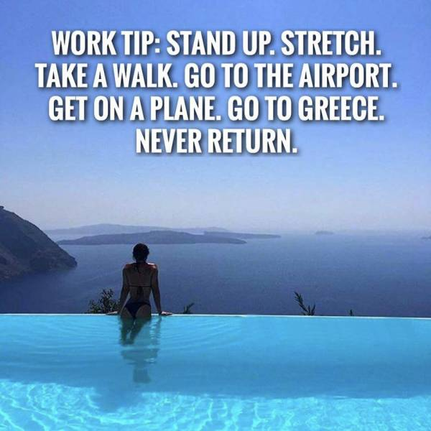

Whatever we have done, one of my prime motivations has always been that it had to have some element of fun attached. Even hard physical work can be fun if you are sharing it with someone who has a good sense of humour and you can laugh at each other's jokes or ribbing. Initially, it was great fun just living here and learning lots of stuff with like-minded people. The local Greeks also have a great sense of humour and fun, and love to rib each other, although sometimes their ribbing can include a nasty element of putting people down. However, most Greeks can give as good as they get, so that is not usually a problem. I love to laugh, have a slightly bizarre outlook on life and usually manage to see the funny side of almost all situations. I have found that if you can share a smile or a laugh with someone, it makes life so much better. I have always looked for what I can share with other people, especially the first time I meet them, and this has worked well for me. I have seen other people looking for what they can dislike in people they meet, and have always felt that their lives are poorer for that.
For the first time, I learned to enjoy water even though, when I first arrived, I could not swim. I taught myself to float on the beach below Betsy’s and eventually found myself swimming one day, after consuming a fair amount of wine and losing my inhibitions. Another hurdle crossed! I am still not fond of water and do not swim for pleasure, but throwing a ball or Frisbee around while standing up to your waist in the warm sea has to be one of the nicer things in life. Initially, I wasn’t very fond of boats (just in case they sunk), but once John had introduced me to windsurfing (where you are, more or less, attached to an unsinkable piece of plastic), my relationship with the sea and wind took off. We started windsurfing at Troulos Beach where John had the use of a plank belonging to a villa owner. When John was out on it, I would walk along the beach to the water sports school and ask Fotis, the owner, if I could take out one of his. He never charged me for this, perhaps reckoning that I didn’t have any money in any case, but probably working on the old Skiathos principle of, “I rub your back, you will eventually rub mine”. Mike, who had taught windsurfing for a couple of years from Koukounaries Beach, agreed to sell me his board and rig which was quite up market for that time. However, the first time I took it out, the wind was too strong for my limited technique and Mike came out in a friend’s boat to rescue me. He then jumped on the board and sped off yelling, “Whoopee!” However, I was hooked, and for the next 15 years or so, wind dominated our lives. The next year we went to Platanias (Aghia Paraskevi) Beach and windsurfed from there but the wind was offshore, and when it got quite strong, we would have great trouble getting back in. Once, I was sitting on my board in despair as the wind had blown me out to the level of Vromolimnos Beach (from where it was really quite difficult to get back), when this blond haired German went screaming past me on his windsurfer. When he next came by, I shouted, “I can’t get back.” To which he shouted back, “I broke my verdammt best board!” When the wind started to blow as John and I were working in the garden, it would be a mad rush to get to the beach before it dropped (which it usually started to do from 13:00 onwards). Lida would sigh but get the girls ready, and we would be off as soon as everything (or most of it) was picked. John and I kept our boards at Vromolimnos Beach that year, under a pine tree next to the taverna. The wind there was cross-shore, and at least we didn’t have to struggle so hard to get back. We were a bit more proficient by then, but were still in the learning stage. One day, after we’d had an excellent strong but steady wind, the German guy turned up at the beach with a sail over his shoulder. He and his family had been on the ferry from Volos when the wind was good but now it had died down, as per normal. He dumped the sail on the sand with a sigh and I thought, “Here’s a man I can understand.” I began to talk to him and we hit it off immediately. He subsequently became my main windsurf guru. Wolfgang was a judge and his wife Ulli a French teacher, which meant they got good long holidays. They came every year, with their son and daughter, for 4 weeks. I followed him around on my old-fashioned plank, and learned a lot by watching his technique and then asking questions. This is the way I have learned everything; by watching, doing, making mistakes and eventually learning to get it right. School was a complete waste of my time – learning something by rote to get past exams was an anathema to me. Every summer, at the end of Wolfgang’s holidays, I would buy some of his windsurfing gear so that I could advance a step or two. Bigger and better sails, smaller and shorter boards were haggled over, until mutually satisfactory prices were reached. I never had much money to invest but he was always keen to move on to the latest gear, so we usually managed get an agreement. Eventually we moved from Vromolimnos to Banana Beach where the wind was cross-shore, blew clean (no headlands to disturb it), and where there were waves! Wolfgang was always better than I was (in fact his son Nicki surpassed me when he was still a teenager), but we always had tons of fun. Angelis, who ran the water sports concession and was also a lover of windsurfing, tells me that he will never forget passing me in the opposite direction one day when I screamed out, “This is the life!”

Windsurfing at Vromolimnos

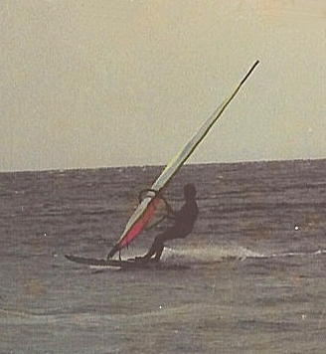
I came comparatively late to windsurfing, I was already close to 40, so I never became one of those kids leaping into the air with their boards and performing somersaults and the like. I was happy if I could get the board to just hop out of the water for a second or two. But I derived huge amounts of pleasure in going out in winds that kept most motorboats, ski jets and the like in harbour, and scudding across the water and hopping off the wave tops. John − my partner in the garden at the time − and I both became windsurfing fanatics. If a good, strong breeze got up while we were picking vegetables, weeding, or watering in the garden, it would be down tools and off to the beach. Fun was more important than earning a living!
I also enjoyed sailing and, when given the opportunity, went out with anyone who needed a crew. John (another John, Irini’s husband) had bought a solid 4.5-metre sailing boat for himself, and so that his kids Alexis and Phaedra could learn to sail. We made a deal that I would look after it, put it in and out of the water at the beginning and end of the season, and have the use of it when he didn’t need it.

Here she is

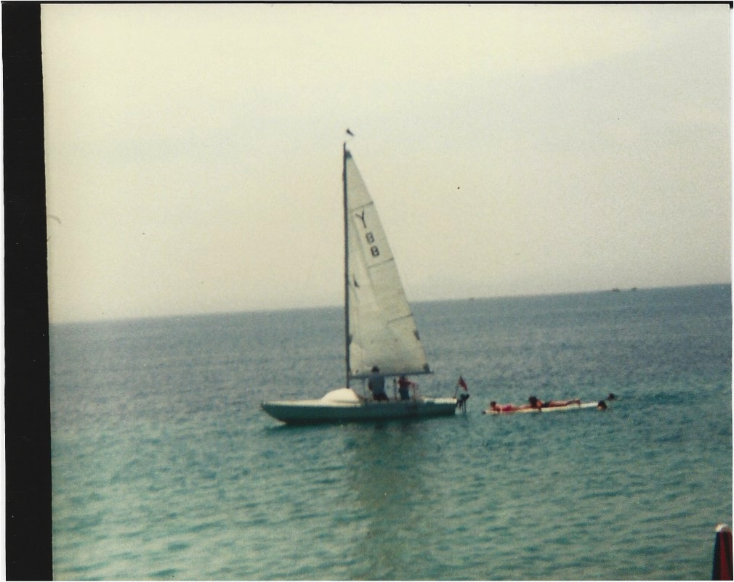

I had done some sailing before, but this boat taught me a lot. It was the first boat that gave me enough confidence to go out alone with. Windsurfing gives you an understanding of wind on the water, but a sailing boat is quite a bit more complicated.
Eventually, I had to give up windsurfing, as it is a sport for young, agile bodies (you need to dance on a board) and mine was no longer like that. At the time that my parents died, we looked at the possibility of buying a sailing boat. Nothing big, just something that you could sail to the mainland, or Skopelos, and back in a day. Coming from windsurfing, I had always liked the idea of a catamaran, as it seemed a waste of energy for a boat to heel over, thus losing power. On the windsurfer, when a gust came along, you’d simply sheet in and go faster, so I wanted a boat with which you could do something similar. Obviously a catamaran, but one that you could sleep (or camp) on. There were no catamarans for sale in Greece in the size I wanted, so I went to the UK that winter to see what was available. I had been in touch with a broker on the south coast, but I didn’t like anything he’d shown me. On returning to his office, I was ready to give up, when a young English couple Chris and Philippa came in and said that they had a catamaran for sale. I said, “Let’s have a look at it.” It was many miles away, but they agreed to take me then and there, as I explained that my time in UK was limited. As soon as I saw it, it seemed to be just what I was looking for. It was almost 8 metres long and a non-standard 5 metres wide, based on a Woods design and called Merlin.

Merlin at Vromolimnos

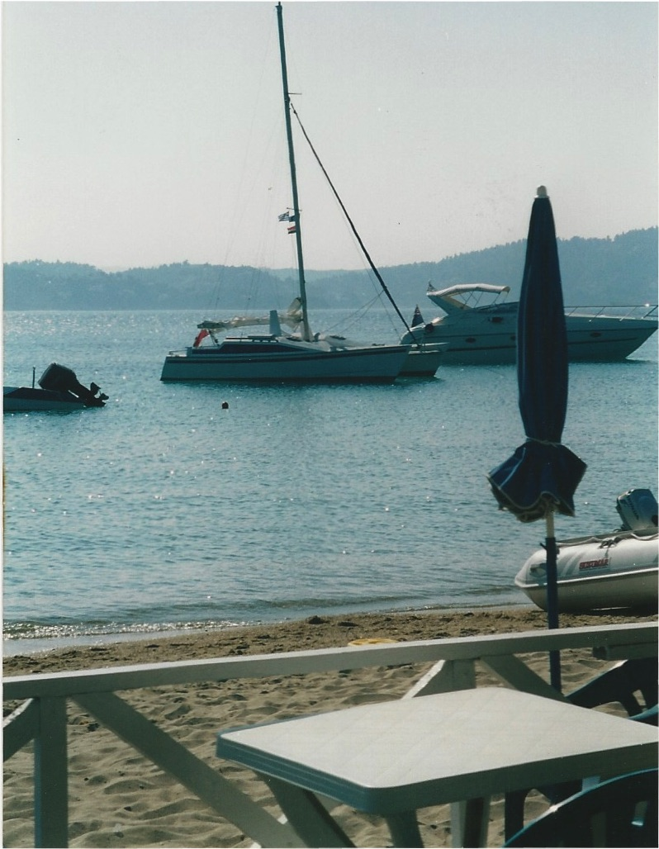

At Tsoungria

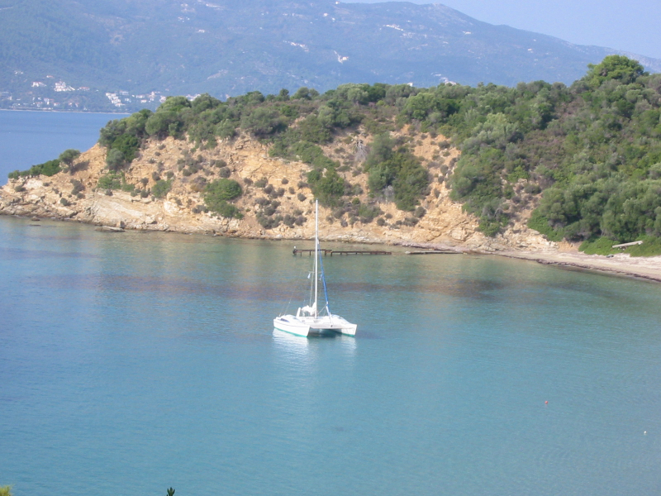

Apparently, the couple who first built it had asked Woods if they could put a taller mast on it. Woods said they could, provided they make it a bit wider to compensate. My problem was that it was in the UK, and I needed it in Greece. So, I suggested I would buy it at the price they were asking, if they were willing to take it apart, put it in a container to Greece, and come out and help me put it together again. I said that they could stay in one of our houses, and once it was back together again, they could take it off for some days, sailing around the beautiful Sporades Islands. They jumped at this offer and we went back to the broker to do the paperwork. In the spring, the container arrived in Pireaus and I went down to collect it. I had to pay some import duty (and a lot of bribes) but a specialist company at the port arranged all that for me, so my hands were not dirty! I just had to keep shelling out one thousand Drachma notes! We put the container on a lorry for Volos, and set out. I have never been so frightened in my life! The driver just kept his foot all the way down, going past every other lorry on the road and only stopping to pay the tolls. I was so happy to arrive in the Volos boat yard in one piece. In the meantime, Chris and Philippa had flown out to Skiathos and taken the ferry for Volos. They met us at the boatyard, and with the help of the driver and his mate, we unloaded the container. There was some slight damage to the side of one hull, nothing really major, but the mast has been damaged a bit and part of it needed welding. Finding someone who could weld aluminium in Volos was not easy, but eventually I managed to get someone to do it. Chris and Philippa had labelled everything when they took the boat apart, and this proved invaluable when re-assembling it. The most difficult thing was to step the mast as it was very long and lots of power and leverage was necessary to get it up. Chris said that they had originally winched it into position using the topping lift and the spinnaker halyard, once it had been propped up at a sufficient angle to get some leverage. The three men who ran the yard said they could do it with a long rope pulling at a shallow angle, so I went with their idea. Well, with Chris and I guiding it from underneath, they got it up about halfway, when one of them lost his grip on the rope. The other two, realising that they could not hold it, just let go! The mast came crashing down, grazing Chris’s shoulder and damaging the track a bit. Chris was livid, and it took all my tact to get him to come back to try again. This time we used his method without any problem and finally had the boat assembled. To launch the boat, we fitted trolleys under the two hulls, which were made from angle iron and glass fibre. It was fairly easy to manoeuvre it on the trolleys, so we pushed the boat down the launch ramp ourselves. Chris would have nothing to do with the yard workers by then! After it was bobbing on the water, we took the trolleys apart and put them on the netting at the front to transport them to Skiathos. After two nights, we arrived at my mooring at Sklithri Beach. Chris and Philippa sailed off into the sunset, and returned 4 days later having had one good last trip with Merlin.

Here she is

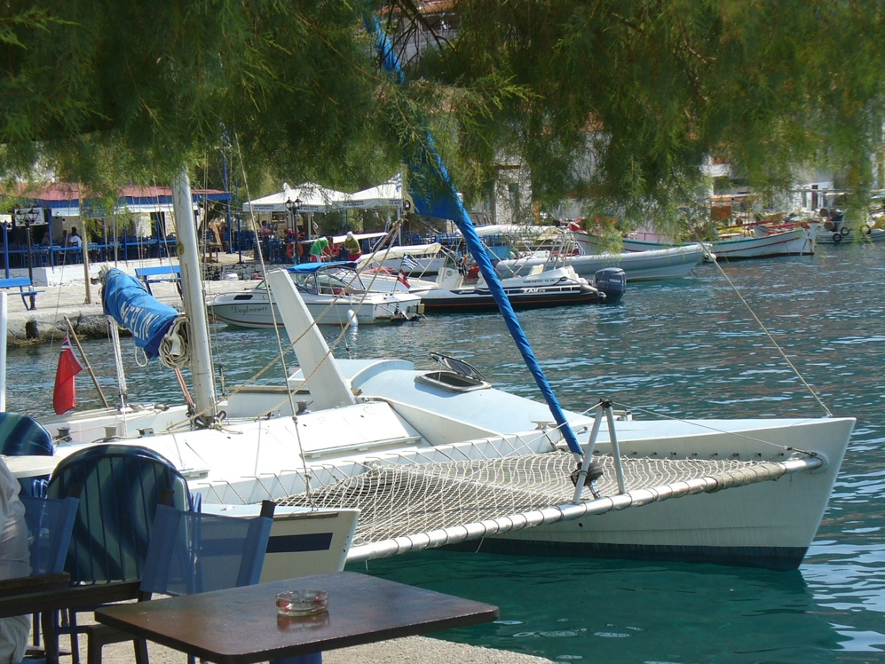

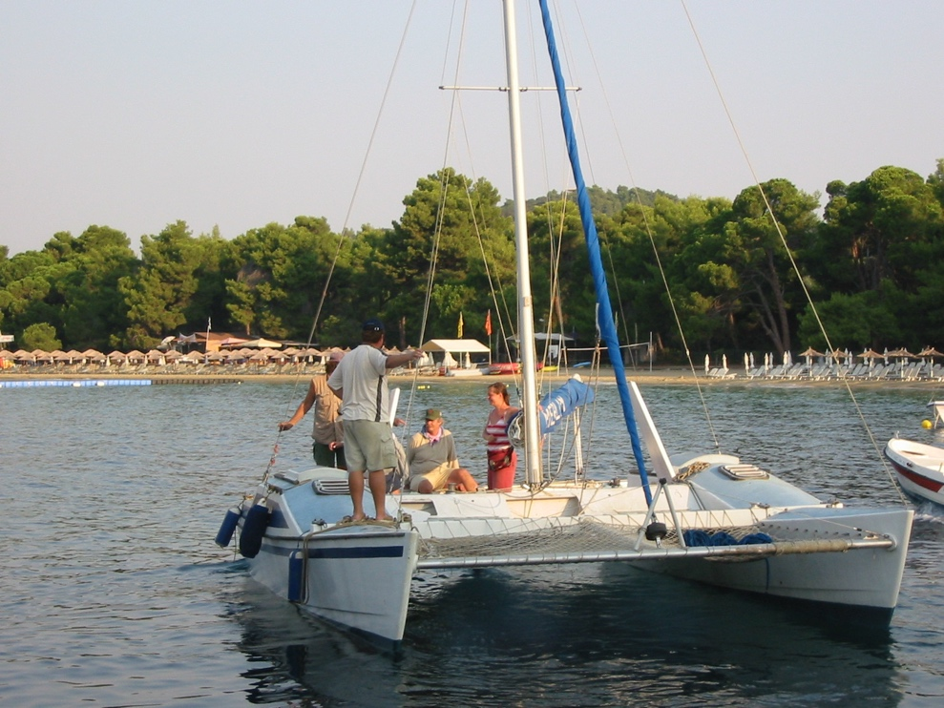

and with Keith on his final visit to Skiathos

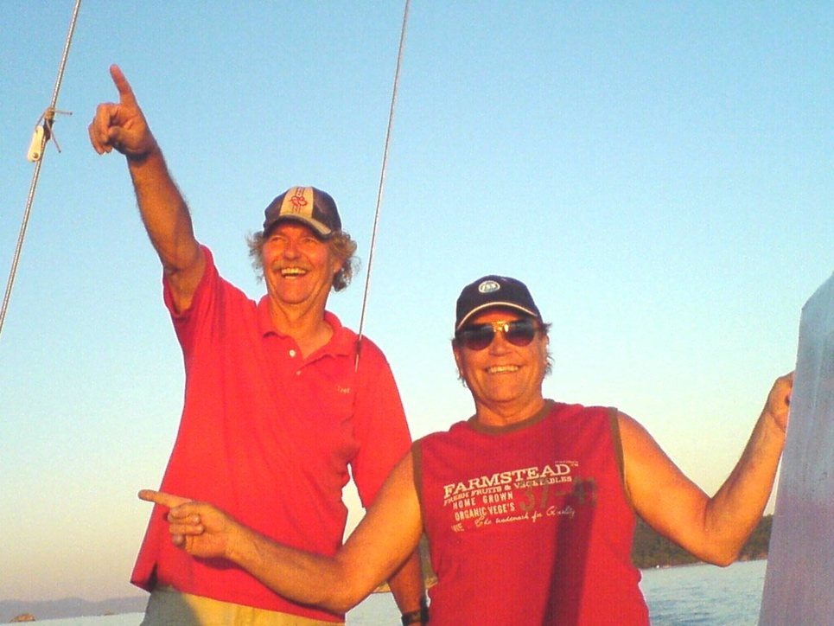

We had many years of fun, sailing her all around the offshore islands, Skopelos, and the mainland. I even started doing day sailing trips with her (long before all the yachts who are now doing it on the Skiathos New Harbour). She was a great sailing boat, and given a fresh wind, she would go like the clappers. She was a safe boat, and we often went on trips with 6 to 8 people. With her dagger boards withdrawn, she had hardly any draft, which meant we could get into small bays and pull up to beaches where normal sailboats couldn’t go. The one problem with her was her width. When we wanted to take her onshore for the winter and the yearly maintenance, it was hard to find a place to pull her out, and even harder to find somewhere we could keep her for 6 months. We kept her in several places onshore over the years, but we never had a specific place.
The last time we took her out of the water was at Koukounaries Harbour, where the ramp was just wide enough to take her. Unfortunately, there were high tension electric cables running across the car park area where I wanted to leave her. We managed to pass under them, prepared her for the winter and left her until spring. After the usual maintenance in the spring (painting, etc.), Jacques and I, with several friends, started to push her back towards the ramp. The VHF aerial on the top of the mast touched the cables (or got close enough to them for the electricity to arc) and 22,000 volts(!) came down the mast. Whether we took a different line, or the cables had sagged a bit with the very warm spring we had that year, no one knows. Only Jacques and I were holding anything metal, and that was an aluminium cross member, but we both got bad electric shocks. Jacques about a third, and me about two thirds. I think if only one of us had been holding onto something metal, he would be dead. Fortunately we shared the damage. We both had burns, but the worst damage was in our feet where the electricity grounded itself. Jacques toes were burned, but they recovered. I was helicoptered to a hospital in Athens and eventually two of my toes had to be amputated. I spent 7 weeks in hospital and Lida was flying back and forth to Athens twice a week, trying to tend to me and run the villa letting at the same time. However, we all survived, and can only thank the gods for that.
That episode was not so much fun! We hadn’t used Merlin that much in the previous few years, and this accident made me decide that it was time to sell her and move on. We had less time in general (as I was working quite hard as a real estate broker throughout the summer) and thought that a motor boat would suit us better; we could get more quickly to the places we liked. Dimitris, a friend of ours from Volos, had always said that he would like to buy Merlin if I ever wanted to sell her, so I decided to take him up on his offer. We repainted her (she had been left in the car park for a couple of years), got her under the cables (with the mast down this time), launched her, and Dimitris and I sailed with some friends to Milina (half way to Volos) where Dimitri intended to keep her. I said my sad farewells to her and Dimitri drove me to Kadi Yiorgi where Jacques came with his motor boat to pick me up. We had a meal and some wine there and then came back to Skiathos.
The following year, I bought a RIB from Eric, a good Dutch friend of ours, as he wanted to get a bigger one. It was 6.5 metres and had a huge 225 HP engine on the back. It was a bigger engine than I wanted, but it was also nice to have some reserve power, just in case it was needed. With this, we could get to the places we liked to go within a half hour, an hour at the most, so we had more possibilities even though I had less time. It was called a Joker Boat, made in Italy, and as I liked the name Joker, that was what it became. I like to joke and laugh, so it seemed appropriate.
Here she is

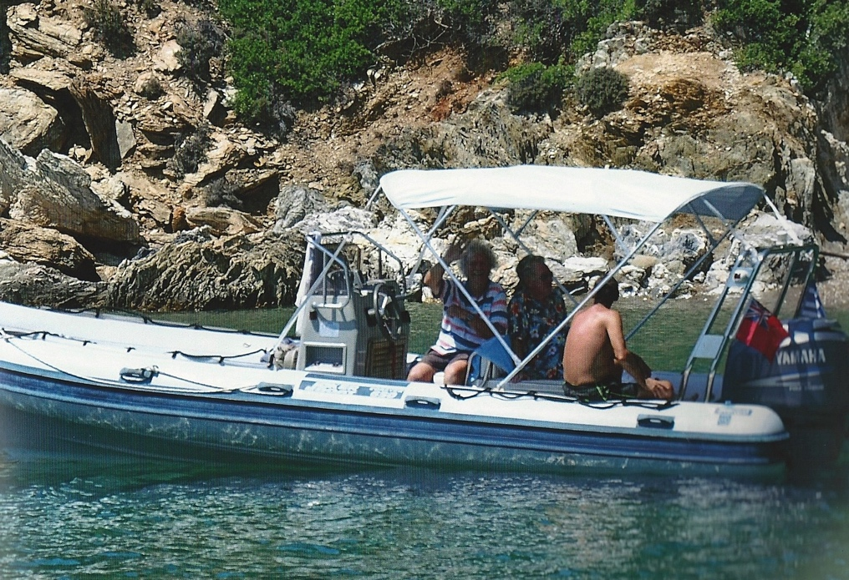

12 - Skiathos and the Greeks
Skiathos is a beautiful island, far greener than one would expect a Greek island to be. It gets a lot of rain in the winter (and sometimes, snow) and this helps to keep it green. Where it has not been cultivated, it is covered by a thick forest of Aleppo Pine trees under which grow (mostly) Arbutus and Tree Heath shrubs. Because of all this growth and the hot, dry summers, Skiathos can be prone to forest fires and it has had more than its fair share in the 40 odd years that I have been here. More on this in the chapter titled, “Fire and energy”.
Skiathos is not a big island, some 12 kilometres (7 miles) long and 6 kilometres (4 miles) wide on average. The highest peak at 433 m (1,421 feet) is mount Karafiltzanaka (39.1904°N 23.4685°E). It has roughly a skewed diamond shape. Here is a satellite image showing Skiathos and its offshore islands:

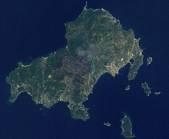

Skiathos is blessed with some 26+ large, sandy beaches and several more tiny beaches, many of which are only accessible by boat. They range from kilometre long, white sandy beaches, fringed with pines to smooth, white stone beaches, with beautiful clear water and towering cliffs behind. It also boasts a comparatively safe harbour and some offshore islands that also have large sandy beaches. There is an old story about the Skopelitees whose harbour, being exposed and north facing, who were jealous of the protected harbour of Skiathos. It goes like this:
Skopelos harbour is exposed to all the bad northern winds and often shut in the winter, whereas Skiathos has a good natural harbour and several offshore islands that protect it. In times of heavy weather and storms, freighters and small tankers shelter in the lee of Skiathos and are perfectly safe. One day (the story goes) the Skopelitees decided to go out with grappling irons to drag off the largest of these islands, Tsoungria, and place it in front of their own harbour to protect it. They plaited ropes out of goat gut (there used to be many large herds of goats on Skopelos) and set out to drag the island back home. The Skiathitees got word off this plot and discussed it at length. Finally, they decided to swim out and attempt to defend their property. Then someone realised the danger in the situation, "Oh! Oh! We might sink, having holes in our bottoms!" After some discussion of this grave problem, somebody came up with the brilliant idea of stuffing up their holes with a wad of cotton. This they did, and swam out heroically, drove the Skopelitees off, and saved Tsoungria. Since that time, The Skopelitees refer to the Skiathitees as Vamvamkokoli (cotton arses) and the Skiathitees call the Skopelitees, Katsikathes (goatees).
Another Skopelos myth is one associated with Saint Rhiginos who is reputed to have killed a dragon at Panormos Bay on the south west coast of Skopleos. Michael Carroll describes this in an excellent book he wrote in the early sixties, capturing a similar feeling he had for Skopelos to the one I have for Skiathos. The book is called An Island in Greece: on the shores of Skopelos (available from Amazon). I often used to sail over to Panormos Bay (which has to be one of the lovelier spots in the Aegean) and always think of Saint Rhiginos chasing the dragon around (or vice versa, of course).
Skiathos has its own myth of the Icon of Kounistra, and how it was found. Apparently, an old hermit living in the valley of Zorbathes (in what we think was the old kalivi on our land) saw a light in the pine trees on the ridge, above the valley. When he went to see what it was, he found a Holy Icon swinging on a tree branch. Kounia means swinging. He informed the church authorities who came and took it away to the main church in Town. The next day it had disappeared and it was found again swinging from the tree! As it obviously wanted to be in this area, a monastery was built close by, where there was a spring of water and a lovely view (the Greeks were not stupid!), and the Icon was housed there for many years. Now it is kept in the main church in Town but on the 20th November every year, It is carried on foot from Town to the monastery, and everybody on the island goes to visit the monastery and kiss the Icon. It is a local bank holiday and everything stops for the Icon! Some people walk barefoot from Town to the monastery, as some kind of penance I guess, but it must be very hard on their feet! The young bloods take their shotguns and shoot off thousands of rounds of shells as they accompany the Icon.
There is also, purportedly, a vast cave under Skiathos, which sometimes emits a loud booming sound that is supposed to herald disaster in one form or another. As far as I know, I have never heard this sound although sometimes, we hear unexplained noises in the distance. In between Megali Ammos and Vasilias Beaches, there is a river of sweet water that runs under the road (and sometimes undermines it) and goes out to sea. They say that if you swim there, the water is much colder than the surrounding sea, and it is sweet water! That’s an awful lot of water! In fact, Skiathos is blessed with a vast amount of water. Some say it comes under the sea from Pelion (which is a huge catchment area), but wherever it comes from, it is a blessing. Without water, life is very limited. With an abundance, life can become luxurious. (See the chapter Water for more insight on this.)
The attractions of Skiathos are not only its beaches, cliffs and seashore, but the inland terrain of the island is also a wonderland of natural beauty. There are streambeds which you can walk up and which lead to old monasteries or secluded beaches on the north side of the island. Other paths go past many country churches, all of which are usually left open. You can go inside them and light a candle or two (whether you are religious or not). All the walks on these country paths have absolutely stunning views. Only towards the north do you see unbroken seascape. Otherwise, you look at Pelion, mainland Greece, Evia, the offshore islands of Tsoungria, Tsoungriaki, Arkos and Maragos, Skopelos and Alonissos. You can see these views time and time again without ever getting bored, as the clarity or the light changes and makes what you are seeing unique to that occasion. On a very clear day (it needs a west wind in the winter which clears all the moisture out of the air) you can see about 100 kilometres north to Mount Athos where all the very old Orthodox monasteries are located. It is usually topped by snow in the winter, and as the sun goes down, the white turns to an incredible rosy pink colour. You can also look to the west and southwest and see range after range of snow-covered mountains as you look across the interior of Greece. There are some 25 hiking trails − of about 200 kilometres in total − that have been maintained by the community via the stimulation of one of our German residents. He has published books of these walks and hikes in English, German and Greek. If you have never ventured into the heartland of Skiathos, you have missed at least half of the soul of the island.
We live in the valley of Zorbathes. It is a stunningly beautiful valley. The streambeds running through it are lined with massive, ancient plane trees. Even in the summer, it is a very green valley. Friends from other areas of Skiathos, who have come to visit, have been known to exclaim, “Oh, how green it is here!” The streams only run in the winter but there are pools (vouthanas) here and there that have water all year round. There used to be terrapins in these pools, but we haven’t seen them for many a long year. Older neighbours talked about catching fish in the pools but that must have been before our time. The hills around us are covered by pine forest and green shrubs. Even though many of these trees and shrubs have been burnt in forest fires, the soil is so fertile that within a few short years, the valley is as green as ever. We do not have a sea view but do not miss it at all. Wherever we go, there is a view of the sea, and personally, I find the myriad hues of green that surround us, far nicer to look at.
At the church of Agios Yiannis Prodromos (Saint John the Baptist) just above Kastro, there is a shrine and a small plaque commemorating the deaths of four Skiathitees, who were struck by lightning on that spot. A (probably apocryphal) story about this incident is that they were drinking and carousing in the churchyard instead of being humble and dutiful and taking part in the service inside the church. The wrath of the lord descended upon them and they were struck down! One of the surnames is the same as the man who sold me my land, and another is the same as a direct neighbour. I do hope that Zorbathes didn’t get a bad name “up there” because of this episode. I have never gone to the trouble to try and find out the true story, as I know that if I ask ten people, I will get ten different versions of what happened!

Here follow some extracts from my Skiathos Newsletters – I sent many of these out over the years, to around 5,000 willing readers, and always tried to capture some flavour of Skiathos, the locals, and Skiathos life. They are not in exact chronological order and there will be a few repetitions, but I think they will give you an idea of life here.

We were sitting in the ouzeri on the Old Port, sipping a tsipouro, listening to the locals stoking each other up over one thing or another, when one of the fishing boats returned to the harbour. It was surrounded by a cloud of gulls making their strange half cat, half baby cries, and was being closely watched by a group of men waiting to see if there would be anything worth buying from the catch. The haul was not large but obviously had some good fish in it because the group grew as the catch was wheeled down to the fish market to be sold. Business was brisk as people vied for the better and bigger fish and then settled down after the first rush. The cats prowled around hoping for an odd fish head or even, if they were lucky, a whole fish or two. The sun, which had been shining brightly all day, dipped down behind the upper church and suddenly the temperature dropped by 5 degrees prompting most of the tables at the ouzeri to call for their bills and head for home.

Today, the 6th of January, is Ta Fota, The Light or Epiphany, in non-Greek Orthodox countries. There is a church service which starts at the main church and then wends its way down to the Old Port of Skiathos, where a cross is thrown into the water to bless the sea and those that work and travel on it. Several local lads dive for this cross (rather them than me) and whoever brings it up has kudos for the rest of the year. He also gets quite a bit of money as he tours the cafes and tavernas afterwards, with the cross on a plate, and everyone kisses it and throws in some coins or notes. Most of this probably goes to the church but I am sure he (no girl has yet managed to retrieve the cross) gets something as well. It is pretty cold waiting for the cross to be thrown and one wonders if the service is prolonged just to see who is hardy enough to keep waiting. In the old days, many of the lads used to smear themselves with olive oil (the Greek equivalent of bear grease). Whether this was to keep out the cold or to bring out the muscle tone for all to see, is a question I have never resolved. Virtually the whole population attend this event, all dressed in their Sunday best, and it is one of the few times one sees whole families together. Sometimes it is hard to recognise some of the artisans and fishermen, as we are used to seeing them covered in paint, plaster, brick dust or fish scales, etc. Everybody shakes hands and wishes each other Xronia Polla (many years, or a long life) and Kali Xronia (a good New Year). Following the event, everyone repairs to the cafes, tavernas and ouzerias that line the waterfront; for coffee, ouzo or tsipouro, and gossip. Normally the weather is sunny but cold, today it is overcast and not very warm. I can’t remember the last time it rained on Ta Fota and the weather is usually pretty nice (the Greek Orthodox God arranges that, just like he usually manages to cry a little rain during the Good Friday service at the monastery). It is an official holiday and more or less marks the end of the holidays, which start just before Christmas. However, tomorrow is Aghios Yiannis and as most people have a Yiannis in their family, they will all be taking a day off! Things slowly get back to normal again, most of the bureaucrats are back at work (God forbid they should ALL be at work together!), the Post Office starts sorting the Christmas mail so we might get some Christmas cards soon, and life reverts more or less to normal.

Having wished you all good health in the following year (and, I hope, for many years to come), I wanted to tell you a little bit about why the Greeks are some of the healthiest people in Europe (despite being among the heaviest smokers). The secret is this; they eat lots of onions, garlic, olive oil, fresh fish and lemons. Often onions will be consumed raw in salads and garlic will be taken on or in food in a barely cooked form. Many who live in or near the countryside will also gather wild greens (horta) which are full of vitamins, minerals and essential trace elements. These are thoroughly (over) cooked and then served with lashings of oil and lemon juice. Fish are always served with large chunks of lemon or with latholemono, a sauce made from olive oil and fresh squeezed lemon juice. All of these good things offset the copious amounts of wine, ouzo or tsipouro commonly used to wash the food down. As I have mentioned before, as a rule, drink is never consumed without food, which mediates the effect of the alcohol.
The Greeks have two sayings, which are very important. One is, Pan metron, ariston, which means, if you exercise moderation in all things, you will always be in top form health wise, and the other is, Ygeia pano apo alla, meaning, health above all. As they say, if you have your health, you can handle anything. You can be a billionaire or own half the island, but without your health, you have nothing and cannot enjoy anything.

Monday 14th March was Katharo Theftera (Clean Monday) when most of Greece goes for picnics, and to fly kites for the beginning of the Lent fasting period. Traditionally only seafood and anything that doesn’t bleed may be eaten, but there is such a wealth of good food within this range that there is always an abundance of things to sample. We go to Koukounaries Beach every year where we meet up with many friends, attempt to get kites up and consume far too much wine and food. Conversation is non-stop and we usually endeavour to be the last to stagger home, where we collapse on to the sofa and wonder why we do this to ourselves every year. Actually, it is always a great day and the weather is hardly ever bad. This year we had blue skies and sun but very little wind. Koukounaries Beach is one of the most beautiful in the Aegean (if not the most beautiful). It is a fine sandy beach, shallow, and it stretches for over 500 metres along the shore. The Koukounaries trees (Stone Pines) – after which the beach is named – run along the back of it and they provide a shady place to cool down. We only go there in the winter; in the summer, it is far too busy for us and is crowded with sunbeds and umbrellas. One of our favourite quick walks is to start at the harbour on the west end, go around the lake behind the Koukounaries woods, through the woods and then back along the beach to the harbour.

Several Sundays ago, the local council organised a Carnival Parade on the newly paved Old Port. The new paving and the absence of the plastic tents – destroyed by the winter’s snow – that used to dominate the Old Port, have bought it back to life. It is so nice to have so much space to stroll around in, meet friends and enjoy the spring weather. The Carnival Parade started with a clown entertaining the kids for an hour or so, and then the school classes and various local organisations paraded past, dressed as drunken Greek farmers, pussycats and witches, to name a few. Free wine, sausages and souvlaki were on offer and we also contributed lots of money to the local ouzeris. A very good time was had by all.

The week before, on a very blustery Sunday, we decided to visit the north side and try to find the last two places we had never visited: Aghios Panteleimon and the Church of the Panayia Glykosfilousa. We set off with our good fiends Becky and Phil, having driven towards the Kechria area from the top of Skiathos near Profitis Ilias, and followed the road that was signposted for Panteleimon. The wind was cold but the sun was out so the walking was very enjoyable. As we approached the olive grove where the church of Aghios Panteleimon is situated we noticed several cars and a pickup truck. Next to the church is a small kalivi, barely 3 metres by 2, in which we found 6 local men sitting around a large table covered in food and wine. With typical Greek hospitality and generosity (but they were not so sure about inviting women into the party), they insisted we came in, made space and plied us with food and locally made wine, both of which were delicious. One of them had been out picking fresh Horta (literally grass but actually wild greens such as young dandelions, etc.) and this had been boiled up and then drenched in olive oil. The bitterness of the greens combined with the sweetness of the olive oil, washed down with draughts of the wine, made for one of the best meals I have ever had. Also on offer, were stuffed calamaries, charcoal grilled fish, fresh shrimps and several other snacks, all prepared by the men themselves. It was their day to get away from their families, get well and truly “happy” on the wine and enjoy themselves with arguments about anything and everything. For some reason they decided that, as a “neutral” party, I had to adjudicate on differences of opinion (of which there were as many as there were people!) and it took all my tact (and a few more glasses of wine) not to offend anyone and to keep the “discussions” rolling along. Actually, when Greeks are arguing, it looks as if they are going to kill each other but we have rarely seen anyone come to blows. Everything is taken in good heart and even vast differences of political stances are eventually accepted on the Greek principle that everyone is entitled to his opinion (however wrong they may be). What looks like war is mostly piss taking (friendly sarcasm). We eventually beat a retreat and pressed on (rather unsteadily) to Glykofilousa where we unpacked our own picnic but only had room for a cup of coffee. Both these churches are small and sweet and are lovely havens of peace and quiet. On the way back, we stopped at Pyrgi and the Church of Anastasia, which is close to where the road dips down towards Kastro. The church is minute and is dedicated to Saint Anastasia who used herbs and natural remedies to cure people of illnesses. The Pyrgi is the remains of an old watchtower that was manned in the days of the Persian invasions, in the centuries B.C. From this tower, all the Northern Aegean was visible and, should enemies be sighted, a beacon was lit which could be seen from above Koukounaries. They in turn lit a beacon, and other beacons were lit across Evvia Island, until the last one was sighted in Athens, thus giving the Athenian League several days’ notice of the approach of trouble. The base of the tower, formed from large-cut black stone blocks that would take many men to lift, can still be seen today.

You may get the impression from the above that all the Greeks (and ourselves) do is eat, drink and talk. Well, of course that isn’t what happens all the time but it is the essence of Greek life. Good food, washed down with wine or ouzo (tsipouro for me), and above all good company (with lots of different opinions), is what makes this society tick. Parayia, company, is all-important. Sometimes locals, who’d spotted me reading a book on the hydrofoil to Volos, would take pity on me, by sitting and chatting with me for the rest of the journey. Obviously, I would only be reading because I didn’t have anyone to talk to!

The 15th of August, the height of the summer madness, was a really good day. It’s a very big Greek religious festival and the time when most Greeks go to the islands for a holiday. For us too, it was a break from the office, as we observe all the Greek Bank holidays. We always say that, if we survive past the 15th, we get to live for another year! We took ourselves off to Kastro Beach, figuring that most people would be recovering from the late night services and probably wouldn’t make it as far as there. We were right. It was very quiet and Apostoli (who runs the lovely beach taverna there) was able to relax and chat in between serving the few customers who had made it down the path. He was also grateful for a quiet day. He’d been extremely busy for the previous month; the weather had been fine and calm, allowing the many tourist boats to stop off every day at his beach to visit the old town of Kastro. We asked if he had any fresh fish and he produced two different kinds, plus a plate of tender calamaries, which we washed down with copious drafts of tsipouro and wine. I crashed out on the beach for a snooze and was later woken by the laughter of our youngest daughter frolicking in the sea with her boyfriend. I staggered back up to the taverna with the raging thirst that one too many tsipouros brings. Apostoli took one look at me and said, “Ella, katsi, kafe, nero?” “Sit, I bring you coffee and water.” He knew immediately what I needed and, with that great Greek hospitality embedded deep in his bones, told me that it was, “on the house”. Sitting there sipping my Greek coffee and drinking my water, I felt so content and happy, and realised once again, that it is the simple things in life that bring real pleasure. After a while, gazing up at the sheer cliffs of Kastro, I started to wonder what it must have been like to live there during the Turkish occupation, and with life occasionally threatened by passing pirates. So different from now. Times were hard then; just scraping a bare living from the soil and the sea and trying to feed the family was a constant worry. Also, having to keep your head down so as not to offend the local Effendi, must have been extremely difficult for a people as proud and independent as the Greeks are. Families were large as that was the only way to have enough hands to feed everyone and to look after the old ones who could no longer do the physical labour. Every wild herb and green was utilised to supplement the diet and help heal the sick. Olives and olive oil were the main staple of the diet. Meat was kept for special occasions and holidays, when perhaps an old goat or sheep that was no longer producing any milk might be slaughtered. Having started our stay in Skiathos trying to do the “back to the land” thing and striving for self-sufficiency, we know just how hard life can be when you are a “peasant” trying to sustain yourself with just what the land can offer.
The Greek Orthodox Church was the mainstay of the Greek culture in those days and kept everything together despite the Turkish occupation. (They say that there were almost as many churches in Kastro as there were houses!) Perhaps that is why the church is still extremely important today in all Greeks lives. Marriages, births and deaths always involve a church service. Even the opening of a new business or venture needs to be blessed by lashings of holy water splashed on everyone with a sprig of basil by the local priest. I stood for the local council some years ago and, even though I am not a Greek Orthodox Church member, I had to receive the priest’s blessing!

We were walking back from the fish market with a bag full of fresh shrimps as the full moon crept up over the Pounta. It was huge and still reddish and looked as if it was only as far away as Skopelos. There was a pleasant southerly breeze ruffling the water, making the fishing boats bob up and down at the quayside, and it seemed to me to be a moment of complete peace and tranquillity. We are not often in Town in the evening but, when we are, we take the opportunity to get some fresh fish or shrimps; there is nothing like fish caught only an hour or two ago for a delicious meal. Many of our foreign friends dislike the smaller fish because of the bones. We, like the locals, prize them for their variety of taste and delicate flavour. Besides, we soon learned the proper way to handle the bones. We can eat all manner of fish without them being a problem. Fish used to be the poor man’s food but, as stocks diminish everywhere (and particularly in the enclosed Mediterranean), they have become ever more expensive. However, we prefer fish (and seafood in general) to meat, as you never know with meat products what is actually in them unless you raise the animals yourself. We no longer keep our own goats and chickens, so tend to be wary unless we know that it was locally raised and then by whom. Having said that, we always roast a baby goat or lamb over coals for Easter and it is one of the highlights of our year. Many of our friends come for the occasion and it is really the beginning of summer and the end of the winter season for us. It takes a good 4 to 6 hours of steady turning to get the meat tender but thoroughly cooked through, and we all take our place at the spit using copious amounts of beer and wine to keep the heat at bay. The animal is stuffed with garlic and herbs and is basted with lemon and oil (or lemon and water) as it turns, (some say water makes the skin crackle nicely, others swear by oil) and there are always discussions as to whether it is cooked enough or not, as the hours pass by. Red dyed eggs are cracked against one another, then peeled and consumed with salt and pepper; the idea being to have an egg that cracks everyone else’s but survives unscathed. After the meal, which is usually completed with fresh salad from the garden, the hardier ones take a walk around the Kalamaki peninsula to try to work off all the food, while the less hardy of us take a siesta! In the evening more wine and spirits flow, we pick at the leftovers and conversation meanders to and fro until we finally tire and wend our way to our beds. The day starts early with the lighting of the fire for coals, finishes quite late and is always one to cherish.

The wild flowers this year seem to be more prolific than ever and the poppies are just starting to cover our fields with a carpet of red. The flowering trees − such as the Judas Trees, the Paschalio (Lilac) and the Wisteria − seem to me to be more vibrant than other years, but Lida thinks that I just forget every year how amazing the colours are. As the plane trees start to get their spring leaves and other trees are getting their early growth, the background shades of green complement the rainbow shades of all the flowers and flowering trees. We had a pretty dry winter (again) but at least got a goodly amount of rain through March, which certainly benefited the local flora. Greece is renowned for its wild flowers, having a climate that ranges from almost sub-tropical to Alpine. Even on Skiathos, there are a range of microclimates that encompass so many different environments and flora. It is a good time for walking, as nature changes so fast in these days!

Skiathos is a very different place from mainland Greece and has a very different economy. OK, we are almost entirely dependent on tourism, but people still keep coming back, year after year. Nowadays we have new guests from Eastern Europe, plus new people from all over the world. In our two villas, we have had South Africans, Americans, Finns, Dutch people, Italians, Russians and residents of Hong Kong − as well as all our regular guests from the UK. The diversity of all these people and their worldviews make for great conversation when we share a drink with them around the pool. The magic of Skiathos remains, whatever the circumstances, and the beaches, offshore islands, the walks, the cultural activities and places to visit have not changed. If you are lucky enough to have a boat (or can hire one), a trip around the island and across to the mainland to Kadi Yiorgy for some fresh fish and wine or tsipouro, make for a day to remember and treasure. Skopelos and Alonissos also beckon and have wonderful places and old, well-kept villages to visit. The physical beauty of these islands has not changed and still knocks me out whenever I come around a bend in the road, or on a footpath, and am presented with yet another stunning view.

We are well into the high season now and the island is very busy. Even though the western economies are going through a hard time, it seems people still need their vacation (from the hard grind of work) and of course, Skiathos lovers will not be kept away. Perhaps they don’t have as much to spend, but they can still lie on a beach for free if they wish, and the appreciation of all the beauty here still costs nothing.
We have had a series of good friends staying with us recently, culminating in last week where we had our friends from California in one house and our German friends from Munster in the other. Many an evening was spent by the BBQ next to the pool while stories of the last years were recounted. We caught up with the news of other mutual friends, new connections were made, and the beaches and beach tavernas of Skiathos were discussed, favourably or otherwise. The highlight of the week was a caique (traditional wooden fishing boat) trip I organised. It took us to a lovely quiet beach on Pelion and then round to Kadi Yiorgi, to the fish taverna there. Copious amounts of wine, beer and tsipouro were consumed as we ate mezedes − both simple and complicated − and excellent fish dishes. There were 37 of us and many different nationalities. A good time was had by all. We returned via Tsoungria Island, spent an hour on the beach and had a drink in the beach taverna there. Tsoungria is still one of my favourite places as I can sit there and look across the water to Skiathos, but have none of the worries and responsibilities of work at that moment. It is also a beautiful place to watch the sun go down, and then motor slowly back across the channel (just before the mosquitoes emerge!). These friends have now left but many more will come in the following 6 weeks. Life can get a bit hectic with parties and taverna meals at night, following the work during the day (It’s a hard life, but someone has to do it!!!).
The movie Mama Mia (which is only topped by the latest Batman movie at the world’s box offices and is number one in the UK) has been playing non-stop to packed audiences at our local open-air cinema, Cinema Paradiso. There have been reports of people dancing in the aisles to the music. Of course, it is very popular here because Skiathos, our neighbouring island of Skopelos and the Pelion peninsula feature hugely; all the beautiful scenery in the movie is from these places. People have already been enquiring about booking places to rent for next year, which can only be good for the local economies.

At the risk of upsetting you, I must tell you that the weather this autumn has been glorious. Just enough rain to freshen the island up and make it vividly green again, followed by long periods of warm breezes from the south and west, resulting in spectacular views and wonderful sunsets to finish the day. In fact, if you are someone who enjoys the outdoor life, walking, sailing, fishing, tennis and other sports, autumn in Skiathos is something not to be missed.

One of those "frequently asked questions" about Skiathos is, "What do you do in the winter?" Well, the quick answer is, "Recover from the summer!" Strange as it may seem, the winter is something many of us look forward to, as we get to see all our local friends again and have time to enjoy the beauty we are surrounded by. Too often, in the summer, we are so busy making a living that we do not see the wood for the trees. One of the things we have been doing recently is tussling with the local council, trying to introduce the idea of recycling the island's rubbish. Skiathos produces an enormous amount of rubbish every summer, wildly disproportionate to the size of the island. This has become a bad problem, which will only grow as time passes, unless we take steps to recycle this waste and turn a drain on our recourses into a positive income.

A traditional yearly event has been the Christmas Bazaar, organised by the International Women's Group of Skiathos. The group is made up of many women from all over the world (but mostly Europe) who live here all year round, have their children in school here or have become so enamoured of Skiathos that they just couldn't leave. They are a talented lot and are a definite asset to the island. The Christmas Bazaar is held early in December and offered for sale are home baked cakes and cookies, and many handcrafted Christmas items. There is a Lucky Dip, a lottery and the kiddies can have their photo taken with Santa Claus. Many people come every year to this event and the money gathered by the women is shared out among various local charities or donated to causes where a little extra can make a big difference to someone's life. I always look forward to getting a nice glow on from the Gluhwein (mulled wine) that they serve at the door. There will be many gatherings over the holiday period, but I don't think anyone is planning much special for New Year's Eve. A nice glass of homemade wine by a roaring fire with my family around me is what I am looking forward to.

It has finally started raining, after almost 7 months of nothing but the odd thundershower. Skiathos was becoming parched and I was spending 2 or more hours watering every morning just trying to keep our lawns, trees and flower borders alive. It is a great relief to see the rain even though I know that I will be fed up with it very soon. The last 2 winters were comparatively dry and, over the last 10 to 15 years, we have definitely been getting less rainfall than we used to. The streambed that runs through our valley (and helps to keep it so green) now only runs while it is raining. When I first came to Skiathos, it used to run until June, and sometimes even July. We had pools of water that were full all year long and had terrapins − and (I am told) even fish − in them. These have all dried up and the terrapins disappeared long ago (more's the pity). During the summer months, we often find ourselves wishing for rain, while all the visitors to the island are praying for none! However, without lots of good rain this island would not be the green haven that it is. A good snow also helps (oh yes, we DO get snow sometimes) as the melt water almost all goes into the ground whereas a terrific downpour will often run off into the sea, particularly after a long dry period.

Enough of the weather. Skiathos has gone into winter mode, with all the shops and tavernas outside the village (bar a couple) shut until next season. The buses, which ran every 15 minutes in the summer, now go only 5 times per day, and the schedule is cunningly worked out to be of no use to anybody. The local people are sitting around in the kafenions, relaxing, drinking and swapping stories of the season just gone, and telling each other how badly they did (just in case the taxman is listening). We are all wondering how the season will be next year, and hoping that the terrorist madness (and the reactions to it) will not have too great an effect on people's wishes to come to a place where they can truly relax and "get away from it all". We took Merlin, our catamaran, out of the water last weekend after a farewell trip to Tsoungria Island and a last picnic on the beach there. Hauling the boat out is always a sad event, as it marks the definitive end to the summer fun. We are preparing our houses for the winter, taking down the mosquito screens and putting up shutters and weatherproofing. The oranges on our trees are ripening and, although they are not so big this year due to lack of rain, they will make us plenty of good marmalade. We picked and pressed the grapes and hope for a decent wine. Again, there were far less than normal. I hope this year’s will be better than last year’s. That never matured properly, as I had picked the grapes a little too early and the wine remained just too sour to be pleasurable. We live in eternal hope!

Here I am, sitting in the office and the rain is pouring down! A steady stream of water is moving down Papadiamanti Street towards the harbour and, if it keeps up at this rate, it will turn into a river.
Greek streets in small towns like Skiathos are cleverly designed with the cobblestones sloping to the middle, so that the water runs in the middle of the street and you can walk on the sides without getting your feet too wet. Unfortunately, as no one has gutters on their roofs here, water pours down on your head, so you have the choice of a wet head or wet feet! Very cunning! No wonder they don’t go out whenever it rains. The good thing here is, you know that within a day or two the weather will clear up and the sun will shine again. Usually, in the winter when the weather gets bad and work is not so pressing, I will not go in to the office, just work from my home computer using logmein.com to work on the office machine. However, today it didn’t look as if it was going to rain that much, so I made the mistake of coming in. Luckily, it’s too warm yet for snow, but I suspect that this winter will be a heavy one and we might well get a dump or two. It will serve us right for having such a wonderful late October and November. The days were gloriously sunny, warm but not too hot, and perfect walking weather, so that’s what we did a lot of at weekends and on some afternoons. The German Walking Club, in conjunction with the Mayor and local helpers, have re-opened many of the old footpaths that had become overgrown since so many roads had been put in on the island. It has been a pleasure to rediscover them and some of them we haven’t walked for 20 years or so. Monasteries and churches are being renovated and a new (cobblestone) road has been made down towards the old town of Kastro. At the end of this road, a half Amphitheatre has been built from stone. You can sit there and get a good view of Kastro. My assumption is that this will be used to host some kind of cultural events, but I haven’t heard anything specific. Many locals have been going to Kastro and staying for the weekend. They have been clearing the paths, renovating rock retaining walls and exposing more of the ruins. It’s very nice and makes the place much more attractive to visit. Of course, they also have a good time barbecuing meat and wild mushrooms, cooking up wild greens and other vegetables, and washing it all down with drafts of wine. They certainly have worked out that balance between work and pleasure!

The off-season is a great time for us folks who live here permanently. We get to see our friends again and have time to swap stories of the summer’s adventures; boat trips, work, tourist woes, and whatever else happened − all over a few glasses of wine or tsipouro. Our bridge club has started again (only 5 or 6 of us) and so Thursday evenings are greatly looked forward to again. There’s more time for walking, tennis (when it’s not raining), gardening, catching up with new contacts made through the summer and generally taking it easier than during the “season”.

Christmas is not such a big thing here (certainly not so big commercially, which is a great relief). There will be the annual Christmas Bazaar at the high school where homemade cakes and crafts are for sale, children play in a (mad) kiddies playroom, the choir sings and typical Greek winter sweets are available (usually provided by the Boy Scouts and Girl Guides of the island). We usually have a few friends for Christmas dinner and our youngest daughter will come from Athens for a week. Unfortunately, our eldest daughter will be in Thessaloniki for Christmas this year so will not be able to join us. She will then be off to the UK to give birth to her baby, our grandchild. Interesting times ahead for us, as we move into a new phase of life. All our friends who have grandchildren seem to be crazy about them, so we have to assume that grandkids are a good thing.

Our orange, lemon and mandarin trees are loaded with fruit this year and we will be drinking lots of fresh juice and making plenty of jars of marmalade. It is not an olive year this year (they usually crop every second year unless they are intensively farmed) but we have enough oil from last year to see us through. The wine has slowed its fermentation down and will soon need a second racking. By the end of January, we will have bottled it all but I can see we will probably have to have a “taste” at Christmas as we are just now finishing last year’s vintage.

In my newsletters, I usually try to leave people with some feeling of Greece and this time I am going to get a little philosophical. An acquaintance quoted me something from Kazantzakis. I probably don’t have it absolutely correct, but it went something like this. “We come from darkness, we go to darkness. The short space of time in between, we call life.”

Life is short. Enjoy it every day. Be good to yourself. Be good to others. Bring a little happiness into someone’s life every day and it will be repaid many times over.

13 - Philosophy
Do unto others as you would have them do unto you.

I don’t have a philosophy as such, but there are many ways to live that I think are good, and many ways that I think are bad, so I guess these could be summed us as, “my philosophy of life”.
I do not follow any religion and do not believe in a “god” who created everything, knows everything, and commands every aspect of our lives. I do think there have been some amazing men (we know them mostly as prophets) who have divulged many wisdoms to the human race, and who I respect. Jesus, Muhammad, Gautama Buddha, among many others. All of them taught that we should love one another. Most religions seem to me to be based on loving everyone who follows that particular religion, but excluding from love anyone who does not follow that religion. This just cannot be right. I respect everyone’s right to follow any religion, as long as they respect everyone else’s right to follow any other religion, or no religion at all.
I once asked a great friend of mine − a minister in a Californian church with whom I never discuss religion (we are usually too busy having fun) − how he would define good and evil. He told me that good is always created out of love, and evil is what happens when there is a total lack of love. Love is hard to define, but you always know when you are giving it or receiving it, and the feeling is wonderful. Give it as often as you can and be open to receiving it whenever it is offered.
I have always wanted to be treated as equal to anyone else. By the same token, I must grant equality to everyone else, regardless of sex, race, skin colour, sexual orientation or any other differences that make up our varied and wonderful species. In Greece, I found that. Here people tend to look other people in the eyes and sum them up based on what they see there, rather than on what they wear, whether they appear to be rich or poor, and all the other superficial judgments we make about people, based on prejudice or class.
The Greeks have a word, Philotimo, which is almost impossible to translate, but which is a combination of honour, dignity, true sense of self-worth, and face (as defined by Chinese thinking). If someone is defined as having philotimo, that is probably the highest honour that can be given by the Greek society. It is something worth striving for.
I have always loved learning, and always struggled against being taught (in the sense of schooling and learning by rote, certain subjects at certain times of the day). Curiosity is what drives us to learn and what takes the human species (mostly) forward. Most schools kill (or at least, stifle) curiosity, as it doesn’t make for great exam results and might even (god forbid) make classes slightly disruptive! I started my real education the day I left school (at the tender age of 15) and have been learning ever since. I ask questions, and I listen to people. Many people have taught me many things, and have my gratitude for that, but I learned lots of things by just doing them, making mistakes, acknowledging my mistakes, researching why I made the mistakes, and then getting it right (sometimes after several attempts!). They say you have to build 3 houses to get one right, well, I have built 5, and am still not sure that I have it absolutely right! I love criticism, as long as it is positive criticism and points me in a better direction. Negative criticism is just that, negative! I hope that I learn something new on the last day of my life. Maybe that thing will be what happens after death – who knows?
The Internet has proved to be a great tool for learning as you can find answers to almost any question out there. Of course, you have to sift the answers to find out what is true, and what is propaganda. Like all tools, it can be used well or badly. A hammer can help you build a house, but it can also be used to kill someone! The Internet can bring people together by making communication a lot easier, but it can also separate people by allowing users to abuse others anonymously. Learning also requires discarding older beliefs, once you have discovered that they are only beliefs, and not based on fact. Of course, it is not possible to prove every fact, but as one gains knowledge (and hopefully, wisdom) it becomes easier to sift the truth from the false beliefs.
We were hippies when we came to Skiathos. In many ways, we are still hippies now. We grew up in the permissive 60’s, although those years were not much more permissive than nowadays. It was just that there were some radical changes, and a belief that one could achieve whatever you decided to do. The main change was The Pill, which liberated women from the fear of an unwanted pregnancy, and co-incidentally, liberated men as well. Therefore, sex could be indulged in happily and was no longer a dirty or smutty word to make people feel bad about it. Hippies were put down as wasters who were only interested in “sex & drugs & rock `n roll” (and of course we were interested in those things, they were fun!). But major aspects of the Hippie “philosophy” were sharing and caring. We shared everything from joints, to crash pads, to partners, to push bikes, to money. It was a fairly egalitarian society and as such, was frowned upon and undermined by “the system” which only wants willing wage slaves to keep the money rolling into the coffers of the fat cats. While we are not going to invite all and sundry to share our life in Zorbathes, we will share as much as possible with people who love to be here. We have many friends who come to stay with us, enjoy days out on the boat, enjoy walking to the north side beaches, and enjoy sharing food, drink and good conversation. We are always open to making new friends as well. We don’t waste our (precious) time on negative people. Let them be negative elsewhere.
Our family is European. None of us lives in the country we were born in. We all speak 3 languages (Mara and Lida speak 4) and Zoi, Mara and I have dual British and Dutch nationality. Only Lida is just Dutch (although her mother was Hungarian). We are proud to be European, living in several European countries. We love the mix of cultures, and the fact that we are all one people, while celebrating our differences − culturally, culinary, linguistically, and temperamentally.
One huge factor in the path we chose, which allowed us the freedom to have a choice, was that we never got into debt. A couple of times we borrowed small amounts from a bank, but we already had the money available, and paid off the loans within months. It was just expedient to take a loan at the time. Debt is what enslaves people. By getting into debt, you have sold your future and tied yourself into a system controlled by banks. Believe me; banks are not controlling it for your benefit, only for theirs! We have been lucky (that word again) in that we received some injections of capital through inheritance, which certainly helped us create our properties in Zorbathes, and allowed us some financial freedom. The downside was that we lost people we loved dearly. However, even when building our houses, we only spent money we had, never money we didn’t have. We also invested what money we inherited or earned in property, never speculative ventures like stock markets or other forms of gambling. I did invest in some crypto currency (which by chance, proved very lucrative), but not to “make” money, just because I think it is the form of exchange that will be used in the future and want to support that.
So that is about it. These are the tenants I live by:

Love and receive love, as much as possible. Look for what you can share with everyone you meet (and we all have many things in common). Don’t look for what you could dislike in someone you meet. There are many people in this world who will not become good friends, but you will make less enemies if you find what you can share together. And each of us shares a lot; the need for love, the search for happiness and/or contentment, the hope to make life better for our children and the next generations, the wish to become a better person, a good laugh, a smile.

14. FOOD (and drink!)
I like to eat. In fact, you could say that I live to eat rather than eating to live.
Greece, like most northern Mediterranean countries, has a wonderful cuisine. It is also influenced by Middle East cuisine and has had the “benefit” of Turkish occupation for 400 odd years, which left a legacy of good Turkish cooking as well.
It is mostly based on that nectar of the gods, olive oil. As I have mentioned elsewhere, the olive tree just keeps giving and giving, but the oil is the most beautiful of gifts. Tasting warm, fresh pressed olive oil, on a bit of charcoal toasted bread, has to be one of the most delicious sensations in the world. Of course, you have to have grown and be pressing your own olives to experience this, unless you have access to an olive oil press and some nice charcoal toasted bread! I use olive oil with all my food, and even though Lida is an amazing cook, I will sometimes add some fresh oil to my plate, just to enhance the taste. It is extremely healthy and is probably the main reason why the Mediterranean diet is considered the healthiest in Europe. I have seen tourists turn their noses up at dishes swimming in olive oil, thinking that they are swimming in grease. Grease and animal fats will heighten your risk of heart problems, whereas olive oil will lower that risk! At the beginning of a session of drinking tsipouro and eating mezedes, we will pour some olive oil on to our plates, season it with salt and pepper, soak it up with bread and eat it. Delicious! And it helps line the stomach with a layer of oil so that the alcohol does not affect you so much.
I have spoken about our love of tsipouro and mezedes often in this book. It is a wonderful way to eat and drink, stretching a meal out over a few hours, giving us plenty of time to talk and laugh. This is, of course, the favourite way for Greeks to eat. For them, food without conversation is not worth eating. Drink is nice too, but not as essential as good company and good conversation.
Most mezedes are traditionally seafood. The sea has provided food for thousands of years and the preparation of it has become an art. Everything from octopus to squid, shrimps to salads, are prepared in a hundred different ways, so that each small plate of food that comes with each small bottle of tsipouro is never the same twice in one session. Tsipouro (Raki in Crete and Turkey), if distilled correctly, is a pure form of alcohol made mostly from grape juice, and as long as it is not adulterated with other flavours, has a lovely delicate aroma and taste, and will not give you a hangover. Many people drink it flavoured with aniseed, as that is reminiscent of ouzo, but I have learned to drink it as is, and sometimes see the “ouzo flavoured” drinkers with a hangover after the event. To avoid hangovers in general, you should always drink lots of water, and in Greece, water is always placed on the table as a matter of course. Tsipouro should be cut with water − half-and-half − and, particularly in the summer, one or two ice cubes should be added. This brings out any subtle flavours and allows the palate to taste the drink rather than be “burnt” by overly strong tsipouro. (Whisky drinkers are divided into 2 camps; one says you should add about 40% water, the other says no water at all! I lean towards the first, even a very good malt will benefit from a little added water.) I cannot begin to describe the various mezedes that are offered, all I can say is find a Tsipourathiko (a taverna specialising in tsipouro and mezedes) and start ordering tsipouro. The food will come (and keep coming!).
When we first came to Greece, everyone drank ouzo. Only in a few small workers’ cafes could you still get a small plate of food with the ouzo. Often just a few olives or a slice or two of tomato and cucumber. For the rest, if you were lucky, you got a small bowl of peanuts. Sometime about 30 years ago, in the town of Volos on the mainland, someone started to sell original tsipouro with a nice seafood meze. Theo, our favourite sailing captain, says that his grandfather − who had originally come to Greece from Asia Minor during the swap of Greeks and Turks in the early 1920’s − brought with him the tradition of drinking a Raki with a plate of good seafood. These refugee Greeks also bought Rebetiko music with them, which is a special form of Greek blues. Nothing to do with the blues that comes from USA but urban songs from the poorest Greek communities, from the late 19th century onwards. They became popular in Greece and were adapted until the early 1960’s. Often they were laments about what they had lost from their homes in Asia Minor. The themes were always, love, joy and sorrow. There has recently been a revival of interest in Rebetika songs. The good food and convivial atmosphere of these Tsipourathika started to make them very popular, and Volos became (and still is) the centre of this trend. Someone in Skiathos opened a small Tsipourathiko and that proved so popular with the local Greeks that Tsipourathika started to spring up everywhere. The competition keeps prices very reasonable (although still more expensive than on the mainland), and means that the food has to be good or the customers will go to the better ones. Businesses that act as restaurants for the tourists in the season, run as Tsipourathika in the off-season, and the good ones are always packed.
I have now started to produce tsipouro from my own still, using our grape juice or wine from a previous year that we haven’t got around to drinking (or considered “not so good”). It is a fascinating process and takes quite some time, so patience (which is not my strong suit) is required. The first alcohol that boils off from the “brew” is lethal and needs to thrown away (or used for rubbing alcohol). Likewise, the “lower wines” (below 40% alcohol) should not be kept but can be used in the following distillation. In fact, I throw these away as well as I want my “hooch” to be the best it can be. I have also started to experiment with making whisky, but although it is eminently drinkable, whisky aficionados will probably turn their noses up at it. Ideally, it should cure for 3 years in an oak barrel and I have asked some Romanian friends to see if they can find a small one for me. Whether I can wait for 3 years is something we will find out!
At home, we eat an interesting combination of food of European, Greek (notice that I do differentiate between Europe and Greece), Indonesian, Dutch, and Lida’s fantasy. She never sticks to a recipe, just using whatever we have to hand and her experience of what works well with what, to produce meals that always delight me. I also cook but do not have Lida’s skills. My cooking is always in a cast-iron skillet and I start with browning onions and garlic in olive oil while I am thinking about what else will go in. I often end up with nice, rich, saucy dishes that go well with pasta, rice or potatoes. Lida’s favourite pan is a cast-iron wok in which she can stir-fry, simmer, or steam a variety of foods. Her stir-fried food is renowned by all that have tasted it and is never quite the same twice. We also love spicy food and our homegrown chili peppers will often be added to a dish. We take a Surinam mango chutney from Holland whenever we visit, which has a very special taste and a fiery heat. Having fresh vegetables from our garden always helps to make the meals delicious. There is nothing like cutting a fresh lettuce and pulling a fat spring onion from the ground for a salad, or plucking a fresh tomato or courgette straight off the plant, and then eating them an hour later!
All our produce from olive oil to oranges are grown organically, with no use of pesticides or other nasty chemicals, so we know that what we eat is the very best and tastiest that we can get. We make a lot of the wine that Lida (mostly) consumes. I prefer tsipouro in the winter and beer in the summer, although in the winter, a glass of good red wine also goes down very nicely. With our neighbours, we also smoke meats and cheeses, and the results of this are usually sliced and kept in vacuum packs, some frozen, some for (almost) immediate consumption. Smoking adds a lovely flavour to food and is well worth the time and effort. Our own olives are cured in various ways (pickled in brine or vinegar and olive oil) and there is almost always a bowl on the table from which we browse as we pass.

15 - Afterword - Lucky to be here.

The title of this book (and website) comes from the fact that I am extremely lucky to be here.
The luck came in many forms, but there were two major ones. The first was meeting Gabi in Freiburg, and her mention of the name Skiathos, at a point in my life where I could have gone anywhere. Had this meeting not happened, the course of my life would definitely have been totally different. Better, perhaps? I cannot imagine so, but who knows?
The second piece of luck was surviving being electrocuted with over 20,000 volts of electricity. How I survived this, I will never know. This is described in detail in the chapter called “Fun”, so I won’t go over it again here.
Lida and I have always felt lucky. So many things could have gone wrong - but didn’t. We hadn’t set out with a specific plan in mind and often just played it by ear, letting our intuition guide us. Mostly it proved to be the right thing to do, and the few mistakes we made were lessons to guide us on to alternative paths. Luck is a strange thing; it can cut both ways, but we have always availed ourselves of opportunities if they presented themselves. I am a firm believer in not planning too much but waiting to see what life presents us with, and then the next logical move is usually pretty obvious. Of course, luck is not without risk, but if you ignore luck, it will probably have its way in the end. Always best to go for it, say I.
So, life goes on and is always changing. Like all things, this is good and bad. We have always tried to retain all the good things from the past and combine them with any good things that the present brings. Keep the good traditional values that enhance our lives, not hamper them, add the positive aspects of all the new tech and science that daily change our lives, while rejecting the bad uses that some of that tech and science can be put to. I am now in my early 70’s and Lida is only 18 months behind me. However, we still enjoy Skiathos immensely and try to keep as fit as possible, while recognising that there are some things that we can no longer do.
Skiathos itself has changed in many ways. It is a tourist island and is very dependent on that income. An awful lot of development has gone on, again, some good, some bad. Some of the most beautiful beaches are now dominated by large hotels or tourist complexes, and it is a pity not to have such easy access to these beaches as we had before. I don’t think that there is any way I could get my windsurfing kit down to Banana Beach any more (assuming I was able to use it!). Still, there are a lot of un-spoilt beaches left, you just have to make a bit of extra effort to get to them. The magic that I found here is still here, but you have to dig a bit deeper to find it. Then again, we have the whole winter to enjoy the island without tourism, when most of the people in the tavernas and tsipouratheka are locals enjoying spending the fruits of their labours in the summer. The locals work very hard in the summer; businesses need to be open 16 hours a day, 7 days a week. There is barely time to have a nap for an hour or two in the midday heat. Fortunately, we never worked directly in the tourist industry (although nearly all our income was a spin off from it) and managed to (mostly) choose our own hours of work.
We definitely feel that we are lucky to be here!

For more information and many more photos in colour, go to:

http://www.lucky-to-be-here.com

ABOUT THE AUTHOR

I have lived on Skiathos since 1972, and have loved the island and its people (warts and all), and still continue to do so.

